Assembler
Analysis 3
Background 3
Definitions 4
Current Systems 5
Summary of Current System Issues 7
Clients and Users 7
Prospective Users 8
Formal Method Analysis 8
Survey 8
Survey Findings 10
The problem 12
Current System 12
Propose System 14
Objectives 14
Main 14
Extra 16
Data Volumes 16
Memory and Variables 16
Data sources and destinations 17
Research Process 17
Computer Science (FDE) 17
Translating 21
Saving / Loading 22
Constraints and Limitations 23
Proposed solution 24
Programming Language 24
Data storage 24
Design 25
System Design 25
Inputs 25
Outputs 25
Processes 26
GUI Design 27
Main Design 27
Modular System Structure 28
Representation of objects 29
Overview 29
Machine Class 31
Editor Class 32
Overall UML 32
Instructions 33
Instruction Set 33
Little Man Computer Instruction Set 35
Registers and Data tore 35
Bit Patterns 36
AQA Instruction Set Bit Patterns 36
Arithmetic Instructions 37
Branching instructions 38
Loading and Storing instructions 38
Bitwise instructions 38
Extra instructions 38
Registers 38
LMC Instruction Set Bit Patterns 38
Assembling – Multiple-Pass Approach 39
Algorithms 39
Pseudocode 39
Machine 39
IsAQAOpcode() 39
IsAQARegister() 39
Gathering Mnemonics 40
Instruction Sets 40
Bit Patterns 40
LoadIntoRAM(string data, int location) 40
AssembleCode() – AQA Instruction Set 41
DrawMemoryAddressLocations() 41
GetSourceCode() 43
ProgramSave() 43
ProgramOpen() 44
Editor 45
CheckErrors() 45
Fetch() 45
Test Strategy 45
Program Security 46
Security of Files 46
Technical Solution 46
PopUp Class 46
Validate Syntax 47
Interpreter 53
Main Window C# 97
Testing 97
Functionality Of Program 97
A level Questions 97
Instructions 103
Evaluation 106
Objective met 106
Extra objectives 108
Feedback 108
Students 108
Autosave 108
Instruction Set 108
Step Function 108
Teachers 108
Improvements 108

Analysis

Background

Assembly language is a type of low levelling programming language which is closely linked with the computer’s hardware. Instructions are represented using mnemonics which allow it to be more readable for humans. In schools which undertake computer science as an A-level, students are taught to program using assembly language. This is so they can answer exam questions that are based on AQA instruction set. Students typically learn how to program using Little Man Computer which is simulation which consist of many features of the Von Neumann Architecture.
Yet many students struggle complete low-level tasks whether it be in class or in an exam. This can negatively affect the student's outcome in the exam.

At the Bishop’s Stortford High School, there are 17 students who are undertaking computer science as an A-level in the current year 12. In our computer science course, Little Man Computer is taught by Mr Mullen, low-level programming is a topic which students generally find difficult. Writing programs can be difficult as there is limited error handling and students find it hard to find and correct mistakes. Little Man Computer does not provide features such as IntelliSense to help aid programming or visually show logical or specify syntax errors.

As per the AQA specification, students should show awareness of the development of types of programming languages and their classification into low-and high-level languages. In addition, they should know that low-level languages are machine-code and assembly languages. Students are required to have a strong understanding of low-level programming and its functions and uses.

In preparation for their exams, students must find an effective way to improve their ability to write using AQA instruction set. My project will provide students with an improved experience which will allow them to write, assemble and execute AQA instruction set and Little Man Computer which in turn will give students the chance to hone their low-level programming skills. This may also help improve the way teachers go about teaching assembly language to their A-level and GCSE students.

Definitions

Memory address | This is the address that is given to a memory location to identify it.
Operand | A variable or value which has an operation performed on it. (e.g. 2)
Opcode | The instruction that should be performed on the operand (e.g. Add)
Direct addressing | This is when the memory address of an operand is specifically called.
Immediate addressing | When the operand itself it called in the program (e.g. #2)
Register | A small and fast storage of memory found within the processor.
Assembler | A program that converts instructions written in mnemonics to machine code.
Mnemonic | A pattern of letters that abbreviate a word.
Machine code | The language which a computer understands, it consists of 0’s and 1’s
Multiple-Pass Assembler | When an assembler passes through the code more than once to convert it to machine code

Current Systems

There are two main ways of writing in assembly, and this is either by hand on paper, as is done during an exam or using a simulator where it can be assembled and ran. The majority of students in my computer science class prefer writing assembly code using a simulation so that they can see the output of their code and ensure that it is functional. This is how it was taught to them by teachers using Little Man Computer.
Students prefer computer and it is much simpler and easier to use than writing on paper which can be seen as tedious; students would rather do something which is efficient and less tasking rather than something tedious for the same efficiency.
- On paper
Routine -
- Identify the task/question that you would like to complete.
- Majority of students may have a copy of the AQA instruction set close by in case they want to check how an instruction works.
- Declare consent or variables using the DAT instruction (LMC).
- Generally, an input will then be taken and stored.
- For loops can be used then when a certain condition is satisfied the HLT (LMC), or HALT (AQA instruction set) can be used to end the program or while loops with a branching condition to end it.
- The program is generally assembled and ran to test the program in sub sections instead of running it once at the end. But since this is on paper, the user must go back through the paper and manually check for any syntax errors (spelling mistakes). They must ensure that they stored values to the correct register. Furthermore, they must check that the logic of the program makes sense. To help with this process, asking a friend to check the work may help.
When writing assembly code by hand, it is very hard to debug logical and syntaxial errors, in addition the student may not even know they have made a mistake as they have no way of assembling and running the code. In addition, a syntax errors will again have to be manually found and corrected by the student which has a similar issue to the first problem. Any logical errors will have to be found by the student by dry running which can be a lengthy process and is not efficient.
Other limitations of writing assembly code on paper are that it is not very portable. It can only be shared with people in the close vicinity to you and cannot be shared to people online. Also, simple problems like handwriting can cause some instructions to be misread by others or even the programmer themselves.
The vast majority of students do not like writing assembly code by hand as it can be deemed as tedious and inefficient for improving their low-level programming, despite it being the way it will be written on their exam if questioned. In terms of practising for an exam, I would say that practising assembly on paper is less efficient and students in my class would further this opinion although ensuring that the students individually have the required skills to be able to evaluate and answer questions using paper is important.

- Using a simulator (Such as Little Man Computer)
Routine -
- Declare labels or variables using the DAT instruction (LMC).
- Take inputs and if any values need to be stored do so.
- Branching can be used then when a certain condition is satisfied then HLT (LMC) or HALT (AQA instruction set) can be used to end the program or while loops with a branching condition to end it.
- The program is generally assembled and run to test the program in sub sections instead of running it once at the end.
- Syntax mistake will be easy to correct on computer. If the program doesn't produce the required output, they must ensure that they stored values to the correct register and the logic of the code is correct.

Using a simulator such as Little Man Computer (LMC) provides slightly more aid and convenience for the student. Using Little Man Computer means that it can be easy to share code with other programs or even reuse or edit code, however this must be done via another app such as word because Little Man Computer doesn’t have a feature for you to do this yourself. Little Man Computer also provides the students with a more efficient way of debugging code as students are able to assemble and run their code. This means that instead of having to dry run code manually where errors can be made easily. They can assemble and then run the code, which will allow them to easily find any logical errors.
Furthermore, students are able to see how memory is allocated, accessed and changed during the execution of their code. This can be beneficial for teacher as it can be easier to explain how memory is used, especially during the FDE cycle. This can be beneficial for student who may be seen as visual learners and is a much more efficient method for students to practise and develop their assembly programming.

Summary of Current System Issues
- As per my survey, students said that the lack of IntelliSense is something that is hindering their programming. There is currently no IntelliSense provided by the current LMC and simulations for AQA instruction set. This is inconvenient for students, using IntelliSense means that students can decrease time spent writing code as IntelliSense can finish word by providing a recommended abbreviation. Majority of IDE’s have IntelliSense so LMC not having IntelliSense is an issue with the current system considering students are used to having IntelliSense.
- LMC doesn’t provide the feature of being able to save/open files which 70% of students in my survey said that they would want. This is inconvenient because it means that in order to save code they would have to copy and paste it in a different location. So, adding a feature which would allow programs to be saved and opened would be a good feature as student can go back to previously made programs and edit or make changes.
- As per some students concerns, there is currently no auto dry runner. This would be a convenient feature to add as it would elevate the need for students to have to assemble and then run their code before seeing the output of the code. This increasing the efficiency of the program.
- Using LMC, there is currently no error menu which presents a complete list of errors that are in the code. For example, using Visual Studios you get an error message which may say ‘; expected’. This type of feature is currently lacking which would be a good addition as it make fixing the problem easier for the student. In addition, if the student forgets part of the syntax, for example ‘LDR Rd <memory ref >’ if they forget to enter the register value the current system does not tell them that they have made this specific mistake. This will help student improve their understanding of syntax and how AQA instruction works to better themselves in their exams.
- Students find assembly hard as low-level languages are written using mnemonics instead of English like words like python. As a result, this means that when writing assembly students find it how to remember what mnemonics do what and the syntax of the instructions. In high pressure situations like an exam, lack of practise may cause errors or mistakes to occur.

Clients and Users
Mr. Mullen, a computer science teacher at the Bishops Stortford High School said that in order to innovate a simulation like Little Man Computer, the use of graphical indicators that will show the programmer which registers are being used and when would be useful when teaching students because typically it is hard to see changes that occur in registers as its too fast. In order to combat this issue, I propose that whenever there is a change in value in a register, the background of the register will light up temporarily and then after a second or so go back to the normal background colour, this will help students identify change easier. In addition, I will allow students to be able to change the execution speed so that they can identify changes.
An overwhelming number of students that I surveyed said that they would prefer to be able to write assembly code on a device rather than paper, a service my assembler will provide. Every student said that they would be learning/practising AQA instruction set as it is needed for exams. Hence every student would be a user of my project.
I interviewed an A-level student we said that looking at examples would be there first course of action if they did not know how to solve a problem. This is crucial as I now know from a student’s perspective what type of help, they would want to help improve their low-level programming.

Prospective Users
My intended users of my project will be A-Level students, GCSE students, Computer Scientists and teachers.
Computer Scientists – Someone who is proficient in computer science and practises it for work.
Teachers - Teachers who teach Computer Science at A-level or GCSE.
A-Level Students and GCSE Students – A level or GCSE students who have chosen Computer Science.
- Teachers will use this project to teach and demonstrate how to write in assembly in lessons. This may be instructing students of how to write for loops or use concepts such as immediate addressing. Teachers may also use my project to show students how instructions are used in registers/addresses such as the MAR.

- The AQA GCSE specification highlights the importance that they understand how assembly languages are written, translated and expressed. My project should provide an amply platform for GCSE students to test and analyse how code runs and the produced output.
- A-Level students are expected to be able to write low-level languages such as is used in their exam (AQA instruction set). Creating a simulation which allows A-level students to be able to practise using AQA instruction set instead of little man's computer which is commonly used and recommended by teachers would be of great assistance to them.

- A computer scientist who works closely with the hardware would be required to have to write in low-level languages despite high-level languages being more favourable. I will provide an environment which will allow them to write low-level code and allow them to test this code. In addition, they will be able to save the code and copy it to another IDE and or use on hardware.

Formal Method Analysis

Survey
In order to gain knowledge of the needs for my project and the capacity, wants and issues that my peer have with low-level programming, I constructed a survey which will allow me to gain knowledge of this. I sent this survey to my teacher who then sent it out to the whole Computer Science class to fill out, I did not send this to my client Mr. Mullen to answer as I had different questions I wanted to ask him. This survey will also help me to construct good objectives for my project so that I have goals to be able to base my project on, so I ensured that I had a good range of open and closed end questions to ask. I think that it is important for me to have a good idea of the current understanding that students have with low-level languages as this may make me have to adapt certain aspects of my project in order to help students learn and understand easier.
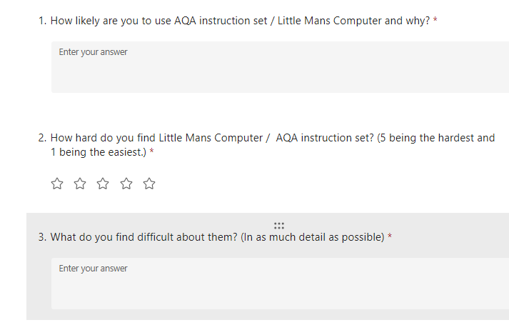

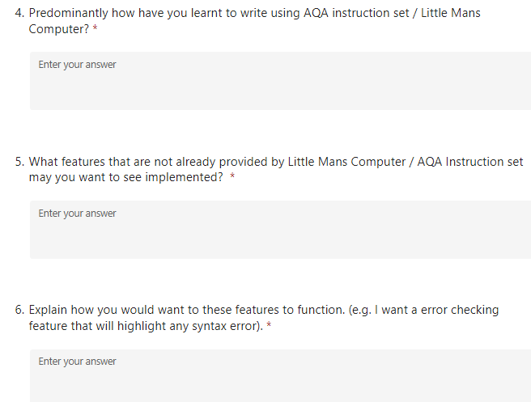
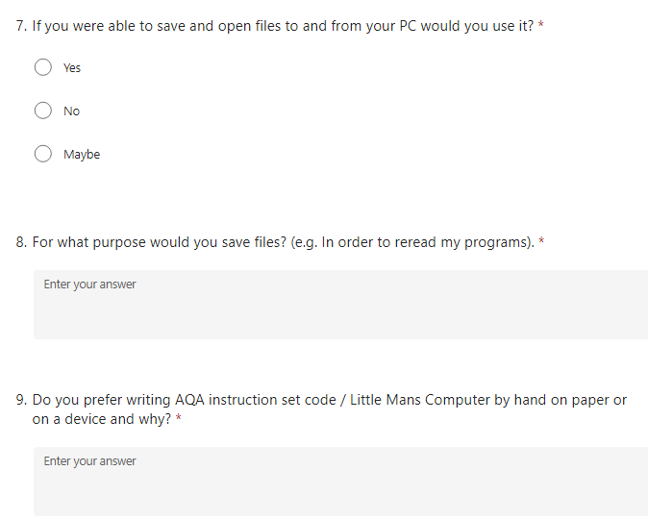

Survey Findings
- Based on question 1, I was able to conclude that every student in my class would be needing to practise AQA instruction set/Little Man Computer in preparation for their A-level exams as all students find this specific topic challenging due to reasons such as syntax or lack of practise. This shows the need for my project as another common response I got was that many students do not know how to write competently in little man’s computer. As a result, I may need to add a feature which will help students learn how to program using AQA instruction set/Little Man computer.
- All the students fell between a difficulty of 3-5 which shows that this topic is challenging for students of all ability, despite AQA instruction set being part of the A-level specification. This is a good opportunity to show that my project can be as use for students to practise and improve their low-level programming. My project will provide students an easy-to-use simulator which will allow students to practise numerous times writing code using low-level languages in order to get a better understanding of the syntax, logic and standard thought process of solving problems. This also highlights the need for my program to have ready made examples so that students can understand the syntax of the language better.
- Over 50% of students said that they find low-level syntax very hard to understand. Some said this is due to it not being similar to the English language like a high-level language such as python. Over said that they do not know what the instructions do or what instructions to use. Other said that the limited functions and instructions make it more challenging, for example instead of having a multiply instruction you have to use binary shifting instead which is less widely used and can be seen to be less efficient.
- Over 2/3 of the students have used past paper questions to help improve their programming using AQA instruction set. Past paper questions are generally the way most students tend to revise. Other students have opted to ask the teacher for help with problems and a minority chose to use the textbook to help improve their programming. This shows that the majority of pupils perform predetermined tasks to complete, so this may necessitate the need for my project to give students questions to answer.
- Over 2/3 of students have suggested that IntelliSense because this is what they are used to using and would be a great addition as it speed up the process by suggesting words. Currently LMC has no IntelliSense so adding this would be a great addition. Furthermore, this would greatly improve the common mistakes such as syntax errors from mistyping a word or improper parameters uses such as not writing a register.
- Many of the students wanted a feature to highlight their error and provide further feedback about how to fix the error by hovering over the error. Furthermore, some students wanted syntax highlighting to highlight where command word, immediate and direct addressing has been used. This will help improve the maintainability of the program and further aid the convenience.
- Over 2/3 of the students said that they would engage with a feature which allows them to save and open programs on their PC. This reiterates the importance of being able to save and reuse, change programs previously made. This enables students to be able to revise code that they have written and improve open work that may be corrected by a teacher. Furthermore, this is convenient because if you save work to your OneDrive, this will allow you to access it from anywhere with an internet connection.
- Many students were in agreement that this feature would be more convenient than having to copy the code and then save it in an external file. They said that it would be useful as it allows them to go back and make changes to programs or if they want to revisit programs for revision then do so. In addition, he convenience of being to access their work anywhere was a use they said would be convenient.
- The majority of students said that they prefer to write assemble code on a device as it is easier to type/write the code rather than by hand. Furthermore, writing code on a device will improve productivity and most likely increase the speed at which you can write code compared to writing code on paper which is said to be more tedious. Which in turn shows that my project would provide as good working tool for students to use in preparation for their exams.

The problem

Current System

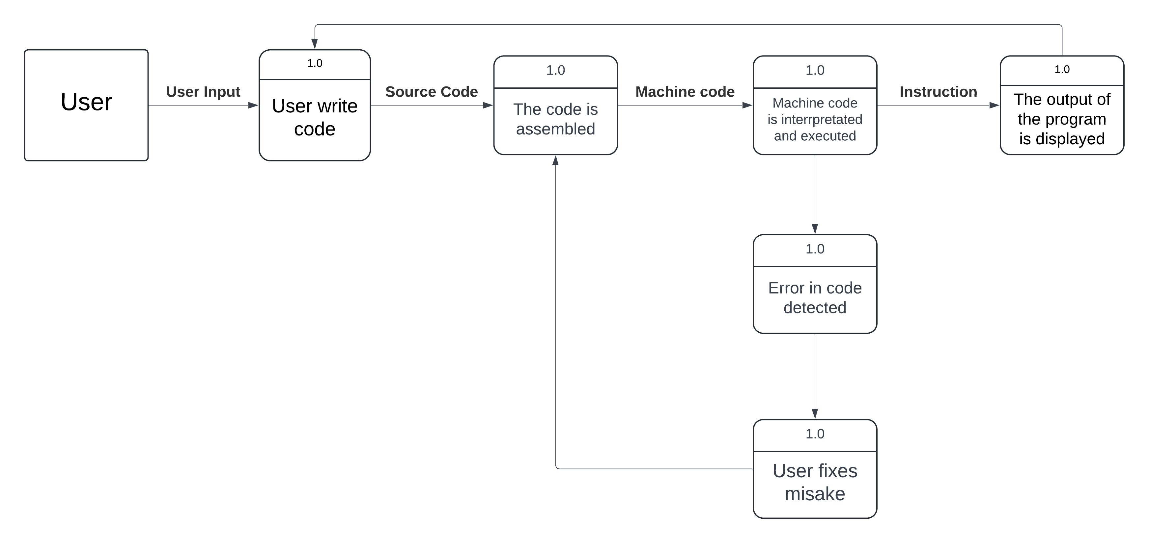
This is how the current LMC operates.

Students find it hard to write using the AQA Instruction set syntax but also find it hard to figure out where logical errors have been made. Currently, students have to write LMC in a simulator which provides no IntelliSense or error messages to help improve the coding experience for the programmer. It is also quite limited in the range of instructions that it provides to the users.
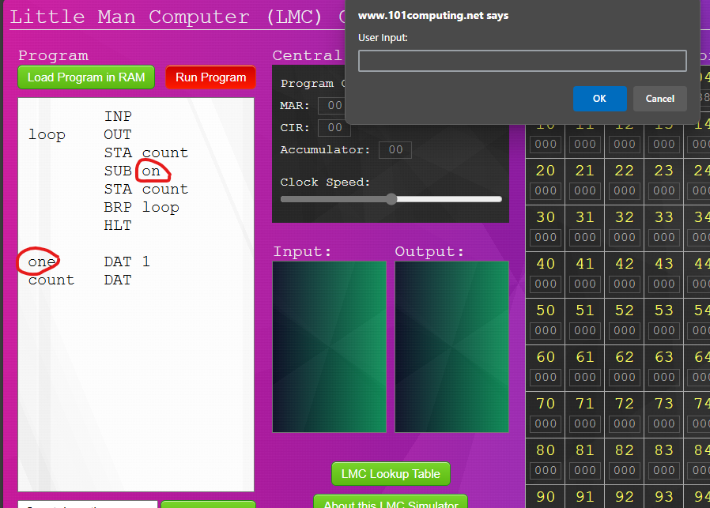
As we can see from the screenshot above, if a syntax error is made it is not detected by the IDE/IntelliSense and the program is still able to run. This mistake can easily be made and may decrease the productivity of the user. As a result, I plan to stop this from happening in my project. I have planned counter measured in my objectives to stop this from occurring.

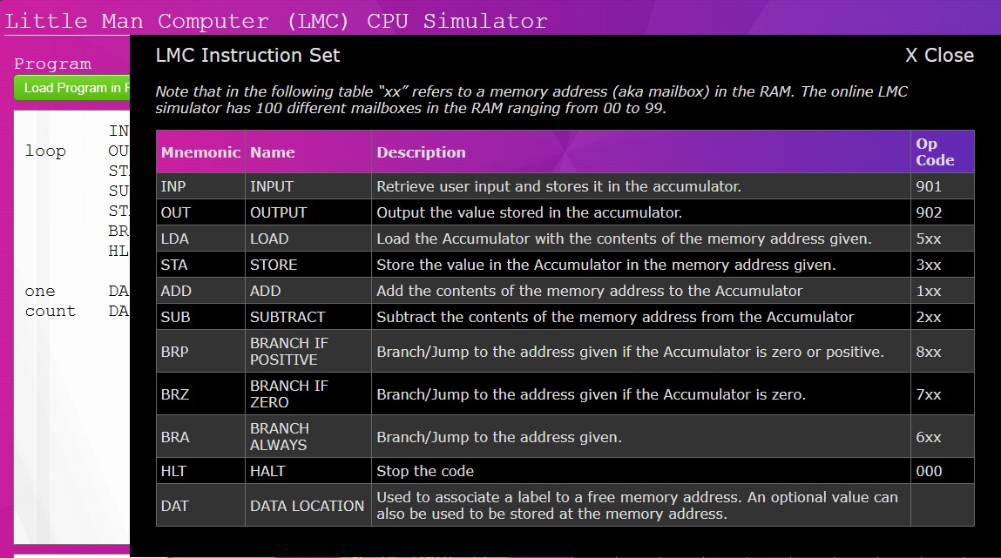
Little man's computer does provide a section which explains all the functions of the instructions, however, it doesn’t show how to use them with registers, and it doesn’t give any examples of using them in code. I plan to fix this in my project by providing working examples that show how to do this.

Propose System
This is my proposed diagram for a student writing AQA instruction set or LMC using my program. It has the feature that LMC simulator does but also has more features to accommodate for the needs of the students I have surveyed and my client's requests.
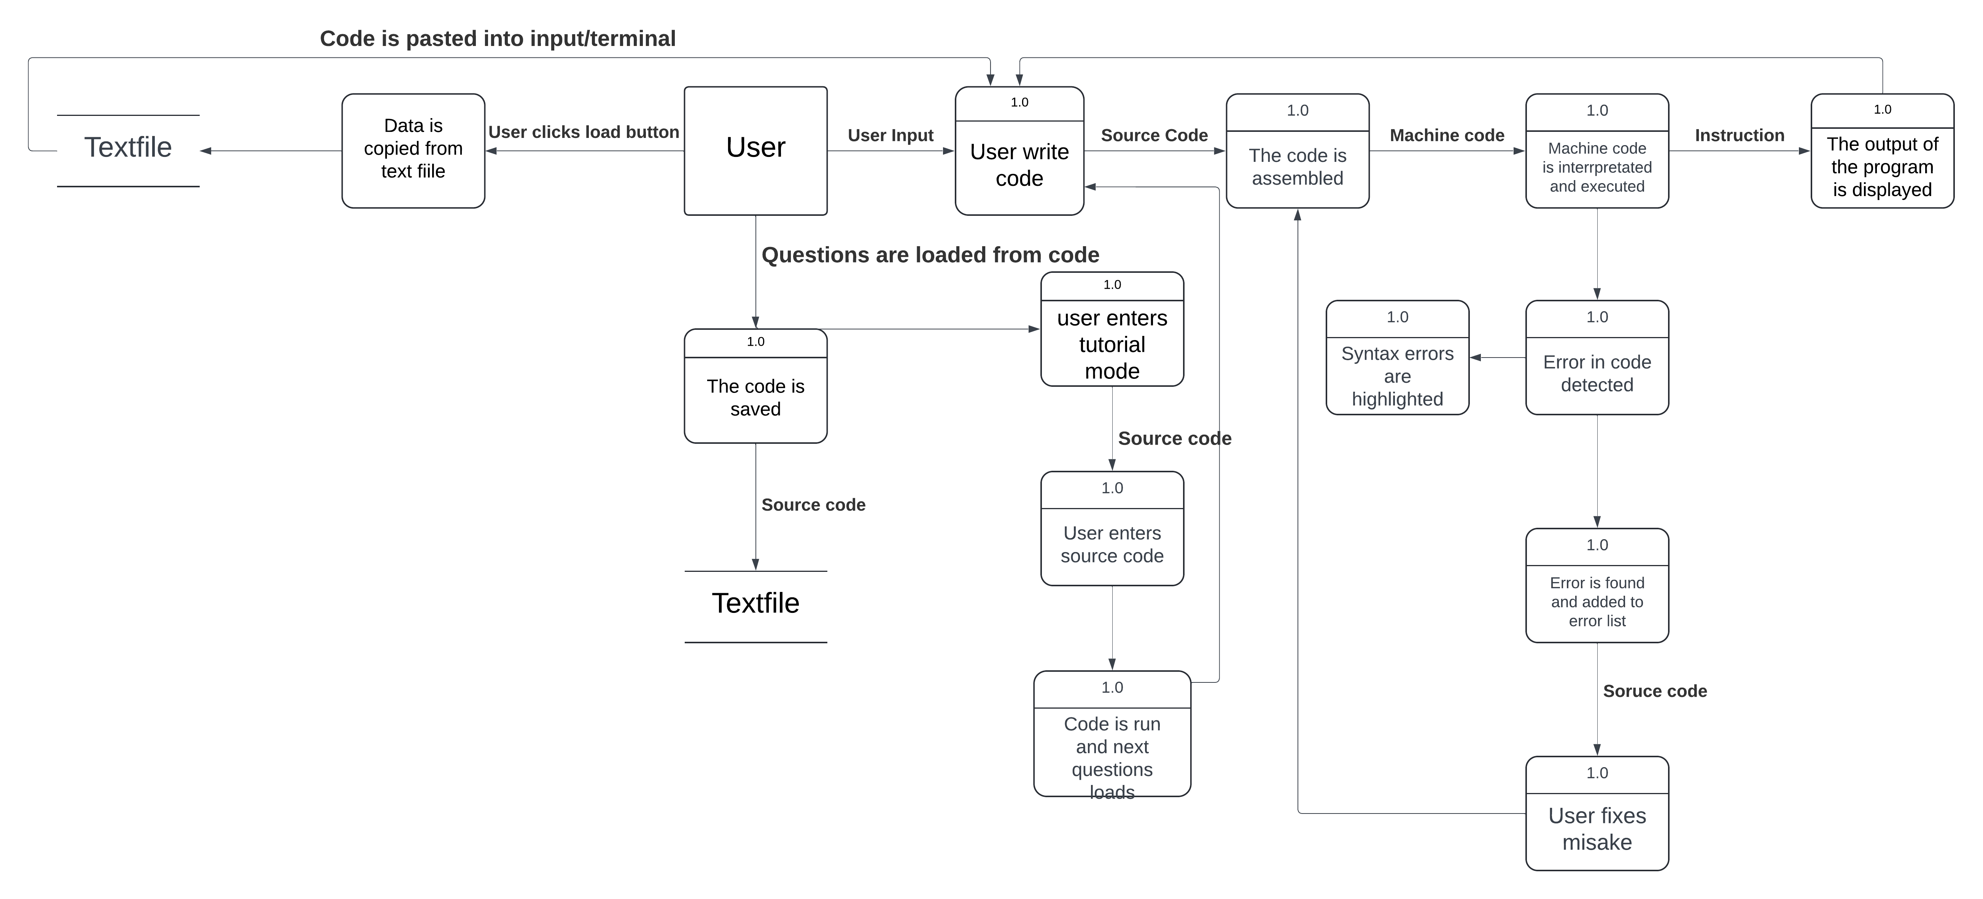
This is my proposition for a new student writing low level code using my project, this is the new things that they can do using my program.

Objectives
I have deemed these objectives to be a necessity for my project, I believe that achieving all of these objectives would significantly improve the practicality and usability of my project.

Main

- The user should be able to see all the registers and changes to the information they contain immediately when they happen clearly without struggle.
Students should be able to see changes that occur within each register and memory location. Every change should be seen by the user, the user should see the order in which registers are being used, the register/memory location currently being used should be highlighted to clearly show this. This will give the user a good understanding of the Fetch-Decode-Execute cycle and also address which buses are being used to transfer the memory address and the data of the memory location.
- If the program is assembled and an error is detected, the program should not crash but tell the user their error. The user should be also to see what error they made within 5 seconds.
Like an IDE such as Visual studio, if there is an error in the code, it should not crash the program, but it should produce an error message of some sort, informing the user of what error has occurred. If there is a syntax error, the program should not allow the user to assemble the code until that error is fixed. The program should also tell the user which line the error was made so that it is easier to detect and find and students said that they found it hard to find their error when writing in Little Mans Computer or on paper for an exam.
- The user’s code should be assembled and executed in a reasonable amount of time.
This is mainly for convenience and efficiency of the user and the program, being able to assemble and execute the program is a reasonable amount of time is a goal that I think it important to the success of the program. In order for this to be a success, I aim to ensure that my program is assembled and begins executing within a 0.5 second span.
- The user should be able to load example programs that have been premade within the click of a button which will give the user options to select.
The user should be able to access a drop-down menu which has several example codes such as countdown, adding two numbers, etc. This is solely for the users benefit of the user in order to grasp a better understanding of how to write assembly or to look at the syntax. Many of the students who responded to my survey said that they do not understand or know the syntax so an example would be a good addition to my program.
- The user should be able to save within the click of a button and open files with ease
User should have the option to save program that they have written and be able to load them back and execute them if they wish. My survey results showed me that many students would want the chance to be able to come back to programs finish them later or to make changes to them. Users code will be stored using a text file as it is easy and convenient for both me the programmer and the user to manipulate.
- The user should be able to change the executing speed of the program which should take effect within 2 seconds of the speed being changed.
The user should be able to adjust the clock speed, which will determine how fast the program is run by using a drag bar to adjust the speed. This will allow them to be able to see the changes in the registers easier and allow them to use register information for other tasks.
- The user should be able to control the cycle of the execution
This will give the user more control over the program, the user should be able to click a button and then the next instruction will run. This is more convenient for the user as if they are answering questions they can run the program at their own digression by the simple click of a button. Which should be easily located by the user.
- Provide denary mode for which to view the registers
The user should be able to switch between machine code and denary for the values in the memory addresses and registers by the click of a button. This should give the user a more clear understanding of what the values actually mean in the memory and registers instead of just seeing 1’s and 0’s

Extra

- The user should be able to change the layout of the IDE.
The user should be able to adjust the background colour of the IDE, colour of text, layout of the IDE to their preferences. Including the background colour at minimum a light mode and dark mode feature should be offered.
- A tutorial provides which explains the use of each instruction.

The user be able to click on a tutorial button which will then show them situations in which each instruction is and can be used. This will evidently show, the instruction be referred to, what it is doing and how it will be used. The parameters of the instruction should also be evidently shown and what they do should be highlighted. This is in case the user has forgotten how a certain instructions syntax is laid out, they can see a premade example.

- Example questions with set answers.

The user should be able to click on a tutorial mode which will give them set tasks to complete by writing code. When their code produces the correct output, the user will then be prompted to try another random question or to end the tutorial session. If all of the questions have been completed, the user will be given some form of congratulation and prompt to go back to the main IDE, the user should also have to option to restart the tutorial if they want to redo it.

The user should be able to enter a tutorial mode and, in this mode, when they hover over an instruction, it should tell them how it works and give them an example of the instruction being used. It should tell them if any registers or addresses are affected.

Data Volumes
This section will brief the data requirements for my project. It will display information such as how much data registers and memory locations can store.

Memory and Variables

Name | Data Type | Size (In bits)
Accumulator | 32 Integer | 32
Memory Address Register | 32 Integer | 32
Memory Data Register | 32 Integer | 32
Arithmetic Logic Unit | 32 Integer | 32
Memory Locations (each) | 32 Integer | 32
Current Instruction Register | 32 Integer | 32
Program Counter | 32 Integer | 32
Memory Address | 32 Integer | 32
Executable | Boolean | 8
Registers | List | 32bits (per item)

Data sources and destinations
Input | Details
Load example programs – Data comes from source code. | Programs will be stored in the source code and will be written into a textbox/terminal when it is requested to be loaded.
User writes code - Data comes from user writing code | The user writes their code in input section in the correct format. Ensuring that each instruction is on a new line.
The user assembles and runs their code. – Data from the user is then used. | The code is assembled and then converted to machine code as assembly code and machine code are one to one.
An output is displayed. – Data comes from assembler | The machine code is then executed and then the output of the code is then displayed in the output section.
Save/Open program – Data comes from input to a text file and vice versa when opening a program. | The user can save the program to the computer so that it can be accessed and opened again if wanted.

Output | Details
IntelliSense | The completed word will appear when the user has typed part of the word/phrase.
Registers | The registers will display the value that is stored inside of them.

Research Process
I ensured that I thoroughly researched each section of my project to ensure that I had a firm understanding of my project. The first part of my research started with ensuring that I understand the FDE cycle and how it processes work. This was crucial to the success of my project. The second part of my research is focussed on the assembling and executing of commands. This is also critical for the success of my project.

Computer Science (FDE)

Extracting information from the video below, we see that the program that the user writes is stored in main memory in machine code, the memory addressing would be in binary. This first video gave my more insight as to how I was planning to make my program.
Fetch Decode Execute Cycle in more detail (youtube.com)
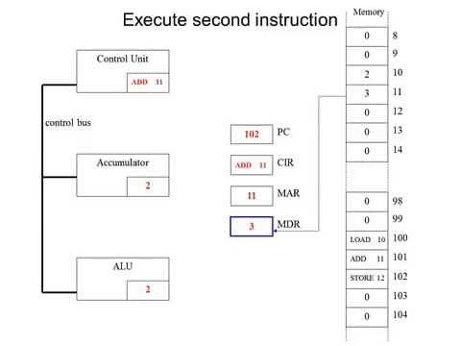

- When a program is executed, the memory address of the next instruction is taken from the PC (Program Counter) and stored in the MAR (Memory Address Register).
- The address bus sends the location of the PC to the RAM and then the data bus sends the contents (data) of the memory address to the MDR (Memory Data Register).
- The data is then fetched from the MDR and placed into the CIR (Current Instruction Register). The program counter then increments by one.
- The instruction is then decoded. In this example the instruction is ‘LOAD 10’ which means load the content of memory address 10.
- We then place the memory address 10 into the MAR (Memory Address Register).
- The contents (data) of the address are then placed into the MDR (Memory Data Register). This will overwrite the previous data.
- Then the data is then loaded into the accumulator where the user can act on the data.

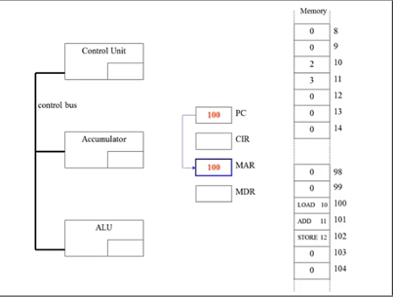
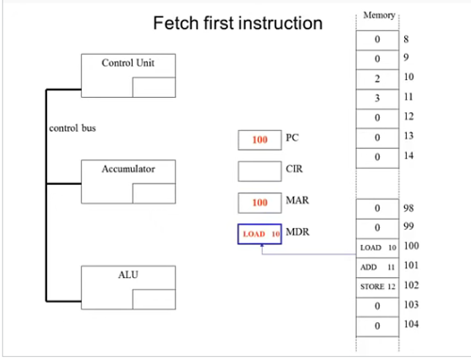
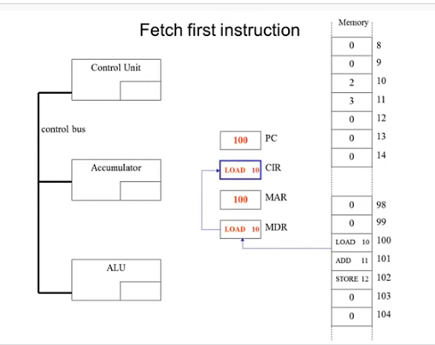
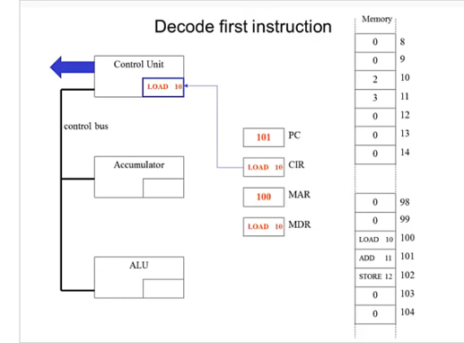
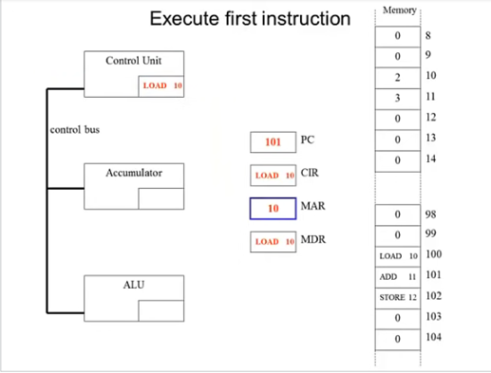
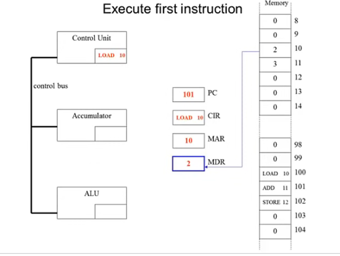
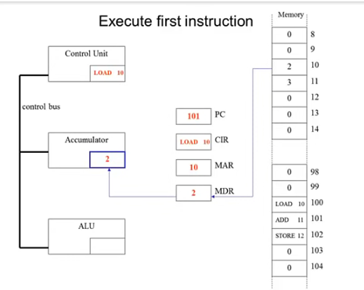

Translating

Understanding how the assembly code is converted into binary machine code is very important for the success of my project. I had a good grasp on how this would work but researched to find out the minute details.
This video helped with my understanding of machine code and how it works.
Machine Code Instructions (youtube.com)
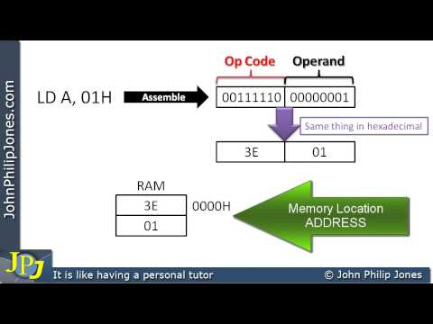

From this video, it gave me a better understanding of how instructions work, more in-depth talking about opcodes, operands, the CPU and RAM. It also spoke about concepts like immediate addressing.
I also learned from my research that machine code and assembly instructions are one to one which is why low-level languages are closer to the hardware than high level languages. This allows for better control over the hardware.

Saving / Loading
C# How to save text to a .txt file (youtube.com)
I knew that my project would need a sabing and loading feature and I was unsure of an efficient way of doing this. As I result, from my research I found that I could create a director and a folder to store code that I made to a text file.
I manage to write the code into the text file to be stored.
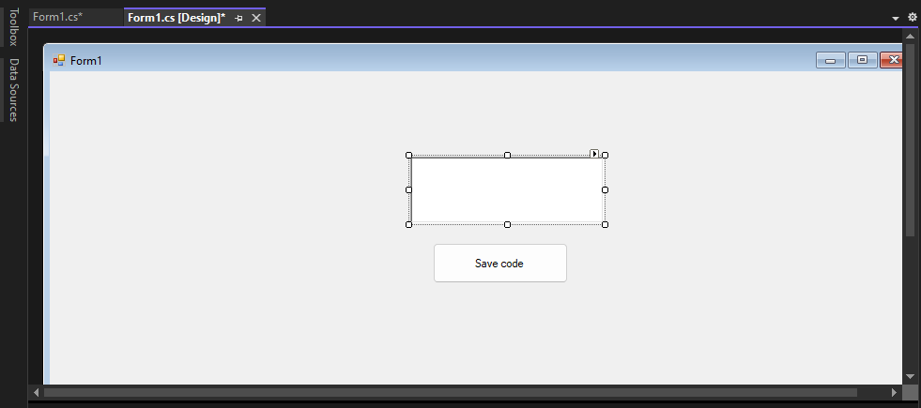
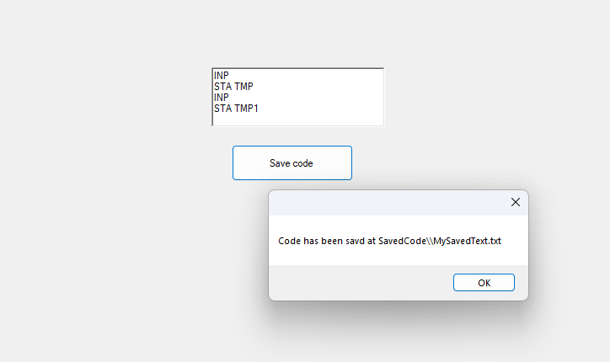
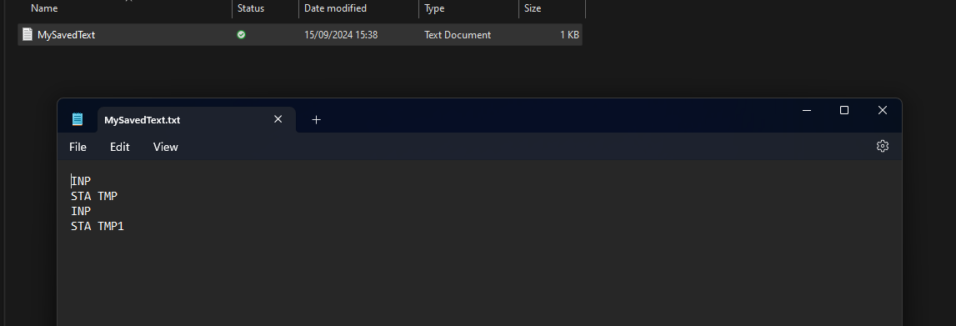

My next objective was to write this code back into the code input, I knew this could be done using a Stream reader I just wasn’t sure how, so I watched another video which went over how to use stream writer and stream reader, and this allowed me to write back from a text file to a textbox.
Read and Write files in 10 minutes | C# (youtube.com)
I wrote ‘hello world’ into the text file and it loaded back into the textbox.
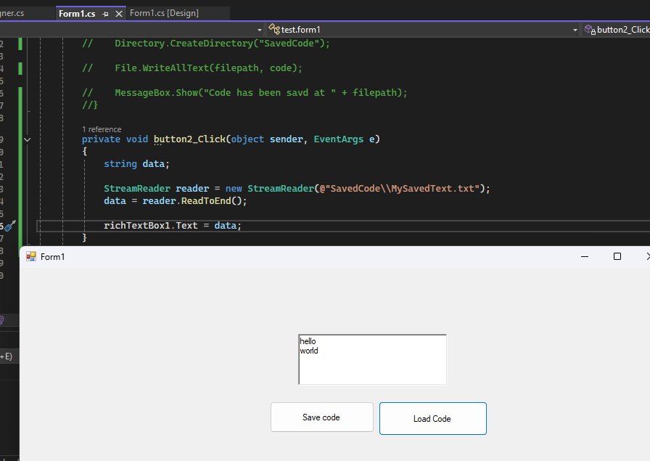

Constraints and Limitations
Assembler
- One challenge may be debugging the code, this is because the code I will be debugging is low level languages which may make it harder to handle syntax errors.
- The speed of the assembler could also be an issue. It is imperative that the program can assemble code in a sufficient amount of time. This shouldn’t be too much of an issue as low-level languages are closer to the hardware compared to high-level languages.
- Assembly language is specific to computers of specific architectures. This because different instructions have different machine code equivalents so I will have to ensure my assembler is compatible with every computer.
- Low-level languages aren't made specifically for writing large programs due to the time it would take and the limiting functions of low-level languages. Furthermore, majority of simulations have small input sections for program code which further limits the size of code.
Users
- Some students find it hard to understand the syntax of low-level languages and this may cause an issue when using my assembler considering there will be limited teaching features.
- My program is targeted at any computer scientist who may uses low-level to program or to practise. This includes GCSE students, A-level students and professionals. As a result, each group may find that it is not optimized for them.
- There are limited IDE features, and many students rely on these to help them program and using low-level languages this is significantly reduced compared to high-level languages.
Maintenance
- My instructions will be written using 32 bits, this is because it allows bits for the opcode and the operand to fit. In addition, it allows for patterns to represent certain commands. For example, and instruction beginning with 0101 can be used to present operations.
- In order to ensure that text file that are being saved by the user will not take up too much storage, I will impose a maximum character limit of approximately 128 words.
My instruction will be grouped so that instructions of similar types can be found from a pattern in the bits.

Proposed solution

Programming Language
I have chosen to use c# for my project as this has been the language I have used at school for a year now. I have a good understanding of how to use c#. In addition, c# being a high-level language makes it easier to read and write code as opposed to a low-level language. Moreover, c# allows the easy application of OOP which will be a great addition to my project. I could have also used python but one of my mains is to ensure that my project runs efficiently and in a reasonable amount of time, c# has much better performance than python as it uses a standard called CLI or Common language infrastructure which is a standard for executing high level code; so was my preference over python.

Data storage
For my project, when the user writes their code, they must be able to save and reopen their program code. This doesn’t require anything too fancy, so I have decided to do this by writing the code to a text file using the in-built Stream writer. This text file can then be saved to the user's user space where they can reuse it if necessary. When the user opens the text file into the program, the text file will be read line by line and the code will be written into the input section in the correct format so that it can be run.
The size of a character in a file depends on the encoding used. Using Unicode, a character can taker around 1-4 bytes of data. I will set a maximum character limit of around 128 which means that the user of my program can use a maximum of 128 * 2.5 bytes. Using 2.5 as an average. This is approximately 320 bytes of data being used.

Design

System Design
This will consist of my inputs, outputs and storage of my project.

Inputs
Input Name | Description
Simulator type | The user selects which simulator type they would like to use as LMC and AQA instruction set have slightly different instruction sets.
Open file | The user can click a load button which will prompt them to select a text file to open. This code will then be converted back into source code and placed into the input section and can be assembled and executed.
Execution speed | The user is able to adjust the execution speed of the program with the slide of a buttons which can slow down how fast or slow instructions are executed.
Load program | The user selects a button which will then load the program Into the RAM as long as there are no syntax errors in the program.
Source code | The user enters the source code of the program into the input section. The input will be cap locked as this makes it easier to look for instructions and makes the writing consistent.

Outputs
Output Name | Description
Assemble Code | The source code is converted into machine code and loaded into a file which can be executed.
Run Code | The executable from is read and the instructions are executed by the simulator and outputted into the output section.
Error Menu | Any errors made by the user are listed in an error menu. When hovering over the error, suggestions should be recommended.
Load File | The user can click a load button which will prompt them to select a text file to open. This code will then be converted back into source code and placed into the input section and can be assembled and executed.
Table of instructions | This will provide the user with all the instructions that can be used and the parameters that are used.
Load example programs | The user will have an array of example programs which can be loaded, and they can visualise how it works.
Memory Locations | The memory location values will constantly be changing when the program is being ran. This will allow the user to see changes that occur. This may happen quite fast so the user will be able to change the execution speed of the program.

Processes
Process Name | Description
Validate input code | Ensure that there are no syntax errors in the source code written in the input section which will affect the output of the code.
Validate questions | The program will ensure that the user code produces the correct output and also has user the required instructions to complete the tasks.
Generate questions | The user can enter a tutorial mode. This will then give them several problems to write solutions to and when all of them are answered correctly, the tutorial will close.
IntelliSense | If the user is typing an input, the IntelliSense can finish the word currently being typed, highlights syntax errors and more.
Switch modes | The user is able to click a button and by doing this, they are offered the choice between a LMC and AQA instruction set mode.
Keyboard shortcuts | When the user presses a shortcut combination, the desired section should take place, for example if the user presses ctrl + x then the line should be deleted.
Execution speed | The user should be able to adjust the executions speed of the program which may help the user to see changes which occur in registers.
Display | The user should be able to adjust the display of the program. They should be able to change background colours, source code colour, ++++
Suggestion generation | If the user has an error, the IntelliSense will generate suggestions which could solve the error.
Save file | The user can select a button and save their code into a text file which can be saved into a specific location on their computer. The executable will be in low level instead of machine code.

GUI Design

Main Design
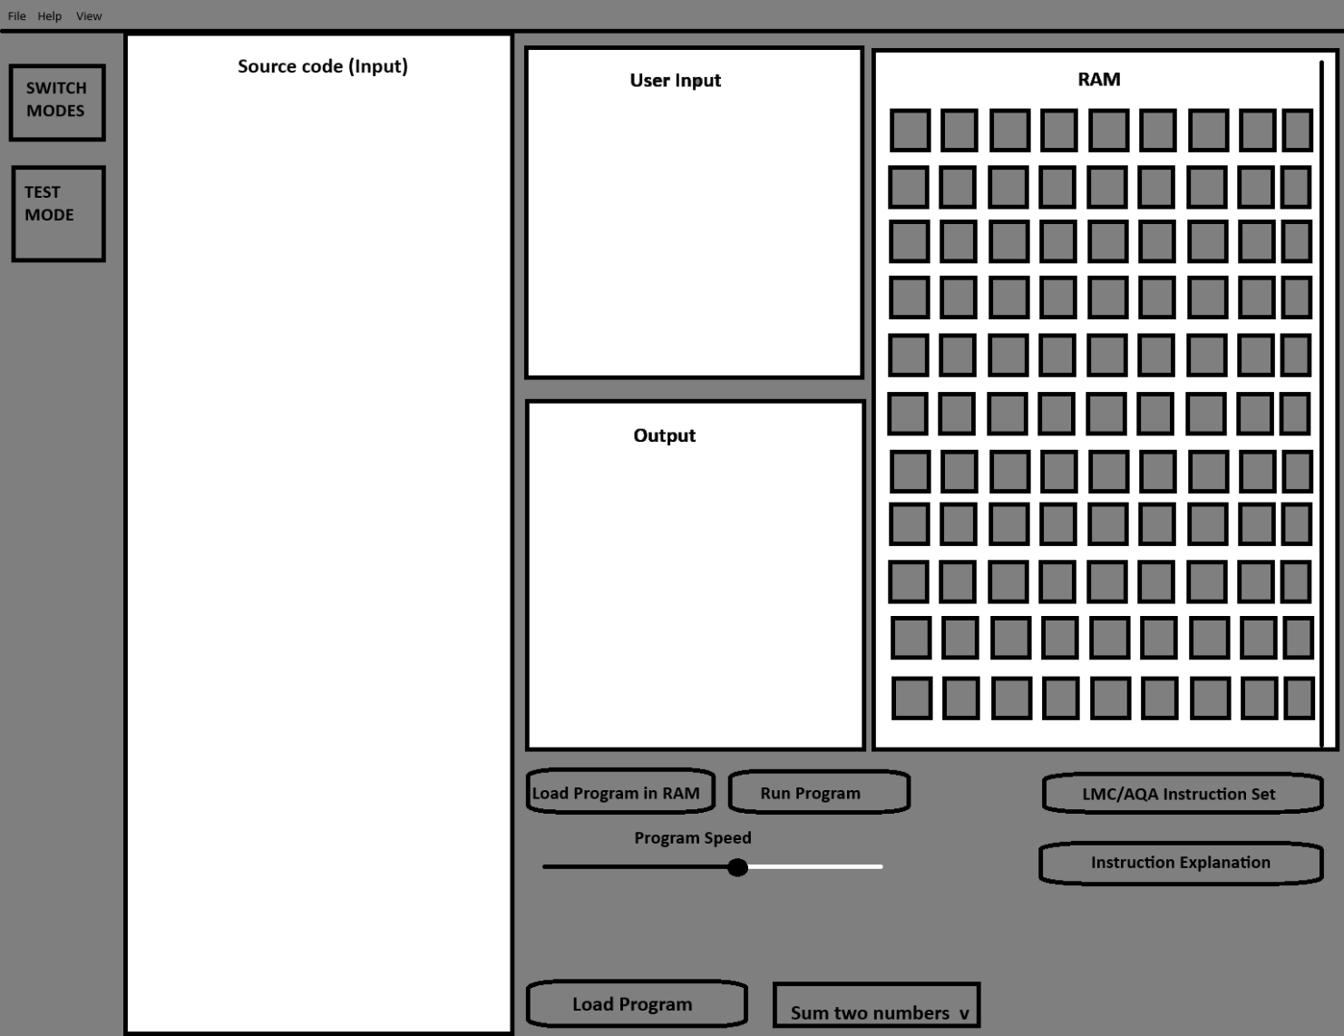
The file button at the top will contain the ‘Save File’, ‘Open File’, ‘Exit’
The view button contains the light and dark mode and other miscellaneous features.
The help button contains answers to some FAQ.
This is my current design; I have ensured that it is simple so that it can be followed very easily. The large box on the left if for input, this is where the user will right their source code. This will most likely be a textbox as it will allow the text to be saved easier.
In the middle, the top box contains my registers, the user can see the values that are stored in the registers and below that is my input and output box respectively. Whenever the user is required to give an input, a pop-up box will allow the user to enter it and then it will be placed into the input box. Any outputs that are displayed will be in the output box next to it.
The large box on the right is for the RAM, where the memory locations will be found. Because I will need a substantial number of memory locations, I have added a scroll bar so that the user can scroll down and see changes the occur in the main memory.
Selecting ‘run program’ will then assemble the code, the source code will be converted into machine code and placed into the RAM in the correct order. Then the instructions will be executed. This will follow the FDE cycle and can be seen by looking at the registers and RAM.
The scrollbar on the left is to adjust the speed of the program because at normal speed, it may be too fast to see the changes that occur in RAM or registers.
‘SWITCH MODES’ will alternate between LMC and AQA instruction set mode. Giving GCSE students the chance to program in LMC and A-level students the option to practise AQA instruction set.
The instructions set button will contain both instruction sets and give you and example of how they can be used in context. This is so the user has a better visualisation on how to use the instruction.
The Load programs section will give the user an array of programs to select from such as ‘Add 2 numbers’ or ‘Multiply two numbers’ this is so that the user can see solutions to problems and can take inspiration from it.
Selecting the ‘TEST’ button, the program will active the test mode which will then give the user a series of problems to write. When they write the correct solution, the next task will load. When all the tasks are completed then the test mode will end. The test mode will have randomised questions and ask 5.

Modular System Structure
My program is mainly split between 3 different parts. The main thing is the IDE where the user is able to program. From this it is split into 3 parts.
The Assembler deals with the main bulk of the program, this is when the user assembles their code, their code is then converted into machine code and then executed. This user can choose to load the machine code into the RAM or other features.
The IntelliSense improves the QOL of the program and makes it more convenient for the user to write code on. By providing indications for any errors made and providing solutions to these problems. Also providing an auto dry runner so that users can keep task of variables.
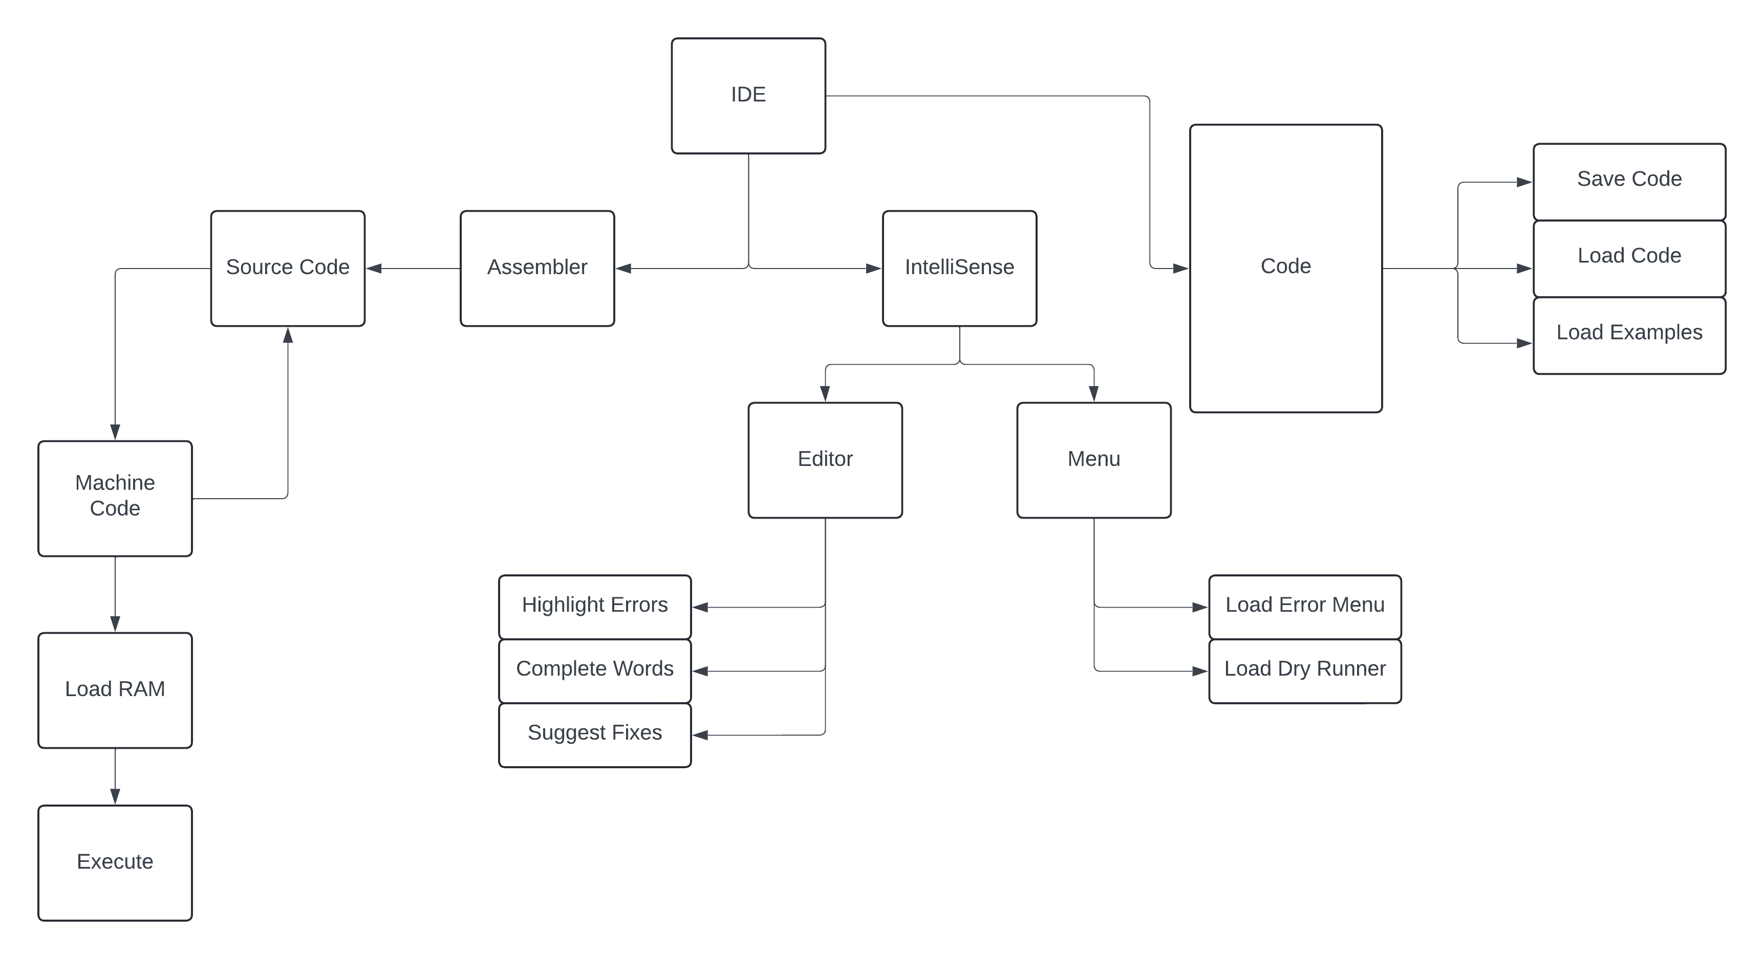
The Code is what the user does to the code. The user can save their source code into a text file. This file can then be loaded backed into the program where it can be executed. In addition, the user can load example programs.

Representation of objects

Overview
Creating an assembler require a class which is able to store data and convert from source code (AQA instruction set/Little Mans Computer) to machine code and hence produce an output. This is why I propose a class called ‘Machine’ that will deal with the bulk of this. My program will need to have two instruction sets stored for my AQA instruction set and Little Mans Computer instruction set.
My program does not require many classes as the Machine class contains many of the methods and properties of the program so my project has very few classes.
I have also implemented a class called Editor. This is to store errors that occur and then they are copied into a menu where the user can then see the errors, also fixes to these errors are also included.

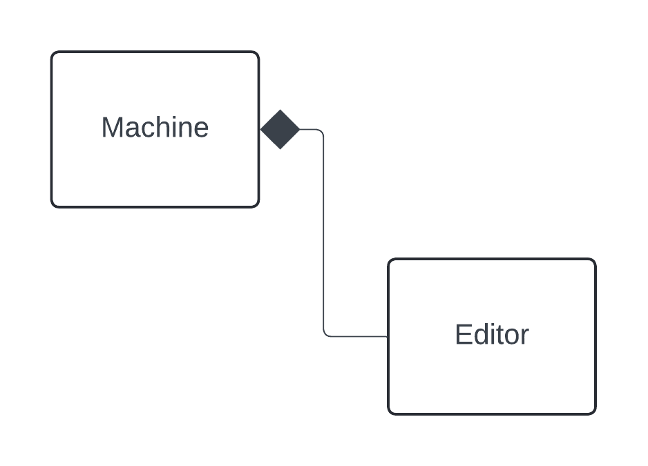
In my program, the machine class contains the bulk of my program. Coordinating events such as assembling, running and executing the program. This will also be backed up with an editor class which is mainly for correction and IntelliSense and user interface which will allow the user to adapt the program accordingly to their likings.
The lack of classes is mainly due to not needing many classes to hold different types of data.

Machine Class
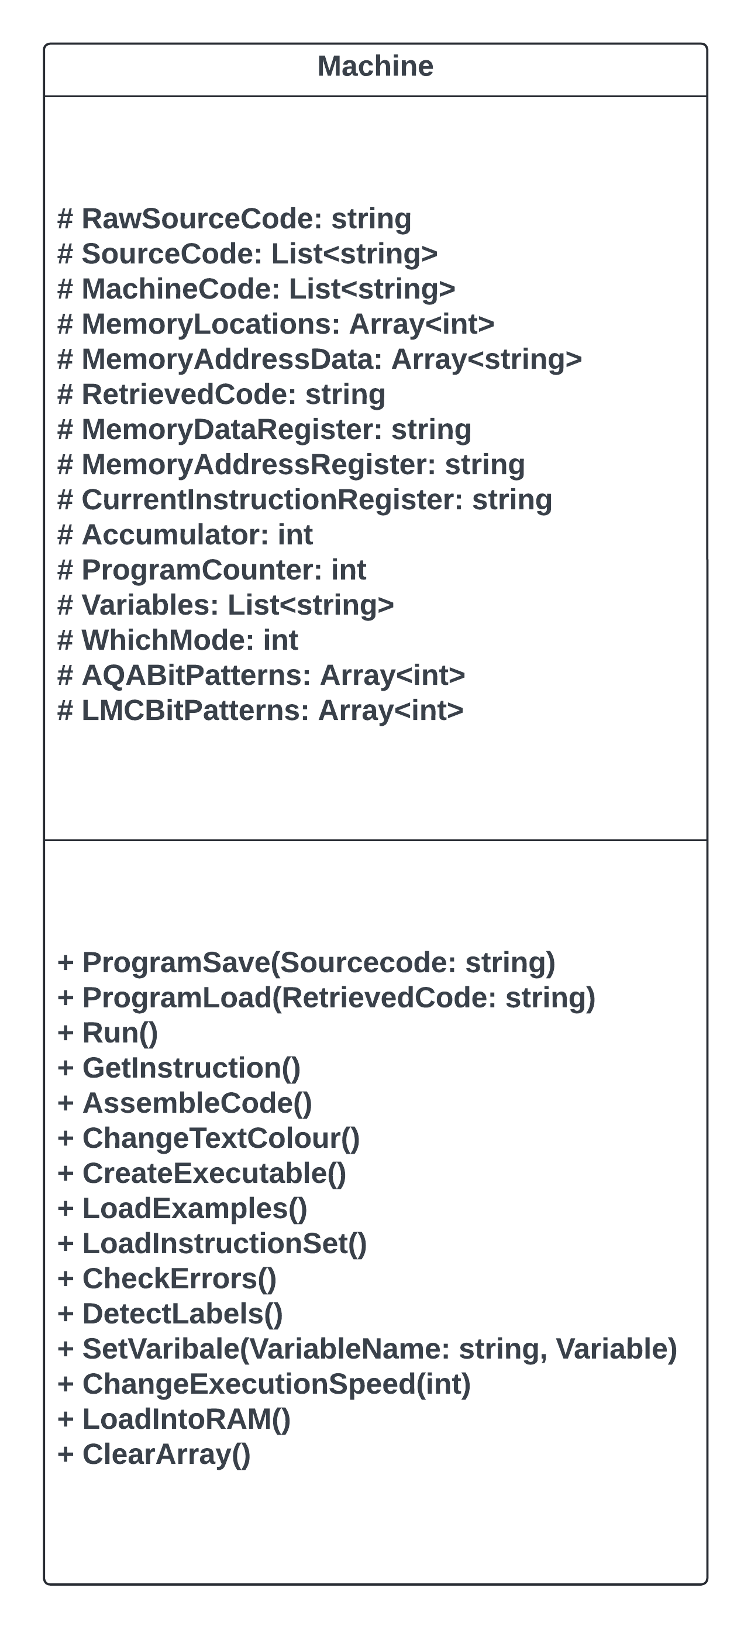
Machine is the parent class and will contain the source code of the program. It is responsible for saving and loading too which I think is a key feature of the program.
It may also potentially contain the methods for a testing section where students will be tasked to program the solution to a problem.

Editor Class
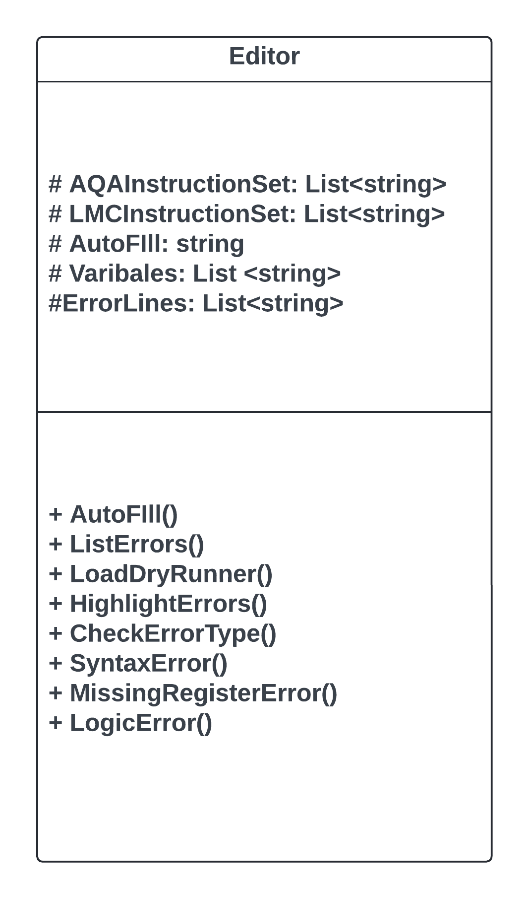
Editor the child class of parent is mainly IntelliSense which will word on data fed from the parent class. It will also store data such as the error menu which will be displayed for the user to see.

Overall UML

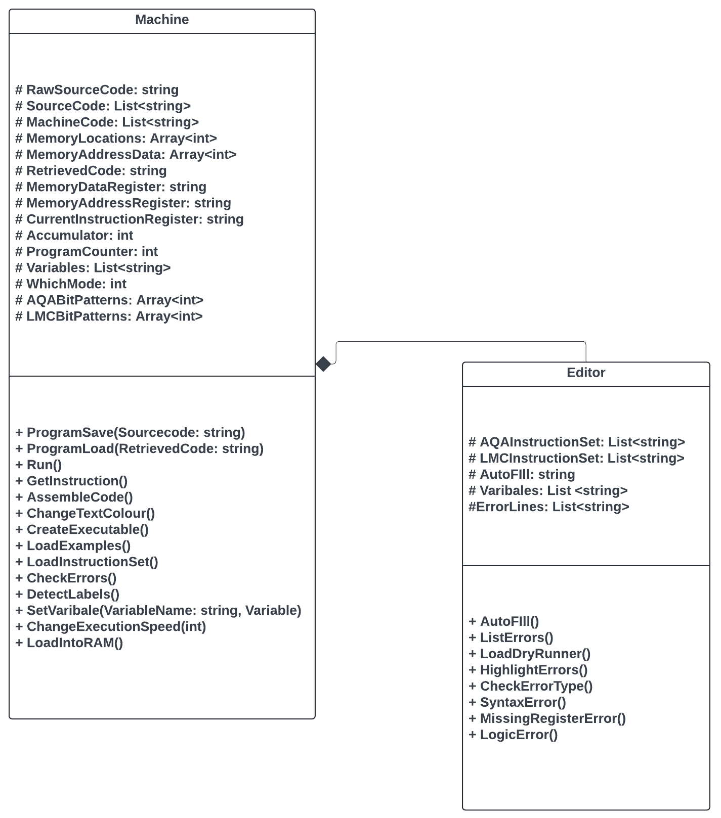

Instructions

Instruction Set

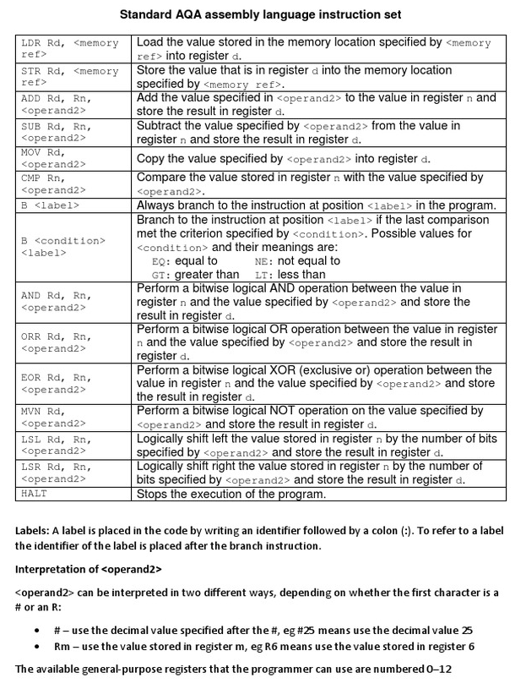
This is the instruction set which is paramount for A-level students to be proficient in as they will be required to know how to program using AQA instruction set as part of their specification. There are some instructions here which are not similar to Little Man Computer like bitwise logical shifts which an A-level student would need to practise for their exam.
Having every instruction in the AQA instruction set would be a minimum for my project to be successful as this is required for A-level students. These extra commands that AQA instruction set have over Little Man Computer is to provide greater functionality for students to program with.

Little Man Computer Instruction Set
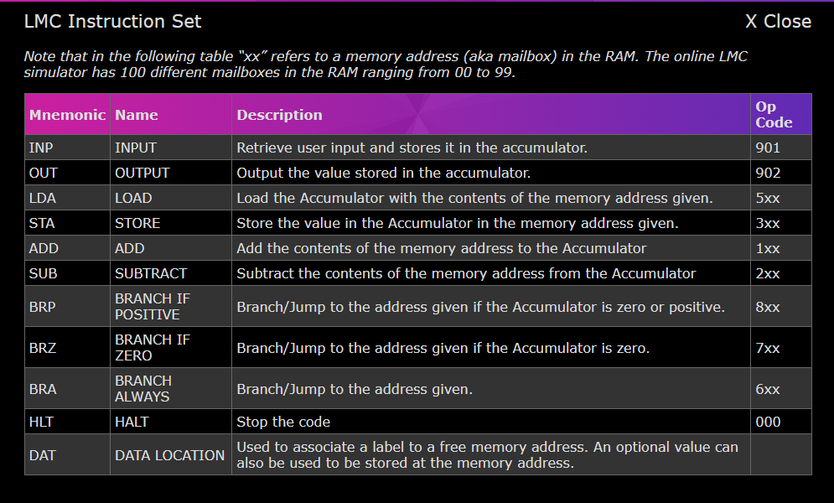
The Instruction set for LMC is more niche than AQA Instruction Set. This means that it may be harder to do tasks such as multiplying and dividing as you don’t have a bitwise logical shift.
LMC has an advantage as it allows you to use the DAT instruction to store constants or values which would be more advantageous when programming with LMC rather than AQA instruction Set. LMC also has slightly differently worded instructions to AQA instruction set which I will have to account for.

Registers and Data tore
Program Counter
The program counter will store the address of the next instruction; the value will be visible for the user to see.
This variable will need to be an integer as it only need to increment by 1.
Memory Address Register
The Memory address will then contain the address of the next instruction obtained from the program counter. This will then be sent via the address bus to main memory.
Memory Data Register
The address of the next instruction will be fetched from the MAR and sent across the address bus. Then the data/instruction of the address will be returned and placed in the memory data register via the data bus.
Current Instruction Register
The instruction in the MDR is then placed into the current instruction register where it is then split into its opcode and operand and decoded and executed.
Arithmetic Logic Unit
If the instruction requires a calculation to be made, this is done by the Arithmetic Logic Unit.
Accumulator
Any result of calculation is then placed in the accumulator.

Bit Patterns
I will structure instructions of similar types with a set bit pattern so that instruction so that type can easily be recognised. I will be using 32 bits for instructions/data so I will use the first 4 to identify each type.

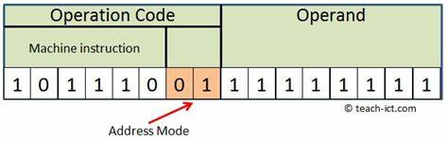
I will have to consider the length of my opcode, addressing made and operand. Given that I will be using 32 bits for my instructions. I will allocate 2 bits for addressing modes as this provides me with enough bits for all the addressing modes. With 30 bits left I propose to use 16 for the opcode and 14 for the operand as I deem that the length of the opcode will be longer than the operand.
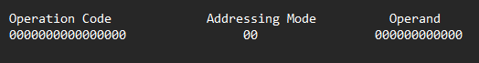

AQA Instruction Set Bit Patterns
There are 18 different instructions; in order to be able to represent all of them I will have to use 4 bits because 2⁵ = 32
The first 4 bits are for the instruction. Some instruction numerous registers so depending on the instruction, my program will check to see which ones are required.

Numbers will be represented using 4 bits in binary, 2⁴
Immediate Addressing – The operand is specified in the instruction
Direct Addressing – The address in the address is the address to be used
Indirect Addressing – The address of the instruction gives the address of the data to be used
Indexed Addressing – An indexed register is added to the address part of the instruction

Instruction | Bit pattern | Explanation
LDR Rd, <memory ref> | 0100(000)
STR Rd, <memory ref> | 0100(010)
ADD Rd, Rn, <operand2> | 0001(000)
SUB Rd, Rn, <operand2> | 0001(010)
MOV Rd, <operand2> | 0100(100)
CMP Rn, <operand2> | 1001(000)
B <label> | 0010(000)
BEQ <label> | 0010(010)
BGT <label> | 0010(110)
BNE <label> | 0010(100)
BLT <label> | 0010(111)
AND Rd, Rn, <operand> | 1000(000)
ORR Rd, Rn, <operand2> | 1000(010)
EOR Rd, Rn, <operand2> | 1000(100)
MVN Rd, <operand2> | 1000(110)
LSL Rd, Rn, <operand2> | 0001(100)
LSR Rd, Rn, <operand2> | 0001(110)
HALT | 1001(010)
INP | 1001(100)
To help with assembling, I will be making bit patterns associated with different type of instructions. This will help identify instructions when they are all in machine code.

Arithmetic Instructions
These instructions will start with the bit pattern 0001.
Then to differentiate them, the next two digits will be slightly different.
ADD – 0001(000)
SUB – 0001(010)
LSL – 0001(100)
LSR – 0001(110)

Branching instructions
Branching instructions will begin with the bit pattern 0010
B – 0010(000)
BEQ – 0010(010)
BNE – 0010(100)
BGT – 0010(110)
BLT – 0010(111)

Loading and Storing instructions
These instructions will start with the bit pattern 0100
LDR – 0100(000)
STR – 0100(010)
MOV – 0100(100)

Bitwise instructions
Bitwise instructions will start with the bit pattern 1000
AND – 1000(000)
ORR – 1000(010)
EOR – 1000(100)
MVN – 1000(110)

Extra instructions
These extra instructions will start with the bit pattern 1001
CMP – 1001(000)
HALT – 1001(010)
INP – 1001(100)

Registers
Registers will then be the next 2 bits so the 8th and 9th bit.
If a R is read then the bit pattern will be 11

LMC Instruction Set Bit Patterns
Instruction | Bit pattern
INP | 1100001
OUT | 1100010
LDA | 1100011
STA | 1100100
ADD | 1100101
SUB | 1100110
BRP | 1100111
BRZ | 1101000
BRA | 1101001
HLT | 1101010
DAT | 1101011

Assembling – Multiple-Pass Approach
The first pass is when memory addresses are assigned to every mnemonic in the source code. Any values that have been declared for labels will then be stored.
During the second pass is when all instructions are converted into their machine code equivalent then and then the program is executed, producing an output.

Algorithms

Pseudocode

Machine

IsAQAOpcode()

IsOpcode = False
Foreach(var word in RawSourceCode)
If (AQAInstructionSet.Contains(word))THEN
IsOpcode = True
END IF
END FOR
Return IsOpcode

IsAQARegister()
IsRegister() = False
Foreach(var word in RawSourceCode)
IF (word[i] == ‘R’ AND word[i+1] == 1 OR word[i+1] == 2 OR word[i+1] == 3 OR word[i+1] == 4 OR word[i+1] == 5 OR word[i+1] == 6 OR word[i+1] == 7 OR word[i+1] == 8 OR word[i+1] == 9) THEN
IsRegister = True
END FOREACH
Return IsRegister

Gathering Mnemonics

mneomonic = “”
List<string> SourceCode = new
For i = 0 to len(RawSourceCode)
If (RawSourceCode[i] != “ “) THEN
mneomonic = mneomonic + RawSourceCode[i]
ELSE
SourceCode.Add(mneomonic)
Mneomonic = “”
END IF
END FOR

Instruction Sets

AQAInstructionSet[] = Array<string> {“LDR”, ”STR” , ”ADD” , ”SUB” , ”MOV” , ”CMP” , “B”, “BEQ”, “BGT”, “BNE”, “BLT”, “AND” , “ORR” , “EOR” , “MVN”, “LSL” , “LSR” , “HALT”}
LMCInstructiOnSet[] = Array<string> {“LDA” , “STA”, “ADD” , “SUB” , “INP” , “OUT” , “HLT” , “BRA” , “BRZ” , “BRP” , “DAT”}

Bit Patterns

AQABitPatterns[] = Array<string> {“10100001”, “10100010”, “10100011”, “10100100”, “10100101”, “10100110”, “10100111”, “10101000”, “10101001”, “10101010”, “10101011”, “10101100”, “10101101”, “10101110”, “10101111”, “10110000, “10110001”, “10110010”}
LMCBitPatterns[] = Array<string>

LoadIntoRAM(string data, int location)

MemoryAddressData[] = Array<string>[128]
MemoryAddressData[location].Add(holder)

AssembleCode() – AQA Instruction Set

List<string> SourceCode = new List
List<string> MachineCode = new List
String holder = “”
Foreach (var word in SourceCode)
For i = 0 to len(AQAInstructionSet), 1))
While(word != AQAInstructionSet[i])
If (word[0] == ‘R’)
holder = word[1:len(word)-1]
MemoryAddressLocation[i] = holder
Holder = “”
ELSE
MachineCode.Add(holder)
Holder = “”
END IF
END WHILE
END FOR
END FOREACH

DrawMemoryAddressLocations()

MemoryAddressLocation = new Button[129]

For i = 0 to len(MemoryAddressLocation)
MemoryAddressLocation[i] = new Button()
MemoryAddressLocation[i].Text = Convert.ToString(i + MemoryAddressData)
MemoryAddressLocation[i].TextAlign = ContentAlignment.TopCenter
MemoryAddressLocation[i].Size = new Size(40, 50)
this.Controls.Add(MemoryAddressLocation[i])
END FOR
For i = 0 to 10
MemoryAddressLocation[i] = new Point(550 + i * 50, 10)
END FOR
For i = 10 to 20
MemoryAddressLocation[i] = new Point(50 + i * 50, 60)
END FOR
For i = 20 to 30
MemoryAddressLocation[i] = new Point(550 + (i-10) * 50, 110)
END FOR
For i = 30 to 40
MemoryAddressLocation[i] = new Point(550 + (i-20) * 50, 160)
END FOR
For i = 40 to 50
MemoryAddressLocation[i] = new Point(550 + (i-30)* 50, 210)
END FOR
For i = 50 to 60
MemoryAddressLocation[i] = new Point(550 + (i-40) * 50, 260)
END FOR
For i = 60 to 70
MemoryAddressLocation[i] = new Point(550 + (i-50) * 50, 310)
END FOR
For i = 70 to 80
MemoryAddressLocation[i] = new Point(550 + (i-60) * 50, 360)
END FOR
For i = 80 to 90
MemoryAddressLocation[i] = new Point(550 + (i-70) * 50, 410)
END FOR
For i = 90 to 100
MemoryAddressLocation[i] = new Point(550 + (i-80) * 50, 460)
END FOR
For i = 100 to 110
MemoryAddressLocation[i] = new Point(550 + (i-90) * 50, 510)
END FOR
For i = 110 to 120
MemoryAddressLocation[i] = new Point(550 + (i-100) * 50, 560)
END FOR
For i = 120 to 129
MemoryAddressLocation[i] = new Point(550 + (i-110) * 50, 610)
END FOR

GetSourceCode()

List<string> ListedSourceCode = new
String inputwords
String holder = “”

Inputwords = Textbox.Text

For i = 0 to len(inputwords)
If (inputwords[i]) != “ “)
holder = holder + inputwords[i]
ELSE
ListSourceCode.Add(holder)
holder = “ ”
END IF
END FOR
return GetSourceCode()

ProgramSave()

*Research was conducted into order to learn to save file*
How to: Write text to a file - .NET | Microsoft Learn

mneomonic = “”
RawSourceCode = “LDR R2 R4 ADD R4 R2 #4”
SourceCode = List<string>
For i = 0 to len(RawSourceCode)
If RawSourceCode[i] != “ “ THEN
mneomonic = mneomonic + RawSourceCode[i]
ELSE
SourceCode.Add(mneomonic)
Mneomonic = “”
END IF
END FOR
String filepath = Enivornemnt.GetFolderPath(Environment.SpecialFolder.MyDocuments)
Using (StreamWriter outputfile = new StreamWriter(Path.Combine(filepath, “Test.txt”)))
Foreach (var item in SourceCode)
Outputfile.Write(\n item)
END FOREACH

ProgramOpen()

*Research was conducted into order to learn to read and write*

List<string> SourceCode = new
String filepath = Enviroment.GetFolderPath(Environment.SpecicalFolder.MyDocuments)
Using (StreamReader outputfile = new StreamReader(Path.Combine(filepath, “*File Name*”)))
While(!outputfile.EndOfStream)
String line = outputfile.ReadLine()
SourceCode.Add(line)
END WHILE

Editor

CheckErrors()

For i = to len(SourceCode)
If(!AQAInstructionSet.Contains(SourceCode[i]) and SourceCode[i].FirstLetter != ‘R’)
ErrorLines.Add(SourceCode[i])
ELSE
Continue
END IF
END FOR

Fetch()

For i = 0 to len(MemoryAddressData)
MemoryAddressRegister = MemoryAddressData[i]

Test Strategy
I plan one ensuring that every part of my program works and make sure that the inputs are all sanitised so that it does not crash based on various input. I plan on testing code whenever it is written and whenever I implement code ensuring it functions with the rest of the system. My program shouldn’t crash under any circumstance but only inform the user of their errors then allow them to be fixed
Furthermore, I would like to ensure that my project have reached the goals I set out from the start so I will ask several students to set different sections of my program and then get a report back from them on how well that section worked and if it would be suitable for them as a student and any additional features that may need to be implemented.
In addition, I will request that a few students try to break my program, be it with invalid input or anything else with the intention to break the program. If successful in breaking the program this will show my where I must improve the code to make my program more robust and maintainable.
After all these tests, I will create a small survey where students will test the program as a whole and then rate each section of my program out of 10. This will give me a general overview of how successful each section of my program is.
Furthermore, I will create several tests which I plan to make sure that my program can pass. These will be unambiguous goals which I do not already know the outcome of and then I will test them or give them to other computer science students to test and then I will validate whether the test is a pass or fail. If it is a failure, then I will fix the problem as long as I have enough time.

Program Security

Security of Files
I will not be making any security measures for the text file as it does not contain any sensitive data such as a name or confidential data. The intended purpose for my program is to be educational and help student to learn to write using AQA instruction set and LMC. If a company were to use it, they may want security to keep their program code safe however this is not my intended purpose.

Technical Solution

PopUp Class

using System;
using System.Collections.Generic;
using System.ComponentModel;
using System.Data;
using System.Drawing;
using System.Linq;
using System.Text;
using System.Threading.Tasks;
using System.Windows.Forms;

namespace Assembler
{
public partial class PopUp : Form
{
public PopUp()
{
InitializeComponent();
button1.Text = "Using the program\r\n\r\nAddressing Modes:\r\n\r\nImmediate\r\nIn order to make use of immediate addressing you will use the prefix ‘#’\r\nFor example, “INP R3 #2”\r\nThis will load the denary value 2 into register 3.\r\n\r\nRelative \r\nIn order to make use of relative addressing you will use the prefix ‘@’\r\nFor Example, “INP R3 @2”\r\nThis will load the value stored in memory address 2 into register 3.\r\n\r\nDirect\r\nIn order to make use of direct addressing you simple need to do the number of register\r\nFor example, “INP R3 2”\r\nThis will store the value in register 2 into register 3.\r\n";
}

private void richTextBox1_TextChanged(object sender, EventArgs e)
{

}
}
}

Validate Syntax
public List<int> ValidSyntax()
{
string[] SourceCodeArray = TokeniseSourceCode();
bool IsValid = true;
int LineCount = 0;
int TotalErrors = 0;
int listcount = 0;
List<int> LineOfErrorsAndNumberOfErrors = new List<int>();
ResolveLabels();

///These validate the source code.
///It ensures that each instruction is properly formatted
for (int i = 0; i < SourceCodeArray.Length; i++)
{
if (SourceCodeArray[i] == "LDRM") ///LOAD RAM
{
///checks whether the string contains a # or @ and then any other digit.
if (!Regex.IsMatch(SourceCodeArray[i + 2], @"^[#]\d+$") || !Regex.IsMatch(SourceCodeArray[i + 2], @"^[@]\d+$"))
{
IsValid = false;
LineOfErrorsAndNumberOfErrors.Add(LineCount);
TotalErrors++;
}
LineCount++;
}
if (SourceCodeArray[i] == "INP")
{
if (!SourceCodeArray[i + 1].Contains('R') || !Regex.IsMatch(SourceCodeArray[i + 2], @"^[#,@]\d+$") && !Regex.IsMatch(SourceCodeArray[i + 2], @"^\d+$"))
{
IsValid = false;
LineOfErrorsAndNumberOfErrors.Add(LineCount);
TotalErrors++;
}
LineCount++;
}
if (SourceCodeArray[i] == "LDR")
{
if (!SourceCodeArray[i + 1].Contains('R') || !Regex.IsMatch(SourceCodeArray[i + 2], @"^[#,@]\d+$") && !Regex.IsMatch(SourceCodeArray[i + 2], @"^\d+$"))
{
IsValid = false;
LineOfErrorsAndNumberOfErrors.Add(LineCount);
TotalErrors++;
}
LineCount++;
}
if (SourceCodeArray[i] == "STR")
{
if (!SourceCodeArray[i + 1].Contains('R') || !Regex.IsMatch(SourceCodeArray[i + 2], @"^[#,@]\d+$") && !Regex.IsMatch(SourceCodeArray[i + 2], @"^\d+$"))
{
IsValid = false;
LineOfErrorsAndNumberOfErrors.Add(LineCount);
TotalErrors++;
}
LineCount++;
}
if (SourceCodeArray[i] == "ADD")
{
if (!SourceCodeArray[i + 1].Contains('R') || !SourceCodeArray[i + 2].Contains('R') || !Regex.IsMatch(SourceCodeArray[i + 3], @"^[#,@]\d+$") && !Regex.IsMatch(SourceCodeArray[i + 3], @"^\d+$"))
{
IsValid = false;
LineOfErrorsAndNumberOfErrors.Add(LineCount);
TotalErrors++;
}
LineCount++;
}
if (SourceCodeArray[i] == "SUB")
{
if (!SourceCodeArray[i + 1].Contains('R') || !SourceCodeArray[i + 2].Contains('R') || !Regex.IsMatch(SourceCodeArray[i + 3], @"^[#,@]\d+$") && !Regex.IsMatch(SourceCodeArray[i + 3], @"^\d+$"))
{
IsValid = false;
LineOfErrorsAndNumberOfErrors.Add(LineCount);
TotalErrors++;
}
LineCount++;
}
if (SourceCodeArray[i] == "MOV")
{
if (!SourceCodeArray[i + 1].Contains('R') || !Regex.IsMatch(SourceCodeArray[i + 2], @"^[#,@]\d+$") && !Regex.IsMatch(SourceCodeArray[i + 2], @"^\d+$"))
{
IsValid = false;
LineOfErrorsAndNumberOfErrors.Add(LineCount);
TotalErrors++;
}
LineCount++;
}
if (SourceCodeArray[i] == "CMP")
{
if (!SourceCodeArray[i + 1].Contains('R') || !Regex.IsMatch(SourceCodeArray[i + 2], @"^[#,@]\d+$") && !Regex.IsMatch(SourceCodeArray[i + 2], @"^\d+$"))
{
IsValid = false;
LineOfErrorsAndNumberOfErrors.Add(LineCount);
TotalErrors++;
}
LineCount++;
}
if (SourceCodeArray[i] == "BGT" || SourceCodeArray[i] == "BEQ" || SourceCodeArray[i] == "BNE" || SourceCodeArray[i] == "BLT")
{
if (!BranchingLabels.ContainsKey(SourceCodeArray[i + 1]))
{
IsValid = false;
LineOfErrorsAndNumberOfErrors.Add(LineCount);
TotalErrors++;
}
LineCount++;
}
if (SourceCodeArray[i] == "B")
{
try
{
if (!BranchingLabels.ContainsKey(SourceCodeArray[i + 1]))
{
IsValid = false;
LineOfErrorsAndNumberOfErrors.Add(LineCount);
TotalErrors++;
}
}
catch (Exception ex)
{
System.Windows.Forms.MessageBox.Show("Loop not properly defined.");
}
LineCount++;
}
if (SourceCodeArray[i] == "AND")
{
if (!SourceCodeArray[i + 1].Contains('R') || !SourceCodeArray[i + 2].Contains('R') || !Regex.IsMatch(SourceCodeArray[i + 3], @"^[#,@]\d+$") && !Regex.IsMatch(SourceCodeArray[i + 3], @"^\d+$"))
{
IsValid = false;
LineOfErrorsAndNumberOfErrors.Add(LineCount);
TotalErrors++;
}
LineCount++;
}
if (SourceCodeArray[i] == "ORR")
{
if (!SourceCodeArray[i + 1].Contains('R') || !SourceCodeArray[i + 2].Contains('R') || !Regex.IsMatch(SourceCodeArray[i + 3], @"^[#,@]\d+$") && !Regex.IsMatch(SourceCodeArray[i + 3], @"^\d+$"))
{
IsValid = false;
LineOfErrorsAndNumberOfErrors.Add(LineCount);
TotalErrors++;
}
LineCount++;
}
if (SourceCodeArray[i] == "EOR")
{
if (!SourceCodeArray[i + 1].Contains('R') || !SourceCodeArray[i + 2].Contains('R') || !Regex.IsMatch(SourceCodeArray[i + 3], @"^[#,@]\d+$") && !Regex.IsMatch(SourceCodeArray[i + 3], @"^\d+$"))
{
IsValid = false;
LineOfErrorsAndNumberOfErrors.Add(LineCount);
TotalErrors++;
}
LineCount++;
}
if (SourceCodeArray[i] == "MVN")
{
if (!SourceCodeArray[i + 1].Contains('R') || !Regex.IsMatch(SourceCodeArray[i + 2], @"^\d+$"))
{
IsValid = false;
LineOfErrorsAndNumberOfErrors.Add(LineCount);
TotalErrors++;
}
LineCount++;
}
if (SourceCodeArray[i] == "LSL")
{
if (!SourceCodeArray[i + 1].Contains('R') || !SourceCodeArray[i + 2].Contains('R') || !Regex.IsMatch(SourceCodeArray[i + 3], @"^\d+$"))
{
IsValid = false;
LineOfErrorsAndNumberOfErrors.Add(LineCount);
TotalErrors++;
}
LineCount++;
}
if (SourceCodeArray[i] == "LSR")
{
if (!SourceCodeArray[i + 1].Contains('R') || !SourceCodeArray[i + 2].Contains('R') || !Regex.IsMatch(SourceCodeArray[i + 3], @"^\d+$"))
{
IsValid = false;
LineOfErrorsAndNumberOfErrors.Add(LineCount);
TotalErrors++;
}
LineCount++;
}
if (SourceCodeArray[i] == "HALT")
{
IsValid = true;
}
}
LineOfErrorsAndNumberOfErrors.Add(TotalErrors);
return LineOfErrorsAndNumberOfErrors;
}

Interpreter

private async void Interpret()
{
string MachineCode;
string TMPMachineCode;
string Instruction;
string TMPInstruction;
string AddressingMode;
string Register1;
string Register2;
string Operand1;

while (ProgramIsRunning)
{
if (!IsDenaryMode)
{
RegistersArrayValueLabel[0].Text = Convert.ToString(ProgramCounter);
MemoryAddressRegister = MemoryArray[ProgramCounter];
RegistersArrayValueLabel[2].Text = Convert.ToString(MemoryAddressRegister, 2);
await Task.Delay(1000);
MemoryDataRegister = MemoryAddressRegister;
RegistersArrayValueLabel[3].Text = Convert.ToString(MemoryDataRegister, 2);
CurrentInstructionRegister = MemoryDataRegister;
RegistersArrayValueLabel[1].Text = Convert.ToString(CurrentInstructionRegister, 2);
}
else
{
RegistersArrayValueLabel[0].Text = Convert.ToString(ProgramCounter);
MemoryAddressRegister = MemoryArray[ProgramCounter];
RegistersArrayValueLabel[2].Text = Convert.ToString(MemoryAddressRegister);
await Task.Delay(1000);
MemoryDataRegister = MemoryAddressRegister;
RegistersArrayValueLabel[3].Text = Convert.ToString(MemoryDataRegister);
CurrentInstructionRegister = MemoryDataRegister;
RegistersArrayValueLabel[1].Text = Convert.ToString(CurrentInstructionRegister);
}

if (MemoryAddressRegister != 0)
{
MachineCode = Convert.ToString(MemoryArray[ProgramCounter], 2);
TMPMachineCode = Convert.ToString(MemoryArray[ProgramCounter + 1], 2);
if (MachineCode.Length == 17)
{
MachineCode = "0" + MachineCode;
}

if (MachineCode.Length == 18)
{
Instruction = MachineCode.Substring(0, 7);
AddressingMode = MachineCode.Substring(7, 2);
Register1 = MachineCode.Substring(9, 5);
Operand1 = MachineCode.Substring(14, 4);
Console.WriteLine(Convert.ToInt32(Operand1,2));

if (InstructionAndBitPatterns.ContainsValue(Convert.ToInt32(Instruction, 2)))
{
string TheInstruction = InstructionAndBitPatterns.FirstOrDefault(x => x.Value == Convert.ToInt32(Instruction, 2)).Key;

//// 01 - direct //10 - immedidate // 11 - relative

if (TheInstruction == "INP")
{
if (AddressingMode == "01")
{
int RegisterAddress = Convert.ToInt32(Register1, 2) - 15;
GeneralRegisterArray[RegisterAddress] = GeneralRegisterArray[Convert.ToInt32(Operand1, 2)];

if (IsDenaryMode)
{
GeneralRegistersArrayValueLabel[RegisterAddress].Text = Convert.ToString(GeneralRegisterArray[Convert.ToInt32(Operand1)]);
}
else
{
GeneralRegistersArrayValueLabel[RegisterAddress].Text = Convert.ToString(GeneralRegisterArray[Convert.ToInt32(Operand1, 2)],2);
}
GeneralRegistersArrayValueLabel[RegisterAddress].BackColor = Color.LightPink;
await Task.Delay(250);
GeneralRegistersArrayValueLabel[RegisterAddress].BackColor = Color.White;
await Task.Delay(wait);
}

if (AddressingMode == "10")
{
int RegisterAddress = Convert.ToInt32(Register1, 2) - 15;
GeneralRegisterArray[RegisterAddress] = Convert.ToInt32(Operand1, 2);
GeneralRegistersArrayValueLabel[RegisterAddress].Text = Convert.ToString(Convert.ToInt32(Operand1, 2), 2);
if (IsDenaryMode)
{
GeneralRegistersArrayValueLabel[RegisterAddress].Text = Convert.ToString(Convert.ToInt32(Operand1, 2));

}
else
{
GeneralRegistersArrayValueLabel[RegisterAddress].Text = Convert.ToString(Convert.ToInt32(Operand1, 2),2);

}
GeneralRegistersArrayValueLabel[RegisterAddress].BackColor = Color.LightPink;
await Task.Delay(250);
GeneralRegistersArrayValueLabel[RegisterAddress].BackColor = Color.White;
await Task.Delay(wait);
}

if (AddressingMode == "11")
{
int RegisterAddress = Convert.ToInt32(Register1, 2) - 15;
GeneralRegisterArray[RegisterAddress] = MemoryArray[Convert.ToInt32(Operand1, 2)];
GeneralRegistersArrayValueLabel[RegisterAddress].Text = Convert.ToString(MemoryArray[Convert.ToInt32(Operand1, 2)], 2);
if (IsDenaryMode)
{
GeneralRegistersArrayValueLabel[RegisterAddress].Text = Convert.ToString(MemoryArray[Convert.ToInt32(Operand1, 2)]);

}
else
{
GeneralRegistersArrayValueLabel[RegisterAddress].Text = Convert.ToString(MemoryArray[Convert.ToInt32(Operand1, 2)], 2);

}
GeneralRegistersArrayValueLabel[RegisterAddress].BackColor = Color.LightPink;
await Task.Delay(250);
GeneralRegistersArrayValueLabel[RegisterAddress].BackColor = Color.White;
await Task.Delay(wait);
}
}
//// 01 - direct //10 - immedidate // 11 - relative

if (TheInstruction == "LDR")
{
if (AddressingMode == "01")
{
int RegisterAddress = Convert.ToInt32(Register1, 2) - 15;
GeneralRegisterArray[RegisterAddress] = MemoryArray[Convert.ToInt32(Operand1, 2)];
GeneralRegistersArrayValueLabel[RegisterAddress].Text = Convert.ToString(MemoryArray[Convert.ToInt32(Operand1, 2)], 2);

if (IsDenaryMode)
{
GeneralRegistersArrayValueLabel[RegisterAddress].Text = Convert.ToString(MemoryArray[Convert.ToInt32(Operand1, 2)]);

}
else
{
GeneralRegistersArrayValueLabel[RegisterAddress].Text = Convert.ToString(MemoryArray[Convert.ToInt32(Operand1, 2)], 2);
}
GeneralRegistersArrayValueLabel[RegisterAddress].BackColor = Color.LightPink;
await Task.Delay(250);
GeneralRegistersArrayValueLabel[RegisterAddress].BackColor = Color.White;
await Task.Delay(wait);
}

if (AddressingMode == "10")
{
int RegisterAddress = Convert.ToInt32(Register1, 2) - 15;
GeneralRegisterArray[RegisterAddress] = Convert.ToInt32(Operand1, 2);
GeneralRegistersArrayValueLabel[RegisterAddress].Text = Convert.ToString(MemoryArray[Convert.ToInt32(Operand1, 2)], 2);

if (IsDenaryMode)
{
GeneralRegistersArrayValueLabel[RegisterAddress].Text = Convert.ToString(MemoryArray[Convert.ToInt32(Operand1, 2)]);

}
else
{
GeneralRegistersArrayValueLabel[RegisterAddress].Text = Convert.ToString(MemoryArray[Convert.ToInt32(Operand1, 2)], 2);
}
GeneralRegistersArrayValueLabel[RegisterAddress].BackColor = Color.LightPink;
await Task.Delay(250);
GeneralRegistersArrayValueLabel[RegisterAddress].BackColor = Color.White;
await Task.Delay(wait);
}

if (AddressingMode == "11")
{
int RegisterAddress = Convert.ToInt32(Register1, 2) - 15;
GeneralRegisterArray[RegisterAddress] = MemoryArray[Convert.ToInt32(Operand1, 2)];
GeneralRegistersArrayValueLabel[RegisterAddress].Text = Convert.ToString(MemoryArray[Convert.ToInt32(Operand1, 2)], 2);

if (IsDenaryMode)
{
GeneralRegistersArrayValueLabel[RegisterAddress].Text = Convert.ToString(MemoryArray[Convert.ToInt32(Operand1, 2)]);

}
else
{
GeneralRegistersArrayValueLabel[RegisterAddress].Text = Convert.ToString(MemoryArray[Convert.ToInt32(Operand1, 2)], 2);

}
GeneralRegistersArrayValueLabel[RegisterAddress].BackColor = Color.LightPink;
await Task.Delay(250);
GeneralRegistersArrayValueLabel[RegisterAddress].BackColor = Color.White;
await Task.Delay(wait);
}
}
if (TheInstruction == "LDRM")
{
if (AddressingMode == "01")
{
int RegisterAddress = Convert.ToInt32(Register1, 2) - 15;
MemoryArray[RegisterAddress] = GeneralRegisterArray[Convert.ToInt32(Register1, 2) - 15];
MainMemoryArrayValue[RegisterAddress].Text = Convert.ToString(GeneralRegisterArray[Convert.ToInt32(Register1, 2) - 15], 2);

if (IsDenaryMode)
{
MainMemoryArrayValue[RegisterAddress].Text = Convert.ToString(GeneralRegisterArray[Convert.ToInt32(Register1, 2) - 15]);

}
else
{
MainMemoryArrayValue[RegisterAddress].Text = Convert.ToString(GeneralRegisterArray[Convert.ToInt32(Register1, 2) - 15], 2);

}
MainMemoryArrayValue[RegisterAddress].BackColor = Color.LightPink;
await Task.Delay(250);
MainMemoryArrayValue[RegisterAddress].BackColor = Color.White;
await Task.Delay(wait);
}

if (AddressingMode == "10")
{
int RegisterAddress = Convert.ToInt32(Register1, 2) - 15;
MemoryArray[RegisterAddress] = Convert.ToInt32(Operand1, 2);
MainMemoryArrayValue[RegisterAddress].Text = Convert.ToString(Convert.ToInt32(Operand1, 2), 2);

if (IsDenaryMode)
{
MainMemoryArrayValue[RegisterAddress].Text = Convert.ToString(Convert.ToInt32(Operand1, 2));

}
else
{
MainMemoryArrayValue[RegisterAddress].Text = Convert.ToString(Convert.ToInt32(Operand1, 2), 2);

}
MainMemoryArrayValue[RegisterAddress].BackColor = Color.LightPink;
await Task.Delay(250);
MainMemoryArrayValue[RegisterAddress].BackColor = Color.White;
await Task.Delay(wait);
}

if (AddressingMode == "11")
{
int RegisterAddress = Convert.ToInt32(Register1, 2) - 15;
MemoryArray[RegisterAddress] = MemoryArray[Convert.ToInt32(Operand1, 2)];
MainMemoryArrayValue[RegisterAddress].Text = Convert.ToString(MemoryArray[Convert.ToInt32(Operand1, 2)], 2);

if (IsDenaryMode)
{
MainMemoryArrayValue[RegisterAddress].Text = Convert.ToString(MemoryArray[Convert.ToInt32(Operand1, 2)]);

}
else
{
MainMemoryArrayValue[RegisterAddress].Text = Convert.ToString(MemoryArray[Convert.ToInt32(Operand1, 2)], 2);

}

MainMemoryArrayValue[RegisterAddress].BackColor = Color.LightPink;
await Task.Delay(250);
MainMemoryArrayValue[RegisterAddress].BackColor = Color.White;
await Task.Delay(wait);
}
}

if (TheInstruction == "STR")
{
if (AddressingMode == "01")
{
int RegisterAddress = Convert.ToInt32(Register1, 2) - 15;
MemoryArray[Convert.ToInt32(Operand1, 2)] = GeneralRegisterArray[RegisterAddress];

MainMemoryArrayValue[Convert.ToInt32(Operand1, 2)].Text = Convert.ToString(GeneralRegisterArray[RegisterAddress], 2);

if (IsDenaryMode)
{
MainMemoryArrayValue[Convert.ToInt32(Operand1, 2)].Text = Convert.ToString(GeneralRegisterArray[RegisterAddress]);
}
else
{
MainMemoryArrayValue[Convert.ToInt32(Operand1, 2)].Text = Convert.ToString(GeneralRegisterArray[RegisterAddress], 2);
}

MainMemoryArrayValue[Convert.ToInt32(Operand1, 2)].BackColor = Color.LightPink;
await Task.Delay(250);
MainMemoryArrayValue[Convert.ToInt32(Operand1, 2)].BackColor = Color.White;
await Task.Delay(wait);
}

if (AddressingMode == "10")
{
int RegisterAddress = Convert.ToInt32(Register1, 2) - 15;
MemoryArray[RegisterAddress] = Convert.ToInt32(Operand1, 2);
MainMemoryArrayValue[RegisterAddress].Text = Convert.ToString(Convert.ToInt32(Operand1, 2));

if (IsDenaryMode)
{
MainMemoryArrayValue[RegisterAddress].Text = Convert.ToString(Convert.ToInt32(Operand1));
}
else
{
MainMemoryArrayValue[RegisterAddress].Text = Convert.ToString(Convert.ToInt32(Operand1, 2));
}

MainMemoryArrayValue[RegisterAddress].BackColor = Color.LightPink;
await Task.Delay(250);
MainMemoryArrayValue[RegisterAddress].BackColor = Color.White;
await Task.Delay(wait);
}

if (AddressingMode == "11")
{
int RegisterAddress = Convert.ToInt32(Register1, 2) - 15;
MemoryArray[RegisterAddress] = MemoryArray[Convert.ToInt32(Operand1, 2)];
MainMemoryArrayValue[RegisterAddress].Text = Convert.ToString(MemoryArray[Convert.ToInt32(Operand1, 2)]);

if (IsDenaryMode)
{
MainMemoryArrayValue[RegisterAddress].Text = Convert.ToString(MemoryArray[Convert.ToInt32(Operand1)]);
}
else
{
MainMemoryArrayValue[RegisterAddress].Text = Convert.ToString(MemoryArray[Convert.ToInt32(Operand1, 2)]);
}

MainMemoryArrayValue[RegisterAddress].BackColor = Color.LightPink;
await Task.Delay(250);
MainMemoryArrayValue[RegisterAddress].BackColor = Color.White;
await Task.Delay(wait);
}
}
//// 01 - direct //10 - immedidate // 11 - relative

if (TheInstruction == "MOV")
{
if (AddressingMode == "01")
{
int RegisterAddress = Convert.ToInt32(Register1, 2) - 15;
GeneralRegisterArray[RegisterAddress] = GeneralRegisterArray[Convert.ToInt32(Operand1, 2)];
GeneralRegistersArrayValueLabel[RegisterAddress].Text = Convert.ToString(GeneralRegisterArray[Convert.ToInt32(Operand1, 2)], 2);

if (IsDenaryMode)
{
GeneralRegistersArrayValueLabel[RegisterAddress].Text = Convert.ToString(GeneralRegisterArray[Convert.ToInt32(Operand1, 2)]);
}
else
{
GeneralRegistersArrayValueLabel[RegisterAddress].Text = Convert.ToString(GeneralRegisterArray[Convert.ToInt32(Operand1, 2)], 2);
}

GeneralRegistersArrayValueLabel[RegisterAddress].BackColor = Color.LightPink;
await Task.Delay(250);
GeneralRegistersArrayValueLabel[RegisterAddress].BackColor = Color.White;
await Task.Delay(wait);
}

if (AddressingMode == "10")
{
int RegisterAddress = Convert.ToInt32(Register1, 2) - 15;
GeneralRegisterArray[RegisterAddress] = Convert.ToInt32(Operand1, 2);
GeneralRegistersArrayValueLabel[RegisterAddress].Text = Convert.ToString(Convert.ToInt32(Operand1, 2), 2);

if (IsDenaryMode)
{
GeneralRegistersArrayValueLabel[RegisterAddress].Text = Convert.ToString(Convert.ToInt32(Operand1, 2));
}
else
{
GeneralRegistersArrayValueLabel[RegisterAddress].Text = Convert.ToString(Convert.ToInt32(Operand1, 2), 2);
}

GeneralRegistersArrayValueLabel[RegisterAddress].BackColor = Color.LightPink;
await Task.Delay(250);
GeneralRegistersArrayValueLabel[RegisterAddress].BackColor = Color.White;
await Task.Delay(wait);
}

if (AddressingMode == "11")
{
int RegisterAddress = Convert.ToInt32(Register1, 2) - 15;
GeneralRegisterArray[RegisterAddress] = MemoryArray[Convert.ToInt32(Operand1)];
GeneralRegistersArrayValueLabel[RegisterAddress].Text = Convert.ToString(MemoryArray[Convert.ToInt32(Operand1)], 2);

if (IsDenaryMode)
{
GeneralRegistersArrayValueLabel[RegisterAddress].Text = Convert.ToString(MemoryArray[Convert.ToInt32(Operand1)]);
}
else
{
GeneralRegistersArrayValueLabel[RegisterAddress].Text = Convert.ToString(MemoryArray[Convert.ToInt32(Operand1)], 2);
}

GeneralRegistersArrayValueLabel[RegisterAddress].BackColor = Color.LightPink;
await Task.Delay(250);
GeneralRegistersArrayValueLabel[RegisterAddress].BackColor = Color.White;
await Task.Delay(wait);
}
}

if (TheInstruction == "CMP")
{
TMPInstruction = TMPMachineCode.Substring(0, 5);
string TMPTheInstruction = InstructionAndBitPatterns.FirstOrDefault(x => x.Value == Convert.ToInt32(TMPInstruction, 2)).Key;
string LocationString = TMPMachineCode.Substring(5, 4);

if (AddressingMode == "01")
{
string BranchingInstruction = "00" + Convert.ToString(MemoryArray[ProgramCounter + 1], 2);
int RegisterAddress = GeneralRegisterArray[Convert.ToInt32(Register1, 2) - 15];
int CompareWith = GeneralRegisterArray[Convert.ToInt32(Operand1, 2)];

if (InstructionAndBitPatterns.FirstOrDefault(x => x.Value == Convert.ToInt32(BranchingInstruction.Substring(0, 7), 2)).Key == "BEQ")
{
if (RegisterAddress == CompareWith)
{
ProgramCounter = Convert.ToInt32(BranchingInstruction.Substring(7, 4), 2) - 1;
await Task.Delay(wait);

}

}

if (InstructionAndBitPatterns.FirstOrDefault(x => x.Value == Convert.ToInt32(BranchingInstruction.Substring(0, 7), 2)).Key == "BNE")
{
if (GeneralRegisterArray[RegisterAddress] != CompareWith)
{
ProgramCounter = Convert.ToInt32(BranchingInstruction.Substring(7, 4), 2) - 1;
await Task.Delay(wait);

}
}

if (InstructionAndBitPatterns.FirstOrDefault(x => x.Value == Convert.ToInt32(BranchingInstruction.Substring(0, 7), 2)).Key == "BGT")
{
if (GeneralRegisterArray[RegisterAddress] > CompareWith)
{
ProgramCounter = Convert.ToInt32(BranchingInstruction.Substring(7, 4), 2) - 1;

await Task.Delay(wait);

}
}

if (InstructionAndBitPatterns.FirstOrDefault(x => x.Value == Convert.ToInt32(BranchingInstruction.Substring(0, 7), 2)).Key == "BLT")
{
if (GeneralRegisterArray[RegisterAddress] < CompareWith)
{
ProgramCounter = Convert.ToInt32(BranchingInstruction.Substring(7, 4), 2) - 1;

await Task.Delay(wait);

}
}
}

if (AddressingMode == "10")
{
string BranchingInstruction = "00" + Convert.ToString(MemoryArray[ProgramCounter + 1], 2);

int RegisterAddress = GeneralRegisterArray[Convert.ToInt32(Register1, 2) - 15];
int CompareWith = Convert.ToInt32(Operand1, 2);

if (InstructionAndBitPatterns.FirstOrDefault(x => x.Value == Convert.ToInt32(BranchingInstruction.Substring(0, 7), 2)).Key == "BEQ")
{
if (RegisterAddress == CompareWith)
{
ProgramCounter = Convert.ToInt32(BranchingInstruction.Substring(7, 4), 2) - 2;

await Task.Delay(wait);

}

}

if (InstructionAndBitPatterns.FirstOrDefault(x => x.Value == Convert.ToInt32(BranchingInstruction.Substring(0, 7), 2)).Key == "BNE")
{
if (RegisterAddress != CompareWith)
{
ProgramCounter = Convert.ToInt32(BranchingInstruction.Substring(7, 4), 2) - 2;

await Task.Delay(wait);

}
}

if (InstructionAndBitPatterns.FirstOrDefault(x => x.Value == Convert.ToInt32(BranchingInstruction.Substring(0, 7), 2)).Key == "BGT")
{
if (RegisterAddress > CompareWith)
{
ProgramCounter = Convert.ToInt32(BranchingInstruction.Substring(7, 4), 2) - 2;

await Task.Delay(wait);

}
}

if (InstructionAndBitPatterns.FirstOrDefault(x => x.Value == Convert.ToInt32(BranchingInstruction.Substring(0, 7), 2)).Key == "BLT")
{
if (RegisterAddress < CompareWith)
{
ProgramCounter = Convert.ToInt32(BranchingInstruction.Substring(7, 4), 2) - 2;

await Task.Delay(wait);

}
}
}

if (AddressingMode == "11")
{
string BranchingInstruction = "00" + Convert.ToString(MemoryArray[ProgramCounter + 1], 2);

int RegisterAddress = GeneralRegisterArray[Convert.ToInt32(Register1, 2) - 15];
int CompareWith = MemoryArray[Convert.ToInt32(Operand1, 2)];

if (InstructionAndBitPatterns.FirstOrDefault(x => x.Value == Convert.ToInt32(BranchingInstruction.Substring(0, 7), 2)).Key == "BEQ")
{
if (RegisterAddress == CompareWith)
{
ProgramCounter = Convert.ToInt32(BranchingInstruction.Substring(7, 4), 2) - 2;

await Task.Delay(wait);

}

}

if (InstructionAndBitPatterns.FirstOrDefault(x => x.Value == Convert.ToInt32(BranchingInstruction.Substring(0, 7), 2)).Key == "BNE")
{
if (RegisterAddress != CompareWith)
{
ProgramCounter = Convert.ToInt32(BranchingInstruction.Substring(7, 4), 2) - 2;

await Task.Delay(wait);

}
}

if (InstructionAndBitPatterns.FirstOrDefault(x => x.Value == Convert.ToInt32(BranchingInstruction.Substring(0, 7), 2)).Key == "BGT")
{
if (RegisterAddress > CompareWith)
{
ProgramCounter = Convert.ToInt32(BranchingInstruction.Substring(7, 4), 2) - 2;

await Task.Delay(wait);

}
}

if (InstructionAndBitPatterns.FirstOrDefault(x => x.Value == Convert.ToInt32(BranchingInstruction.Substring(0, 7), 2)).Key == "BLT")
{
if (RegisterAddress < CompareWith)
{
ProgramCounter = Convert.ToInt32(BranchingInstruction.Substring(7, 4), 2) - 2;

await Task.Delay(wait);

}
}

}

}

//// 01 - direct //10 - immedidate // 11 - relative

if (TheInstruction == "MVN")
{
if (AddressingMode == "01")
{
int RegisterAddress = Convert.ToInt32(Register1, 2) - 15;
int result = ~GeneralRegisterArray[Convert.ToInt32(Operand1, 2)];
GeneralRegisterArray[RegisterAddress] = result;
GeneralRegistersArrayValueLabel[RegisterAddress].Text = Convert.ToString(result, 2);

if (IsDenaryMode)
{
GeneralRegistersArrayValueLabel[RegisterAddress].Text = Convert.ToString(result);
}
else
{
GeneralRegistersArrayValueLabel[RegisterAddress].Text = Convert.ToString(result, 2);
}

GeneralRegistersArrayValueLabel[RegisterAddress].BackColor = Color.LightPink;
await Task.Delay(250);
GeneralRegistersArrayValueLabel[RegisterAddress].BackColor = Color.White;
await Task.Delay(wait);
}

if (AddressingMode == "10")
{
int RegisterAddress = Convert.ToInt32(Register1, 2) - 15;
int result = ~Convert.ToInt32(Operand1, 2);
GeneralRegisterArray[RegisterAddress] = result;
GeneralRegistersArrayValueLabel[RegisterAddress].Text = Convert.ToString(result, 2);

if (IsDenaryMode)
{
GeneralRegistersArrayValueLabel[RegisterAddress].Text = Convert.ToString(result);
}
else
{
GeneralRegistersArrayValueLabel[RegisterAddress].Text = Convert.ToString(result, 2);
}

GeneralRegistersArrayValueLabel[RegisterAddress].BackColor = Color.LightPink;
await Task.Delay(250);
GeneralRegistersArrayValueLabel[RegisterAddress].BackColor = Color.White;
await Task.Delay(wait);
}

if (AddressingMode == "11")
{
int RegisterAddress = Convert.ToInt32(Register1, 2) - 15;
int result = ~MemoryArray[Convert.ToInt32(Operand1, 2)];
GeneralRegisterArray[RegisterAddress] = result;
GeneralRegistersArrayValueLabel[RegisterAddress].Text = Convert.ToString(result, 2);

if (IsDenaryMode)
{
GeneralRegistersArrayValueLabel[RegisterAddress].Text = Convert.ToString(result);
}
else
{
GeneralRegistersArrayValueLabel[RegisterAddress].Text = Convert.ToString(result, 2);
}

GeneralRegistersArrayValueLabel[RegisterAddress].BackColor = Color.LightPink;
await Task.Delay(250);
GeneralRegistersArrayValueLabel[RegisterAddress].BackColor = Color.White;
await Task.Delay(wait);

}
}

}

}

if (MachineCode.Length == 9)
{
MachineCode = "00" + MachineCode;

if (InstructionAndBitPatterns.FirstOrDefault(x => x.Value == Convert.ToInt32(MachineCode.Substring(0, 7), 2)).Key == "B")
{
ProgramCounter = Convert.ToInt32(MachineCode.Substring(7, 4), 2) - 2;

await Task.Delay(wait);
}
}

if (MachineCode.Length > 18)
{

if (MachineCode.Length == 20)
{
MachineCode = "000" + MachineCode;
}

Instruction = MachineCode.Substring(0, 7);

if (InstructionAndBitPatterns.ContainsValue(Convert.ToInt32(Instruction, 2)))
{
string TheInstruction = InstructionAndBitPatterns.FirstOrDefault(x => x.Value == Convert.ToInt32(Instruction, 2)).Key;
//// 01 - direct //10 - immedidate // 11 - relative

if (TheInstruction == "ADD")
{
int sum = 0;
Instruction = MachineCode.Substring(0, 7);
AddressingMode = MachineCode.Substring(7, 2);
Register1 = MachineCode.Substring(9, 5);
Register2 = MachineCode.Substring(14, 5);
Operand1 = MachineCode.Substring(19, 4);

int RegisterAddress1 = Convert.ToInt32(Register1, 2) - 15;
int RegisterAddress2 = Convert.ToInt32(Register2, 2) - 15;

if (AddressingMode == "01")
{
sum = GeneralRegisterArray[RegisterAddress2] + GeneralRegisterArray[Convert.ToInt32(Operand1, 2)];
GeneralRegisterArray[RegisterAddress1] = sum;
GeneralRegistersArrayValueLabel[RegisterAddress1].Text = Convert.ToString(sum, 2);

if (IsDenaryMode)
{
GeneralRegistersArrayValueLabel[RegisterAddress1].Text = Convert.ToString(sum);
}
else
{
GeneralRegistersArrayValueLabel[RegisterAddress1].Text = Convert.ToString(sum, 2);
}

GeneralRegistersArrayValueLabel[RegisterAddress1].BackColor = Color.LightPink;
await Task.Delay(250);
GeneralRegistersArrayValueLabel[RegisterAddress1].BackColor = Color.White;
await Task.Delay(wait);
}

if (AddressingMode == "10")
{

sum = GeneralRegisterArray[RegisterAddress2] + Convert.ToInt32(Operand1, 2);
GeneralRegisterArray[RegisterAddress1] = sum;
GeneralRegistersArrayValueLabel[RegisterAddress1].Text = Convert.ToString(Convert.ToInt32(GeneralRegisterArray[RegisterAddress1]), 2);

if (IsDenaryMode)
{
GeneralRegistersArrayValueLabel[RegisterAddress1].Text = Convert.ToString(Convert.ToInt32(GeneralRegisterArray[RegisterAddress1]));
}
else
{
GeneralRegistersArrayValueLabel[RegisterAddress1].Text = Convert.ToString(Convert.ToInt32(GeneralRegisterArray[RegisterAddress1]), 2);
}

GeneralRegistersArrayValueLabel[RegisterAddress1].BackColor = Color.LightPink;
await Task.Delay(250);
GeneralRegistersArrayValueLabel[RegisterAddress1].BackColor = Color.White;
await Task.Delay(wait);

}
if (AddressingMode == "11")
{
sum = GeneralRegisterArray[RegisterAddress2] + MemoryArray[Convert.ToInt32(Operand1, 2)];
GeneralRegisterArray[RegisterAddress1] = sum;
GeneralRegistersArrayValueLabel[RegisterAddress1].Text = Convert.ToString(sum, 2);

if (IsDenaryMode)
{
GeneralRegistersArrayValueLabel[RegisterAddress1].Text = Convert.ToString(sum);
}
else
{
GeneralRegistersArrayValueLabel[RegisterAddress1].Text = Convert.ToString(sum, 2);
}

GeneralRegistersArrayValueLabel[RegisterAddress1].BackColor = Color.LightPink;
await Task.Delay(250);
GeneralRegistersArrayValueLabel[RegisterAddress1].BackColor = Color.White;
await Task.Delay(wait);
}
}

if (TheInstruction == "LSL")
{

int result = 0;
Instruction = MachineCode.Substring(0, 7);
AddressingMode = MachineCode.Substring(7, 2);
Register1 = MachineCode.Substring(9, 5);
Register2 = MachineCode.Substring(14, 5);
Operand1 = MachineCode.Substring(19, 4);

int RegisterAddress1 = Convert.ToInt32(Register1, 2) - 15;
int RegisterAddress2 = Convert.ToInt32(Register2, 2) - 15;

if (AddressingMode == "01")
{
result = GeneralRegisterArray[RegisterAddress2] << GeneralRegisterArray[Convert.ToInt32(Operand1, 2)];
GeneralRegisterArray[RegisterAddress1] = result;
GeneralRegistersArrayValueLabel[RegisterAddress1].Text = Convert.ToString(result, 2);

if (IsDenaryMode)
{
GeneralRegistersArrayValueLabel[RegisterAddress1].Text = Convert.ToString(result);
}
else
{
GeneralRegistersArrayValueLabel[RegisterAddress1].Text = Convert.ToString(result, 2);
}

GeneralRegistersArrayValueLabel[RegisterAddress1].BackColor = Color.LightPink;
await Task.Delay(250);
GeneralRegistersArrayValueLabel[RegisterAddress1].BackColor = Color.White;
await Task.Delay(wait);
}

if (AddressingMode == "10")
{
result = GeneralRegisterArray[RegisterAddress2] << Convert.ToInt32(Operand1, 2);
GeneralRegisterArray[RegisterAddress1] = result;
GeneralRegistersArrayValueLabel[RegisterAddress1].Text = Convert.ToString(result, 2);

if (IsDenaryMode)
{
GeneralRegistersArrayValueLabel[RegisterAddress1].Text = Convert.ToString(result);
}
else
{
GeneralRegistersArrayValueLabel[RegisterAddress1].Text = Convert.ToString(result, 2);
}

GeneralRegistersArrayValueLabel[RegisterAddress1].BackColor = Color.LightPink;
await Task.Delay(250);
GeneralRegistersArrayValueLabel[RegisterAddress1].BackColor = Color.White;
await Task.Delay(wait);
}

if (AddressingMode == "11")
{
result = GeneralRegisterArray[RegisterAddress2] << MemoryArray[Convert.ToInt32(Operand1, 2)];
GeneralRegisterArray[RegisterAddress1] = result;
GeneralRegistersArrayValueLabel[RegisterAddress1].Text = Convert.ToString(result, 2);

if (IsDenaryMode)
{
GeneralRegistersArrayValueLabel[RegisterAddress1].Text = Convert.ToString(result);
}
else
{
GeneralRegistersArrayValueLabel[RegisterAddress1].Text = Convert.ToString(result, 2);
}

GeneralRegistersArrayValueLabel[RegisterAddress1].BackColor = Color.LightPink;
await Task.Delay(250);
GeneralRegistersArrayValueLabel[RegisterAddress1].BackColor = Color.White;
await Task.Delay(wait);
}
}

if (TheInstruction == "LSR")
{
int result = 0;
Instruction = MachineCode.Substring(0, 7);
AddressingMode = MachineCode.Substring(7, 2);
Register1 = MachineCode.Substring(9, 5);
Register2 = MachineCode.Substring(14, 5);
Operand1 = MachineCode.Substring(19, 4);

int RegisterAddress1 = Convert.ToInt32(Register1, 2) - 15;
int RegisterAddress2 = Convert.ToInt32(Register2, 2) - 15;

if (AddressingMode == "01")
{
result = GeneralRegisterArray[RegisterAddress2] >> GeneralRegisterArray[Convert.ToInt32(Operand1, 2)];
GeneralRegisterArray[RegisterAddress1] = result;
GeneralRegistersArrayValueLabel[RegisterAddress1].Text = Convert.ToString(result, 2);

if (IsDenaryMode)
{
GeneralRegistersArrayValueLabel[RegisterAddress1].Text = Convert.ToString(result);
}
else
{
GeneralRegistersArrayValueLabel[RegisterAddress1].Text = Convert.ToString(result, 2);
}

GeneralRegistersArrayValueLabel[RegisterAddress1].BackColor = Color.LightPink;
await Task.Delay(250);
GeneralRegistersArrayValueLabel[RegisterAddress1].BackColor = Color.White;

await Task.Delay(wait);
}

if (AddressingMode == "10")
{
result = GeneralRegisterArray[RegisterAddress2] >> Convert.ToInt32(Operand1, 2);
GeneralRegisterArray[RegisterAddress1] = result;
GeneralRegistersArrayValueLabel[RegisterAddress1].Text = Convert.ToString(result, 2);

if (IsDenaryMode)
{
GeneralRegistersArrayValueLabel[RegisterAddress1].Text = Convert.ToString(result);
}
else
{
GeneralRegistersArrayValueLabel[RegisterAddress1].Text = Convert.ToString(result, 2);
}

GeneralRegistersArrayValueLabel[RegisterAddress1].BackColor = Color.LightPink;
await Task.Delay(250);
GeneralRegistersArrayValueLabel[RegisterAddress1].BackColor = Color.White;
await Task.Delay(wait);
}

if (AddressingMode == "11")
{
result = GeneralRegisterArray[RegisterAddress2] >> MemoryArray[Convert.ToInt32(Operand1, 2)];
GeneralRegisterArray[RegisterAddress1] = result;
GeneralRegistersArrayValueLabel[RegisterAddress1].Text = Convert.ToString(result, 2);

if (IsDenaryMode)
{
GeneralRegistersArrayValueLabel[RegisterAddress1].Text = Convert.ToString(result);
}
else
{
GeneralRegistersArrayValueLabel[RegisterAddress1].Text = Convert.ToString(result, 2);
}

GeneralRegistersArrayValueLabel[RegisterAddress1].BackColor = Color.LightPink;
await Task.Delay(250);
GeneralRegistersArrayValueLabel[RegisterAddress1].BackColor = Color.White;
await Task.Delay(wait);
}
}

if (TheInstruction == "AND")
{
int result;
Instruction = MachineCode.Substring(0, 7);
AddressingMode = MachineCode.Substring(7, 2);
Register1 = MachineCode.Substring(9, 5);
Register2 = MachineCode.Substring(14, 5);
Operand1 = MachineCode.Substring(19, 4);

if (AddressingMode == "01")
{
result = GeneralRegisterArray[Convert.ToInt32(Register2, 2) - 15] & GeneralRegisterArray[Convert.ToInt32(Operand1, 2)];
GeneralRegisterArray[Convert.ToInt32(Register1, 2) - 15] = result;
GeneralRegistersArrayValueLabel[Convert.ToInt32(Register1, 2) - 15].Text = Convert.ToString(result, 2);

if (IsDenaryMode)
{
GeneralRegistersArrayValueLabel[Convert.ToInt32(Register1, 2) - 15].Text = Convert.ToString(result);
}
else
{
GeneralRegistersArrayValueLabel[Convert.ToInt32(Register1, 2) - 15].Text = Convert.ToString(result, 2);
}

GeneralRegistersArrayValueLabel[Convert.ToInt32(Register1, 2) - 15].BackColor = Color.LightPink;
await Task.Delay(250);
GeneralRegistersArrayValueLabel[Convert.ToInt32(Register1, 2) - 15].BackColor = Color.White;
await Task.Delay(wait);
}

if (AddressingMode == "10")
{
result = GeneralRegisterArray[Convert.ToInt32(Register2, 2)] & Convert.ToInt32(Operand1, 2);
GeneralRegisterArray[Convert.ToInt32(Register1, 2)] = result;
GeneralRegistersArrayValueLabel[Convert.ToInt32(Register1, 2)].Text = Convert.ToString(result, 2);

if (IsDenaryMode)
{
GeneralRegistersArrayValueLabel[Convert.ToInt32(Register1, 2)].Text = Convert.ToString(result);
}
else
{
GeneralRegistersArrayValueLabel[Convert.ToInt32(Register1, 2)].Text = Convert.ToString(result, 2);
}

GeneralRegistersArrayValueLabel[Convert.ToInt32(Register1, 2)].BackColor = Color.LightPink;
await Task.Delay(250);
GeneralRegistersArrayValueLabel[Convert.ToInt32(Register1, 2)].BackColor = Color.White;
await Task.Delay(wait);
}

if (AddressingMode == "11")
{
result = GeneralRegisterArray[Convert.ToInt32(Register2, 2)] & MemoryArray[Convert.ToInt32(Operand1, 2)];
GeneralRegisterArray[Convert.ToInt32(Register1, 2)] = result;
GeneralRegistersArrayValueLabel[Convert.ToInt32(Register1, 2)].Text = Convert.ToString(result, 2);

if (IsDenaryMode)
{
GeneralRegistersArrayValueLabel[Convert.ToInt32(Register1, 2)].Text = Convert.ToString(result);
}
else
{
GeneralRegistersArrayValueLabel[Convert.ToInt32(Register1, 2)].Text = Convert.ToString(result, 2);
}

GeneralRegistersArrayValueLabel[Convert.ToInt32(Register1, 2)].BackColor = Color.LightPink;
await Task.Delay(250);
GeneralRegistersArrayValueLabel[Convert.ToInt32(Register1, 2)].BackColor = Color.White;
await Task.Delay(wait);

}
}

if (TheInstruction == "ORR")///not working.wrong base idk error
{
int result = 0;
Instruction = MachineCode.Substring(0, 7);
AddressingMode = MachineCode.Substring(7, 2);
Register1 = MachineCode.Substring(9, 5);
Register2 = MachineCode.Substring(14, 5);
Operand1 = MachineCode.Substring(19, 4);

if (AddressingMode == "01")
{
result = GeneralRegisterArray[Convert.ToInt32(Register2, 1)] | GeneralRegisterArray[Convert.ToInt32(Operand1, 2)];
GeneralRegisterArray[Convert.ToInt32(Register1, 2)] = result;
GeneralRegistersArrayValueLabel[Convert.ToInt32(Register1, 2)].Text = Convert.ToString(result, 2);

if (IsDenaryMode)
{
GeneralRegistersArrayValueLabel[Convert.ToInt32(Register1, 2)].Text = Convert.ToString(result);
}
else
{
GeneralRegistersArrayValueLabel[Convert.ToInt32(Register1, 2)].Text = Convert.ToString(result, 2);
}

GeneralRegistersArrayValueLabel[Convert.ToInt32(Register1, 2)].BackColor = Color.LightPink;
await Task.Delay(250);
GeneralRegistersArrayValueLabel[Convert.ToInt32(Register1, 2)].BackColor = Color.White;
await Task.Delay(wait);
}

if (AddressingMode == "10")
{
result = GeneralRegisterArray[Convert.ToInt32(Register2, 1)] | Convert.ToInt32(Operand1, 2);
GeneralRegisterArray[Convert.ToInt32(Register1, 2)] = result;
GeneralRegistersArrayValueLabel[Convert.ToInt32(Register1, 2)].Text = Convert.ToString(result);

if (IsDenaryMode)
{
GeneralRegistersArrayValueLabel[Convert.ToInt32(Register1, 2)].Text = Convert.ToString(result);
}
else
{
GeneralRegistersArrayValueLabel[Convert.ToInt32(Register1, 2)].Text = Convert.ToString(result,2);
}

GeneralRegistersArrayValueLabel[Convert.ToInt32(Register1, 2)].BackColor = Color.LightPink;
await Task.Delay(250);
GeneralRegistersArrayValueLabel[Convert.ToInt32(Register1, 2)].BackColor = Color.White;
await Task.Delay(wait);
}

if (AddressingMode == "11")
{
result = GeneralRegisterArray[Convert.ToInt32(Register2, 1)] | MemoryArray[Convert.ToInt32(Operand1, 2)];
GeneralRegisterArray[Convert.ToInt32(Register1, 2)] = result;
GeneralRegistersArrayValueLabel[Convert.ToInt32(Register1, 2)].Text = Convert.ToString(result, 2);

if (IsDenaryMode)
{
GeneralRegistersArrayValueLabel[Convert.ToInt32(Register1, 2)].Text = Convert.ToString(result);
}
else
{
GeneralRegistersArrayValueLabel[Convert.ToInt32(Register1, 2)].Text = Convert.ToString(result, 2);
}

GeneralRegistersArrayValueLabel[Convert.ToInt32(Register1, 2)].BackColor = Color.LightPink;
await Task.Delay(250);
GeneralRegistersArrayValueLabel[Convert.ToInt32(Register1, 2)].BackColor = Color.White;
await Task.Delay(wait);
}
}

if (TheInstruction == "EOR")
{
int result = 0;
Instruction = MachineCode.Substring(0, 7);
AddressingMode = MachineCode.Substring(7, 2);
Register1 = MachineCode.Substring(9, 5);
Register2 = MachineCode.Substring(14, 5);
Operand1 = MachineCode.Substring(19, 4);

if (AddressingMode == "01")
{
result = GeneralRegisterArray[Convert.ToInt32(Register2, 1)] ^ GeneralRegisterArray[Convert.ToInt32(Operand1, 2)];
GeneralRegisterArray[Convert.ToInt32(Register1, 2)] = result;
GeneralRegistersArrayValueLabel[Convert.ToInt32(Register1, 2)].Text = Convert.ToString(result, 2);

if (IsDenaryMode)
{
GeneralRegistersArrayValueLabel[Convert.ToInt32(Register1, 2)].Text = Convert.ToString(result);
}
else
{
GeneralRegistersArrayValueLabel[Convert.ToInt32(Register1, 2)].Text = Convert.ToString(result, 2);
}

GeneralRegistersArrayValueLabel[Convert.ToInt32(Register1, 2)].BackColor = Color.LightPink;
await Task.Delay(250);
GeneralRegistersArrayValueLabel[Convert.ToInt32(Register1, 2)].BackColor = Color.White;
await Task.Delay(wait);
}

if (AddressingMode == "10")
{
result = GeneralRegisterArray[Convert.ToInt32(Register2, 1)] ^ Convert.ToInt32(Operand1, 2);
GeneralRegisterArray[Convert.ToInt32(Register1, 2)] = result;
GeneralRegistersArrayValueLabel[Convert.ToInt32(Register1, 2)].Text = Convert.ToString(result);

if (IsDenaryMode)
{
GeneralRegistersArrayValueLabel[Convert.ToInt32(Register1, 2)].Text = Convert.ToString(result);
}
else
{
GeneralRegistersArrayValueLabel[Convert.ToInt32(Register1, 2)].Text = Convert.ToString(result, 2);
}

GeneralRegistersArrayValueLabel[Convert.ToInt32(Register1, 2)].BackColor = Color.LightPink;
await Task.Delay(250);
GeneralRegistersArrayValueLabel[Convert.ToInt32(Register1, 2)].BackColor = Color.White;
await Task.Delay(wait);
}

if (AddressingMode == "11")
{
result = GeneralRegisterArray[Convert.ToInt32(Register2, 1)] ^ MemoryArray[Convert.ToInt32(Operand1, 2)];
GeneralRegisterArray[Convert.ToInt32(Register1, 2)] = result;
GeneralRegistersArrayValueLabel[Convert.ToInt32(Register1, 2)].Text = Convert.ToString(result, 2);

if (IsDenaryMode)
{
GeneralRegistersArrayValueLabel[Convert.ToInt32(Register1, 2)].Text = Convert.ToString(result);
}
else
{
GeneralRegistersArrayValueLabel[Convert.ToInt32(Register1, 2)].Text = Convert.ToString(result, 2);
}

GeneralRegistersArrayValueLabel[Convert.ToInt32(Register1, 2)].BackColor = Color.LightPink;
await Task.Delay(250);
GeneralRegistersArrayValueLabel[Convert.ToInt32(Register1, 2)].BackColor = Color.White;
await Task.Delay(wait);
}
}

if (TheInstruction == "SUB")
{
int sum = 0;
Instruction = MachineCode.Substring(0, 7);
AddressingMode = MachineCode.Substring(7, 2);
Register1 = MachineCode.Substring(9, 5);
Register2 = MachineCode.Substring(14, 5);
Operand1 = MachineCode.Substring(19, 4);

int RegisterAddress1 = Convert.ToInt32(Register1, 2) - 15;
int RegisterAddress2 = Convert.ToInt32(Register2, 2) - 15;

if (AddressingMode == "01")
{
sum = GeneralRegisterArray[RegisterAddress2] - GeneralRegisterArray[Convert.ToInt32(Operand1, 2)];
GeneralRegisterArray[RegisterAddress1] = sum;
GeneralRegistersArrayValueLabel[RegisterAddress1].Text = Convert.ToString(sum, 2);

if (IsDenaryMode)
{
GeneralRegistersArrayValueLabel[RegisterAddress1].Text = Convert.ToString(sum);
}
else
{
GeneralRegistersArrayValueLabel[RegisterAddress1].Text = Convert.ToString(sum, 2);
}

GeneralRegistersArrayValueLabel[RegisterAddress1].BackColor = Color.LightPink;
await Task.Delay(250);
GeneralRegistersArrayValueLabel[RegisterAddress1].BackColor = Color.White;
await Task.Delay(wait);
}

if (AddressingMode == "10")
{
sum = GeneralRegisterArray[RegisterAddress2] - Convert.ToInt32(Operand1, 2);
GeneralRegisterArray[RegisterAddress1] = sum;
GeneralRegistersArrayValueLabel[RegisterAddress1].Text = Convert.ToString(sum, 2);

if (IsDenaryMode)
{
GeneralRegistersArrayValueLabel[RegisterAddress1].Text = Convert.ToString(sum);
}
else
{
GeneralRegistersArrayValueLabel[RegisterAddress1].Text = Convert.ToString(sum, 2);
}

GeneralRegistersArrayValueLabel[RegisterAddress1].BackColor = Color.LightPink;
await Task.Delay(250);
GeneralRegistersArrayValueLabel[RegisterAddress1].BackColor = Color.White;
await Task.Delay(wait);
}

if (AddressingMode == "11")
{
sum = GeneralRegisterArray[RegisterAddress2] - MemoryArray[Convert.ToInt32(Operand1, 2)];
GeneralRegisterArray[RegisterAddress1] = sum;
GeneralRegistersArrayValueLabel[RegisterAddress1].Text = Convert.ToString(sum, 2);

if (IsDenaryMode)
{
GeneralRegistersArrayValueLabel[RegisterAddress1].Text = Convert.ToString(sum);
}
else
{
GeneralRegistersArrayValueLabel[RegisterAddress1].Text = Convert.ToString(sum, 2);
}

GeneralRegistersArrayValueLabel[RegisterAddress1].BackColor = Color.LightPink;
await Task.Delay(250);
GeneralRegistersArrayValueLabel[RegisterAddress1].BackColor = Color.White;
await Task.Delay(wait);
}
}

}
}
ProgramCounter++;
}
else
{
break;
}
}
}

Main Window C#
Here is where the bulk of my code resides. This contains the majority of subroutines and is the ‘Machine class’. This contains functionalities such as execution speed, displaying errors, saving, and other methods
using FastColoredTextBoxNS;
using System;
using System.Collections;
using System.Collections.Generic;
using System.ComponentModel;
using System.ComponentModel.Design;
using System.Data;
using System.Diagnostics.Eventing.Reader;
using System.Drawing;
using System.IO;
using System.Linq;
using System.Reflection;
using System.Runtime.DesignerServices;
using System.Runtime.Hosting;
using System.Runtime.InteropServices;
using System.Runtime.InteropServices.ComTypes;
using System.Runtime.InteropServices.WindowsRuntime;
using System.Runtime.Remoting.Messaging;
using System.Runtime.Remoting.Metadata;
using System.Security.AccessControl;
using System.Text;
using System.Text.RegularExpressions;
using System.Threading;
using System.Threading.Tasks;
using System.Windows.Forms;
using System.Windows.Forms.VisualStyles;
using static System.Net.Mime.MediaTypeNames;
using static System.Windows.Forms.VisualStyles.VisualStyleElement;

namespace Assembler
{
public partial class Machine : Form
{
private List<int> ListedMachineCode;
Label[] MainMemoryArray = new Label[129];
Label[] MainMemoryArrayValue = new Label[129];
Label[] RegistersArrayLabel = new Label[8]; //dw
Label[] RegistersArrayValueLabel = new Label[8]; //dw
Label[] GeneralRegistersArrayLabel = new Label[16];
Label[] GeneralRegistersArrayValueLabel = new Label[16];
Dictionary<string, int> LabelsAndValues = new Dictionary<string, int>();
Dictionary<string, int> BranchingLabels = new Dictionary<string, int>();
List<string> NewUserCode = new List<string>();
Dictionary<string, int> InstructionAndBitPatterns = new Dictionary<string, int>()
{
{"LDR", 0b_0100000},
{"STR", 0b_0100010},
{"ADD", 0b_0001000},
{"SUB", 0b_0001010},
{"MOV", 0b_0100100},
{"CMP", 0b_1001000},
{"B", 0b_0010000},
{"BEQ", 0b_0010010},
{"BGT",0b_0010110},
{"BNE", 0b_0010100},
{"BLT", 0b_0010111},
{"AND", 0b_1000000},
{"ORR", 0b_1000010},
{"EOR", 0b_1000100},
{"MVN", 0b_1000110},
{"LSL", 0b_0001100},
{"LSR", 0b_0001110},
{"HALT", 0b_1001010},
{"INP", 0b_1001100},
{"LDRM", 0b_1001101 },
{"OUT", 0b_1001110 }

};
string[] RegistersLabel = { "PC: ", "CIR: ", "MAR: ", "MDR: ", "ACC: ", "INPUT: ", "OUTPUT: " };

private string[] AQAInstructionSet = { "LDR", "STR", "ADD", "SUB", "MOV", "CMP", "B", "BEQ", "BGT", "BNE", "BLT", "AND", "ORR", "EOR", "MVN", "LSL", "LSR", "HALT", "INP", "LDRM", "OUT" };

private int[] AQABinaryPatterns = new int[] { 0b_0100000, 0b_0100010, 0b_0001000, 0b_0001010, 0b_0100100, 0b_1001000, 0b_0010000, 0b_0010010, 0b_0010110, 0b_0010100, 0b_0010111, 0b_1000000, 0b_1000010, 0b_1000100, 0b_1000110, 0b_0001100, 0b_0001110, 0b_1001010, 0b_1001100, 0b_1001101, 0b_1001110 };
int[] RegisterArray = new int[8];
int wait = 1000;
int ProgramCounter;
int MemoryAddressRegister;
int MemoryDataRegister;
int MemoryBufferRegister;
int CurrentInstructionRegister;
int Accumulator;
int[] GeneralRegisterArray = new int[16];
List<string> LabelsNames = new List<string>();
List<string> ErrorHandling = new List<string>();
int[] MemoryArray = new int[129];
private string SourceCode;
string[] Tokens;
bool ProgramIsRunning = true;
bool IsDenaryMode = false;
bool FileHasBeenSaved = false;
string SavedFilename;
public Machine()
{
InitializeComponent();
DrawMainMemory();
DrawRegisters();
UserInputBox.Select();
LabelOfSpeed.Visible = false;
SpeedOfExecution_txt.Visible = false;
ConfirmSpeed.Visible = false;
textBox1.Visible = false;
}

private void Form1_Load(object sender, EventArgs e)
{

}

private string[] TokeniseSourceCode()
{
string[] Tokens = GetSourceCode().Split(); //seperates source code into words
return Tokens;
}

public List<int> ValidSyntax()
{
string[] SourceCodeArray = TokeniseSourceCode();
bool IsValid = true;
int LineCount = 0;
int TotalErrors = 0;
int listcount = 0;
List<int> LineOfErrorsAndNumberOfErrors = new List<int>();
ResolveLabels();

///These validate the source code.
///It ensures that each instruction is properly formatted
for (int i = 0; i < SourceCodeArray.Length; i++)
{
if (SourceCodeArray[i] == "LDRM") ///LOAD RAM
{
///checks whether the string contains a # or @ and then any other digit.
if (!SourceCodeArray[i + 1].Contains('R') || !Regex.IsMatch(SourceCodeArray[i + 2], @"^[#,@]\d+$") && !Regex.IsMatch(SourceCodeArray[i + 2], @"^\d+$"))
{
IsValid = false;
LineOfErrorsAndNumberOfErrors.Add(LineCount);
TotalErrors++;
}
LineCount++;
}
if (SourceCodeArray[i] == "INP")
{
if (!SourceCodeArray[i + 1].Contains('R') || !Regex.IsMatch(SourceCodeArray[i + 2], @"^[#,@]\d+$") && !Regex.IsMatch(SourceCodeArray[i + 2], @"^\d+$"))
{
IsValid = false;
LineOfErrorsAndNumberOfErrors.Add(LineCount);
TotalErrors++;
}
LineCount++;
}
if (SourceCodeArray[i] == "LDR")
{
if (!SourceCodeArray[i + 1].Contains('R') || !Regex.IsMatch(SourceCodeArray[i + 2], @"^[#,@]\d+$") && !Regex.IsMatch(SourceCodeArray[i + 2], @"^\d+$"))
{
IsValid = false;
LineOfErrorsAndNumberOfErrors.Add(LineCount);
TotalErrors++;
}
LineCount++;
}
if (SourceCodeArray[i] == "STR")
{
if (!SourceCodeArray[i + 1].Contains('R') || !Regex.IsMatch(SourceCodeArray[i + 2], @"^[#,@]\d+$") && !Regex.IsMatch(SourceCodeArray[i + 2], @"^\d+$"))
{
IsValid = false;
LineOfErrorsAndNumberOfErrors.Add(LineCount);
TotalErrors++;
}
LineCount++;
}
if (SourceCodeArray[i] == "ADD")
{
if (!SourceCodeArray[i + 1].Contains('R') || !SourceCodeArray[i + 2].Contains('R') || !Regex.IsMatch(SourceCodeArray[i + 3], @"^[#,@]\d+$") && !Regex.IsMatch(SourceCodeArray[i + 3], @"^\d+$"))
{
IsValid = false;
LineOfErrorsAndNumberOfErrors.Add(LineCount);
TotalErrors++;
}
LineCount++;
}
if (SourceCodeArray[i] == "SUB")
{
if (!SourceCodeArray[i + 1].Contains('R') || !SourceCodeArray[i + 2].Contains('R') || !Regex.IsMatch(SourceCodeArray[i + 3], @"^[#,@]\d+$") && !Regex.IsMatch(SourceCodeArray[i + 3], @"^\d+$"))
{
IsValid = false;
LineOfErrorsAndNumberOfErrors.Add(LineCount);
TotalErrors++;
}
LineCount++;
}
if (SourceCodeArray[i] == "MOV")
{
if (!SourceCodeArray[i + 1].Contains('R') || !Regex.IsMatch(SourceCodeArray[i + 2], @"^[#,@]\d+$") && !Regex.IsMatch(SourceCodeArray[i + 2], @"^\d+$"))
{
IsValid = false;
LineOfErrorsAndNumberOfErrors.Add(LineCount);
TotalErrors++;
}
LineCount++;
}
if (SourceCodeArray[i] == "CMP")
{
if (!SourceCodeArray[i + 1].Contains('R') || !Regex.IsMatch(SourceCodeArray[i + 2], @"^[#,@]\d+$") && !Regex.IsMatch(SourceCodeArray[i + 2], @"^\d+$"))
{
IsValid = false;
LineOfErrorsAndNumberOfErrors.Add(LineCount);
TotalErrors++;
}
LineCount++;
}
if (SourceCodeArray[i] == "BGT" || SourceCodeArray[i] == "BEQ" || SourceCodeArray[i] == "BNE" || SourceCodeArray[i] == "BLT")
{
if (!BranchingLabels.ContainsKey(SourceCodeArray[i + 1]))
{
IsValid = false;
LineOfErrorsAndNumberOfErrors.Add(LineCount);
TotalErrors++;
}
LineCount++;
}
if (SourceCodeArray[i] == "B")
{
try
{
if (!BranchingLabels.ContainsKey(SourceCodeArray[i + 1]))
{
IsValid = false;
LineOfErrorsAndNumberOfErrors.Add(LineCount);
TotalErrors++;
}
}
catch (Exception ex)
{
System.Windows.Forms.MessageBox.Show("Loop not properly defined.");
}
LineCount++;
}
if (SourceCodeArray[i] == "AND")
{
if (!SourceCodeArray[i + 1].Contains('R') || !SourceCodeArray[i + 2].Contains('R') || !Regex.IsMatch(SourceCodeArray[i + 3], @"^[#,@]\d+$") && !Regex.IsMatch(SourceCodeArray[i + 3], @"^\d+$"))
{
IsValid = false;
LineOfErrorsAndNumberOfErrors.Add(LineCount);
TotalErrors++;
}
LineCount++;
}
if (SourceCodeArray[i] == "OUT")
{
if (!SourceCodeArray[i + 1].Contains('R') && !SourceCodeArray[i + 1].Contains('#') && !SourceCodeArray[i + 1].Contains('?'))
{
IsValid = false;
LineOfErrorsAndNumberOfErrors.Add(LineCount);
TotalErrors++;
}
LineCount++;
}
if (SourceCodeArray[i] == "ORR")
{
if (!SourceCodeArray[i + 1].Contains('R') || !SourceCodeArray[i + 2].Contains('R') || !Regex.IsMatch(SourceCodeArray[i + 3], @"^[#,@]\d+$") && !Regex.IsMatch(SourceCodeArray[i + 3], @"^\d+$"))
{
IsValid = false;
LineOfErrorsAndNumberOfErrors.Add(LineCount);
TotalErrors++;
}
LineCount++;
}
if (SourceCodeArray[i] == "EOR")
{
if (!SourceCodeArray[i + 1].Contains('R') || !SourceCodeArray[i + 2].Contains('R') || !Regex.IsMatch(SourceCodeArray[i + 3], @"^[#,@]\d+$") && !Regex.IsMatch(SourceCodeArray[i + 3], @"^\d+$"))
{
IsValid = false;
LineOfErrorsAndNumberOfErrors.Add(LineCount);
TotalErrors++;
}
LineCount++;
}
if (SourceCodeArray[i] == "MVN")
{
if (!SourceCodeArray[i + 1].Contains('R') || !Regex.IsMatch(SourceCodeArray[i + 2], @"^[#,@]\d+$") && !Regex.IsMatch(SourceCodeArray[i + 2], @"^\d+$"))
{
IsValid = false;
LineOfErrorsAndNumberOfErrors.Add(LineCount);
TotalErrors++;
}
LineCount++;
}
if (SourceCodeArray[i] == "LSL")
{
if (!SourceCodeArray[i + 1].Contains('R') || !SourceCodeArray[i + 2].Contains('R') || !Regex.IsMatch(SourceCodeArray[i + 3], @"^[#,@]\d+$") && !Regex.IsMatch(SourceCodeArray[i + 3], @"^\d+$"))
{
IsValid = false;
LineOfErrorsAndNumberOfErrors.Add(LineCount);
TotalErrors++;
}
LineCount++;
}
if (SourceCodeArray[i] == "LSR")
{
if (!SourceCodeArray[i + 1].Contains('R') || !SourceCodeArray[i + 2].Contains('R') || !Regex.IsMatch(SourceCodeArray[i + 3], @"^[#,@]\d+$") && !Regex.IsMatch(SourceCodeArray[i + 3], @"^\d+$"))
{
IsValid = false;
LineOfErrorsAndNumberOfErrors.Add(LineCount);
TotalErrors++;
}
LineCount++;
}
if (SourceCodeArray[i] == "HALT")
{
IsValid = true;
}
}
LineOfErrorsAndNumberOfErrors.Add(TotalErrors);
return LineOfErrorsAndNumberOfErrors;
}

private void DrawRegisters()
{
string[] RegistersLabel = { "PC: ", "CIR: ", "MAR: ", "MDR: ", "ACC: ", "INPUT: ", "OUTPUT: " };

int count = 0;
int y = 0;
int x = 0;

///labels
for (int i = 0; i < RegistersLabel.Length; i++)
{
y += 30;

RegistersArrayLabel[i] = new Label();
RegistersArrayLabel[i].Text = RegistersLabel[count];
RegistersArrayLabel[i].Padding = new Padding(2, 2, 2, 2);
RegistersArrayLabel[i].Size = new Size(80, 25);
RegistersArrayLabel[i].TextAlign = System.Drawing.ContentAlignment.BottomCenter;
RegistersArrayLabel[i].Font = new Font(Label.DefaultFont, FontStyle.Bold);
RegistersArrayLabel[i].Location = new Point(x + 10, y);
RegistersPanel.Controls.Add(RegistersArrayLabel[i]);
if (count < 6)
{
count++;
}
}

///values
for (int i = 0; i < RegistersArrayValueLabel.Length - 1; i++)
{
y += 31;

RegistersArrayValueLabel[i] = new Label();
RegistersArrayValueLabel[i].Text = "0";
RegistersArrayValueLabel[i].Padding = new Padding(2, 2, 2, 2);
RegistersArrayValueLabel[i].Size = new Size(160, 25);
RegistersArrayValueLabel[i].BackColor = Color.White;
RegistersArrayValueLabel[i].Location = new Point(x + 100, y - 210);
RegistersPanel.Controls.Add(RegistersArrayValueLabel[i]);
}

for (int i = 0; i < GeneralRegistersArrayLabel.Length; i++)
{
if (i % 4 == 0)
{
y += 70;
x = 0;
}
x += 72;

GeneralRegistersArrayLabel[i] = new Label();
GeneralRegistersArrayLabel[i].Name = "Memory" + i;
GeneralRegistersArrayLabel[i].Text = Convert.ToString(i);
GeneralRegistersArrayLabel[i].Font = new Font(Label.DefaultFont, FontStyle.Bold);
GeneralRegistersArrayLabel[i].Size = new Size(80, 25);
GeneralRegistersArrayLabel[i].TextAlign = System.Drawing.ContentAlignment.BottomCenter;
GeneralRegistersArrayLabel[i].Padding = new Padding(2, 2, 2, 2);
GeneralRegistersArrayLabel[i].Location = new Point(x - 70, y - 90);
RegistersPanel.Controls.Add(GeneralRegistersArrayLabel[i]);
}

for (int i = 0; i < GeneralRegistersArrayValueLabel.Length; i++)
{
if (i % 4 == 0)
{
y += 70;
x = 0;
}
x += 72;

GeneralRegistersArrayValueLabel[i] = new Label();
GeneralRegistersArrayValueLabel[i].Name = "Memory" + i;
GeneralRegistersArrayValueLabel[i].Text = "0";
GeneralRegistersArrayValueLabel[i].TextAlign = System.Drawing.ContentAlignment.MiddleRight;
GeneralRegistersArrayValueLabel[i].Size = new Size(60, 25);
GeneralRegistersArrayValueLabel[i].Padding = new Padding(2, 2, 2, 2);
GeneralRegistersArrayValueLabel[i].BackColor = Color.White;
GeneralRegistersArrayValueLabel[i].Location = new Point(x - 70, y - 345);
RegistersPanel.Controls.Add(GeneralRegistersArrayValueLabel[i]);
}
}

private void DrawMainMemory()
{
int y = 0;
int x = 10;

for (int i = 0; i < MainMemoryArray.Length; i++)
{
if (i % 8 == 0)
{
y += 105;
x = 0;
}

x += 118;
MainMemoryArray[i] = new Label();
MainMemoryArray[i].Name = "Memory" + i;
MainMemoryArray[i].Text = Convert.ToString(i);
MainMemoryArray[i].Font = new Font(Label.DefaultFont, FontStyle.Bold);
MainMemoryArray[i].Size = new Size(115, 40);
MainMemoryArray[i].Padding = new Padding(2, 2, 2, 2);
MainMemoryArray[i].Location = new Point(x - 90, y - 96);
MainMemoryArray[i].TextAlign = System.Drawing.ContentAlignment.BottomCenter;
MainMemoryPanel.Controls.Add(MainMemoryArray[i]);

MainMemoryArrayValue[i] = new Label();
MainMemoryArrayValue[i].Name = "Memory" + i;
MainMemoryArrayValue[i].Text = "0";
MainMemoryArrayValue[i].Size = new Size(115, 40);
MainMemoryArrayValue[i].Padding = new Padding(2, 2, 2, 2);
MainMemoryArrayValue[i].BackColor = Color.White;
MainMemoryArrayValue[i].Location = new Point(x - 90, y - 56);
MainMemoryArrayValue[i].TextAlign = System.Drawing.ContentAlignment.MiddleRight;
MainMemoryPanel.Controls.Add(MainMemoryArrayValue[i]);
}

}

public string GetSourceCode()
{
SourceCode = GetText().Trim();
return SourceCode;
}

private string GetText()
{
string UserText = UserInputBox.Text;
return UserText;
}

private string[] Tokenisation()
{

string NormalisedInput = GetText().ToUpper();
List<string> TMPPreNormalisedInput = NormalisedInput.Split(new char[] { ' ' }).ToList();
List<string> PreNormalisedInput = new List<string>();

string[] PreNormalised = UserInputBox.Text.Split('\n');

return PreNormalised;
}

private void LoadIntoRAM()
{

string DenaryOfInsructions = "";
string tmp = "";
int tmp2 = 0;
int CurrentAddress = 0;
int index = 0;
List<string> Labels = new List<string>();

///Iterates through the code line by line
///Splits the line in seperate components and then checks if it is in the Instruction set
///Then sets index to the place of the instruction
for (int i = 0; i < UserInputBox.Lines.Count(); i++)
{
string[] LineWords = UserInputBox.Lines[i].Trim().Split(' ');

for (int j = 0; j < LineWords.Length; j++)
{
if (AQAInstructionSet.Contains(LineWords[j]))
{
for (int t = 0; t < AQAInstructionSet.Length; t++)
{
if (AQAInstructionSet[t] == LineWords[j])
{
index = t;
}

}
DenaryOfInsructions += (AQABinaryPatterns[index]);
}

if (LineWords[j].Substring(0, 1) == "R")
{
tmp = LineWords[j].Substring(1);
tmp2 = Convert.ToInt32(tmp) + 15;
DenaryOfInsructions += (Convert.ToInt32(tmp2));
}

if (LineWords[j].Substring(0, 1) != "R" && !AQAInstructionSet.Contains(LineWords[j]))
{
DenaryOfInsructions += LineWords[j];
}

}

MainMemoryArrayValue[CurrentAddress].Text += DenaryOfInsructions;

CurrentAddress++;
DenaryOfInsructions = "";
}
CurrentAddress = 0;
}

private void saveASToolStripMenuItem1_Click(object sender, EventArgs e)
{
///Used to save files into users directory
SaveFileDialog SaveSourceCode = new SaveFileDialog();

SaveSourceCode.Filter = "txt files (*.txt)|*.txt|All files (*.*)|*.*";
SaveSourceCode.FilterIndex = 2;
SaveSourceCode.RestoreDirectory = true;

if (SaveSourceCode.ShowDialog() == DialogResult.OK)
{
System.IO.StreamWriter File = new System.IO.StreamWriter(SaveSourceCode.FileName.ToString());
SavedFilename = SaveSourceCode.FileName;
File.WriteLine(UserInputBox.Text);
File.Close();
FileHasBeenSaved = true;

}
///source below + learn
}

private void openToolStripMenuItem1_Click(object sender, EventArgs e)
{
///Used to open files from directory
///It took some inspiration from https://stackoverflow.com/questions/31425190/c-sharp-saving-a-text-in-a-specific-directory
///In addition, i learned how to do a few other things that helped me create this
using (OpenFileDialog OpenFile = new OpenFileDialog())
{
try
{
OpenFile.Filter = "All files(*.*)|*.*";
OpenFile.InitialDirectory = "D:";
OpenFile.Title = "Open";
if (OpenFile.ShowDialog() == DialogResult.OK)
{
StreamReader sr = new StreamReader(OpenFile.FileName, Encoding.Default);
string str = sr.ReadToEnd();
sr.Close();
UserInputBox.Text = str;
}
}
catch (Exception ErrorMessage)
{
MessageBox.Show(ErrorMessage.Message);
}
}
}

private void checkErrorsToolStripMenuItem_Click(object sender, EventArgs e)
{
ErrorMenuTextBox.Clear();
///The last number in LineOfErrorsAndNumberOfErrors will contain the number of errors in the code, if it is 0 there is no errors.
List<int> LineOfErrorsAndNumberOfErrors = ValidSyntax();
ErrorMenuTextBox.Text += "Total Number of Errors: " + LineOfErrorsAndNumberOfErrors[LineOfErrorsAndNumberOfErrors.Count - 1] + "\n" + "\n";

for (int i = 0; i < LineOfErrorsAndNumberOfErrors.Count - 1; i++)
{
ErrorMenuTextBox.Text += "There are errors on line: " + LineOfErrorsAndNumberOfErrors[i] + "\n";
}
}

private void toolStripButton3_Click_1(object sender, EventArgs e)
{
List<int> LineOfErrorsAndNumberOfErrors = ValidSyntax();

if (LineOfErrorsAndNumberOfErrors[LineOfErrorsAndNumberOfErrors.Count - 1] == 0)
{
//Run();
}
else
{
Console.WriteLine("Error in code");
}
}

private void DisplayErrors()
{

List<int> LineOfErrorsAndNumberOfErrors = ValidSyntax();
ErrorMenuTextBox.Text = "";

if (LineOfErrorsAndNumberOfErrors[LineOfErrorsAndNumberOfErrors.Count - 1] == 0 && ErrorHandling.Count == 0) //check the number of error and if its 0 then it does the following
{
ErrorMenuTextBox.Text += "No other errors found";
ErrorMenuTextBox.Text += "\n";
}

else
{
for (int i = 0; i < LineOfErrorsAndNumberOfErrors[LineOfErrorsAndNumberOfErrors.Count - 1]; i++)
{
ErrorMenuTextBox.Text += "\n" + "Error on line : " + LineOfErrorsAndNumberOfErrors[i]; ///writes the errors and their line number
}
}
}

private void checkErrorsToolStripMenuItem_Click_1(object sender, EventArgs e)
{
DisplayErrors();
}

private void AssembleInstructions()
{
List<string> TheLabels = ResolveLabels();

if (ValidateLabels())
{
System.Windows.Forms.MessageBox.Show("Labels have been resolved successfully");
DisplayMachineCode();
}

else
{
System.Windows.Forms.MessageBox.Show("Labels have not been resolved");
}
}

private bool ValidateLabels()
{

string[] ListOfMnemonicsTMP = TokeniseSourceCode();
List<string> ListOfMnemonics = new List<string>();
List<string> VerifyLabels = new List<string>();
List<string> DuplicatesVerifyLabels = new List<string>();

for (int i = 0; i < ListOfMnemonicsTMP.Length; i++) //GETS RID OF EMPTY SPACES
{
if (ListOfMnemonicsTMP[i] != "")
{
ListOfMnemonics.Add(ListOfMnemonicsTMP[i]);
}
}

for (int i = 0; i < ListOfMnemonics.Count; i++)
{
if (!AQAInstructionSet.Contains(ListOfMnemonics[i]) && ListOfMnemonics[i].Substring(0, 1) != "R" && ListOfMnemonics[i].Substring(0, 1) != "#" && !char.IsDigit(ListOfMnemonics[i][0]))
{
VerifyLabels.Add(ListOfMnemonics[i]);
}
}

int count = 0;
for (int i = 0; i < VerifyLabels.Count; i++) // LOOP LOOP
{
if (!DuplicatesVerifyLabels.Contains(VerifyLabels[i])) //making a duplicate list to check
{
DuplicatesVerifyLabels.Add(VerifyLabels[i]);
count = 0;
}

else if (DuplicatesVerifyLabels.Contains(VerifyLabels[i]))
{
count++;
}
}

if (count == 1 || DuplicatesVerifyLabels.Count == 0)
{
return true;
}

else
{
return false;
}
}
private List<string> ResolveLabels()
{
string[] UserCode = TokeniseSourceCode();
UserCode = UserCode.Where(x => !string.IsNullOrEmpty(x)).ToArray();
List<string> NewUserCode = new List<string>();
List<string> LineOfInstructions = Tokenisation().ToList();
int count = 0;

for (int i = 0; i < UserCode.Length; i++)
{
if (AQAInstructionSet.Contains(UserCode[i]))
{
count++;
}
if (!AQAInstructionSet.Contains(UserCode[i]) && !BranchingLabels.ContainsKey(UserCode[i]) && UserCode[i][0] != 'R' && int.TryParse(UserCode[i], out _) == false && UserCode[i][0] != '#') ///gets rid of labels
{
BranchingLabels.Add(UserCode[i], count); ///save name of label and pos in array
}

else
{
NewUserCode.Add(UserCode[i]);
}
}

count = 0;

for (int i = 0; i < UserCode.Length; i++)
{
if (AQAInstructionSet.Contains(UserCode[i]) || BranchingLabels.ContainsKey(UserCode[i]))
{
count++;
}
if (!AQAInstructionSet.Contains(UserCode[i]) && !LabelsAndValues.ContainsKey(UserCode[i]) && UserCode[i][0] != 'R' && int.TryParse(UserCode[i], out _) == false && UserCode[i][0] != '#') ///gets rid of labels
{
LabelsAndValues.Add(UserCode[i], count); ///save name of label and pos in array
}

else
{
NewUserCode.Add(UserCode[i]);
}
}
return NewUserCode;

}

private void toolStripButton3_Click_2(object sender, EventArgs e)
{
ProgramCounter = 0;
ProgramIsRunning = true;
List<int> LineOfErrorsAndNumberOfErrors = ValidSyntax();
if (LineOfErrorsAndNumberOfErrors[LineOfErrorsAndNumberOfErrors.Count - 1] != 0)
{
System.Windows.Forms.MessageBox.Show("Input is invalid");
}
else
{
Interpret();
}
}

private void fAQToolStripMenuItem_Click(object sender, EventArgs e)
{
ProgramCounter = 0;
if (UserInputBox.Text == "")
{
MessageBox.Show("Error: No code to assemble");
return;
}
if (FileHasBeenSaved)
{
System.IO.StreamWriter File = new System.IO.StreamWriter(SavedFilename.ToString());
File.WriteLine(UserInputBox.Text);
File.Close();
FileHasBeenSaved = true;
}
LoadIntoMemory();
}

//// <summary>
//// address of the next instruction in PC in placed in the MAR
//// Then the instruction is placed from memory into the MDR.
//// The instruction is then placed into the CIR
//// Instruction is then decoded.
//// Instruction is then executed
//// </summary>
private async void Interpret()
{
string MachineCode;
string TMPMachineCode;
string Instruction;
string TMPInstruction;
string AddressingMode;
string Register1;
string Register2;
string Operand1;
///checks the program is running and then which mode so that any value changes can be in the correct mode

while (ProgramIsRunning)
{
if (!IsDenaryMode)
{
RegistersArrayValueLabel[0].Text = Convert.ToString(ProgramCounter);
Console.WriteLine(ProgramCounter);
MemoryAddressRegister = MemoryArray[ProgramCounter];
RegistersArrayValueLabel[2].Text = Convert.ToString(MemoryAddressRegister, 2);
await Task.Delay(1000);
MemoryDataRegister = MemoryAddressRegister;
RegistersArrayValueLabel[3].Text = Convert.ToString(MemoryDataRegister, 2);
CurrentInstructionRegister = MemoryDataRegister;
RegistersArrayValueLabel[1].Text = Convert.ToString(CurrentInstructionRegister, 2);

}
else
{
RegistersArrayValueLabel[0].Text = Convert.ToString(ProgramCounter);
Console.WriteLine(ProgramCounter);
MemoryAddressRegister = MemoryArray[ProgramCounter];
RegistersArrayValueLabel[2].Text = Convert.ToString(MemoryAddressRegister);
await Task.Delay(1000);
MemoryDataRegister = MemoryAddressRegister;
RegistersArrayValueLabel[3].Text = Convert.ToString(MemoryDataRegister);
CurrentInstructionRegister = MemoryDataRegister;
RegistersArrayValueLabel[1].Text = Convert.ToString(CurrentInstructionRegister);
}

//makes sure that the memory is not empty
if (MemoryAddressRegister != 0)
{
MachineCode = Convert.ToString(MemoryArray[ProgramCounter], 2);
TMPMachineCode = Convert.ToString(MemoryArray[ProgramCounter + 1], 2);
if (MachineCode.Length == 17)
{
MachineCode = "0" + MachineCode;
}

if (MachineCode.Length == 13)
{
Instruction = MachineCode.Substring(0, 7);
AddressingMode = MachineCode.Substring(7, 2);
Register1 = MachineCode.Substring(9, 4);
string TheInstruction = InstructionAndBitPatterns.FirstOrDefault(x => x.Value == Convert.ToInt32(Instruction, 2)).Key;

if (TheInstruction == "HALT")
{
break;
}
if (TheInstruction == "OUT")
{
if (AddressingMode == "01")
{

if (IsDenaryMode)
{
RegistersArrayValueLabel[6].Text = Convert.ToString(GeneralRegisterArray[Convert.ToInt32(MachineCode.Substring(9, 5), 2) - 15]);

}
else
{
RegistersArrayValueLabel[6].Text = Convert.ToString(GeneralRegisterArray[Convert.ToInt32(MachineCode.Substring(9, 5), 2) - 15], 2);

}
}

if (AddressingMode == "10")
{
if (IsDenaryMode)
{
RegistersArrayValueLabel[6].Text = Convert.ToString(Convert.ToInt32(Register1, 2));

}
else
{
RegistersArrayValueLabel[6].Text = Convert.ToString(Convert.ToInt32(Register1, 2), 2);

}
}
if (AddressingMode == "11")
{

if (IsDenaryMode)
{
RegistersArrayValueLabel[6].Text = Convert.ToString(MemoryArray[Convert.ToInt32(Register1, 2)]);

}
else
{
RegistersArrayValueLabel[6].Text = Convert.ToString(MemoryArray[Convert.ToInt32(Register1, 2)], 2);
}
}
}
}
if (MachineCode.Length == 14)
{

Instruction = MachineCode.Substring(0, 7);
AddressingMode = MachineCode.Substring(7, 2);
Register1 = MachineCode.Substring(9, 5);
string TheInstruction = InstructionAndBitPatterns.FirstOrDefault(x => x.Value == Convert.ToInt32(Instruction, 2)).Key;

if (TheInstruction == "OUT")
{
if (AddressingMode == "01")
{

if (IsDenaryMode)
{
RegistersArrayValueLabel[6].Text = Convert.ToString(GeneralRegisterArray[Convert.ToInt32(MachineCode.Substring(9, 5), 2) - 15]);

}
else
{
RegistersArrayValueLabel[6].Text = Convert.ToString(GeneralRegisterArray[Convert.ToInt32(MachineCode.Substring(9, 5), 2) - 15], 2);

}
}

if (AddressingMode == "10")
{
if (IsDenaryMode)
{
RegistersArrayValueLabel[6].Text = Convert.ToString(Convert.ToInt32(Register1, 2));

}
else
{
RegistersArrayValueLabel[6].Text = Convert.ToString(Convert.ToInt32(Register1, 2), 2);

}
}
if (AddressingMode == "11")
{

if (IsDenaryMode)
{
RegistersArrayValueLabel[6].Text = Convert.ToString(MemoryArray[Convert.ToInt32(Register1, 2)]);

}
else
{
RegistersArrayValueLabel[6].Text = Convert.ToString(MemoryArray[Convert.ToInt32(Register1, 2)], 2);
}
}
}
}

if (MachineCode.Length == 18)
{
Instruction = MachineCode.Substring(0, 7);
AddressingMode = MachineCode.Substring(7, 2);
Register1 = MachineCode.Substring(9, 5);
Operand1 = MachineCode.Substring(14, 4);

if (InstructionAndBitPatterns.ContainsValue(Convert.ToInt32(Instruction, 2)))
{
string TheInstruction = InstructionAndBitPatterns.FirstOrDefault(x => x.Value == Convert.ToInt32(Instruction, 2)).Key;

//// 01 - direct //10 - immedidate // 11 - relative

if (TheInstruction == "INP")
{
if (AddressingMode == "01")
{
int RegisterAddress = Convert.ToInt32(Register1, 2) - 15;
GeneralRegisterArray[RegisterAddress] = GeneralRegisterArray[Convert.ToInt32(Operand1, 2)];

if (IsDenaryMode)
{
GeneralRegistersArrayValueLabel[RegisterAddress].Text = Convert.ToString(GeneralRegisterArray[Convert.ToInt32(Operand1)]);
RegistersArrayValueLabel[5].Text = Convert.ToString(GeneralRegisterArray[Convert.ToInt32(Operand1)]);

}
else
{
GeneralRegistersArrayValueLabel[RegisterAddress].Text = Convert.ToString(GeneralRegisterArray[Convert.ToInt32(Operand1, 2)], 2);
RegistersArrayValueLabel[5].Text = Convert.ToString(GeneralRegisterArray[Convert.ToInt32(Operand1)], 2);

}
GeneralRegistersArrayValueLabel[RegisterAddress].BackColor = Color.LightPink;
await Task.Delay(250);
GeneralRegistersArrayValueLabel[RegisterAddress].BackColor = Color.White;
await Task.Delay(wait);
}

if (AddressingMode == "10")
{
int RegisterAddress = Convert.ToInt32(Register1, 2) - 15;
GeneralRegisterArray[RegisterAddress] = Convert.ToInt32(Operand1, 2);
GeneralRegistersArrayValueLabel[RegisterAddress].Text = Convert.ToString(Convert.ToInt32(Operand1, 2), 2);
if (IsDenaryMode)
{
GeneralRegistersArrayValueLabel[RegisterAddress].Text = Convert.ToString(Convert.ToInt32(Operand1, 2));
RegistersArrayValueLabel[5].Text = Convert.ToString(Convert.ToInt32(Operand1, 2));
}
else
{
GeneralRegistersArrayValueLabel[RegisterAddress].Text = Convert.ToString(Convert.ToInt32(Operand1, 2), 2);
RegistersArrayValueLabel[5].Text = Convert.ToString(Convert.ToInt32(Operand1, 2), 2);
}
GeneralRegistersArrayValueLabel[RegisterAddress].BackColor = Color.LightPink;
await Task.Delay(250);
GeneralRegistersArrayValueLabel[RegisterAddress].BackColor = Color.White;
await Task.Delay(wait);
}

if (AddressingMode == "11")
{
int RegisterAddress = Convert.ToInt32(Register1, 2) - 15;
GeneralRegisterArray[RegisterAddress] = MemoryArray[Convert.ToInt32(Operand1, 2)];
GeneralRegistersArrayValueLabel[RegisterAddress].Text = Convert.ToString(MemoryArray[Convert.ToInt32(Operand1, 2)], 2);
if (IsDenaryMode)
{
GeneralRegistersArrayValueLabel[RegisterAddress].Text = Convert.ToString(MemoryArray[Convert.ToInt32(Operand1, 2)]);
RegistersArrayValueLabel[5].Text = Convert.ToString(MemoryArray[Convert.ToInt32(Operand1, 2)]);

}
else
{
GeneralRegistersArrayValueLabel[RegisterAddress].Text = Convert.ToString(MemoryArray[Convert.ToInt32(Operand1, 2)], 2);
RegistersArrayValueLabel[5].Text = Convert.ToString(MemoryArray[Convert.ToInt32(Operand1, 2)], 2);

}
GeneralRegistersArrayValueLabel[RegisterAddress].BackColor = Color.LightPink;
await Task.Delay(250);
GeneralRegistersArrayValueLabel[RegisterAddress].BackColor = Color.White;
await Task.Delay(wait);
}
}
//// 01 - direct //10 - immedidate // 11 - relative

if (TheInstruction == "LDR")
{
if (AddressingMode == "01")
{
int RegisterAddress = Convert.ToInt32(Register1, 2) - 15;
GeneralRegisterArray[RegisterAddress] = MemoryArray[Convert.ToInt32(Operand1, 2)];
GeneralRegistersArrayValueLabel[RegisterAddress].Text = Convert.ToString(MemoryArray[Convert.ToInt32(Operand1, 2)], 2);

if (IsDenaryMode)
{
GeneralRegistersArrayValueLabel[RegisterAddress].Text = Convert.ToString(MemoryArray[Convert.ToInt32(Operand1, 2)]);

}
else
{
GeneralRegistersArrayValueLabel[RegisterAddress].Text = Convert.ToString(MemoryArray[Convert.ToInt32(Operand1, 2)], 2);
}
GeneralRegistersArrayValueLabel[RegisterAddress].BackColor = Color.LightPink;
await Task.Delay(250);
GeneralRegistersArrayValueLabel[RegisterAddress].BackColor = Color.White;
await Task.Delay(wait);
}

if (AddressingMode == "10")
{
int RegisterAddress = Convert.ToInt32(Register1, 2) - 15;
GeneralRegisterArray[RegisterAddress] = Convert.ToInt32(Operand1, 2);
GeneralRegistersArrayValueLabel[RegisterAddress].Text = Convert.ToString(MemoryArray[Convert.ToInt32(Operand1, 2)], 2);

if (IsDenaryMode)
{
GeneralRegistersArrayValueLabel[RegisterAddress].Text = Convert.ToString(MemoryArray[Convert.ToInt32(Operand1, 2)]);

}
else
{
GeneralRegistersArrayValueLabel[RegisterAddress].Text = Convert.ToString(MemoryArray[Convert.ToInt32(Operand1, 2)], 2);
}
GeneralRegistersArrayValueLabel[RegisterAddress].BackColor = Color.LightPink;
await Task.Delay(250);
GeneralRegistersArrayValueLabel[RegisterAddress].BackColor = Color.White;
await Task.Delay(wait);
}

if (AddressingMode == "11")
{
int RegisterAddress = Convert.ToInt32(Register1, 2) - 15;
GeneralRegisterArray[RegisterAddress] = MemoryArray[Convert.ToInt32(Operand1, 2)];
GeneralRegistersArrayValueLabel[RegisterAddress].Text = Convert.ToString(MemoryArray[Convert.ToInt32(Operand1, 2)], 2);

if (IsDenaryMode)
{
GeneralRegistersArrayValueLabel[RegisterAddress].Text = Convert.ToString(MemoryArray[Convert.ToInt32(Operand1, 2)]);

}
else
{
GeneralRegistersArrayValueLabel[RegisterAddress].Text = Convert.ToString(MemoryArray[Convert.ToInt32(Operand1, 2)], 2);

}
GeneralRegistersArrayValueLabel[RegisterAddress].BackColor = Color.LightPink;
await Task.Delay(250);
GeneralRegistersArrayValueLabel[RegisterAddress].BackColor = Color.White;
await Task.Delay(wait);
}
}
if (TheInstruction == "LDRM")
{
if (AddressingMode == "01")
{
int RegisterAddress = Convert.ToInt32(Register1, 2) - 15;
MemoryArray[RegisterAddress] = GeneralRegisterArray[Convert.ToInt32(Register1, 2) - 15];
MainMemoryArrayValue[RegisterAddress].Text = Convert.ToString(GeneralRegisterArray[Convert.ToInt32(Register1, 2) - 15], 2);

if (IsDenaryMode)
{
MainMemoryArrayValue[RegisterAddress].Text = Convert.ToString(GeneralRegisterArray[Convert.ToInt32(Register1, 2) - 15]);

}
else
{
MainMemoryArrayValue[RegisterAddress].Text = Convert.ToString(GeneralRegisterArray[Convert.ToInt32(Register1, 2) - 15], 2);

}
MainMemoryArrayValue[RegisterAddress].BackColor = Color.LightPink;
await Task.Delay(250);
MainMemoryArrayValue[RegisterAddress].BackColor = Color.White;
await Task.Delay(wait);
}

if (AddressingMode == "10")
{
int RegisterAddress = Convert.ToInt32(Register1, 2) - 15;
MemoryArray[RegisterAddress] = Convert.ToInt32(Operand1, 2);
MainMemoryArrayValue[RegisterAddress].Text = Convert.ToString(Convert.ToInt32(Operand1, 2), 2);

if (IsDenaryMode)
{
MainMemoryArrayValue[RegisterAddress].Text = Convert.ToString(Convert.ToInt32(Operand1, 2));

}
else
{
MainMemoryArrayValue[RegisterAddress].Text = Convert.ToString(Convert.ToInt32(Operand1, 2), 2);

}
MainMemoryArrayValue[RegisterAddress].BackColor = Color.LightPink;
await Task.Delay(250);
MainMemoryArrayValue[RegisterAddress].BackColor = Color.White;
await Task.Delay(wait);
}

if (AddressingMode == "11")
{
int RegisterAddress = Convert.ToInt32(Register1, 2) - 15;
MemoryArray[RegisterAddress] = MemoryArray[Convert.ToInt32(Operand1, 2)];
MainMemoryArrayValue[RegisterAddress].Text = Convert.ToString(MemoryArray[Convert.ToInt32(Operand1, 2)], 2);

if (IsDenaryMode)
{
MainMemoryArrayValue[RegisterAddress].Text = Convert.ToString(MemoryArray[Convert.ToInt32(Operand1, 2)]);

}
else
{
MainMemoryArrayValue[RegisterAddress].Text = Convert.ToString(MemoryArray[Convert.ToInt32(Operand1, 2)], 2);

}

MainMemoryArrayValue[RegisterAddress].BackColor = Color.LightPink;
await Task.Delay(250);
MainMemoryArrayValue[RegisterAddress].BackColor = Color.White;
await Task.Delay(wait);
}
}

if (TheInstruction == "STR")
{
if (AddressingMode == "01")
{
int RegisterAddress = Convert.ToInt32(Register1, 2) - 15;
MemoryArray[Convert.ToInt32(Operand1, 2)] = GeneralRegisterArray[RegisterAddress];

MainMemoryArrayValue[Convert.ToInt32(Operand1, 2)].Text = Convert.ToString(GeneralRegisterArray[RegisterAddress], 2);

if (IsDenaryMode)
{
MainMemoryArrayValue[Convert.ToInt32(Operand1, 2)].Text = Convert.ToString(GeneralRegisterArray[RegisterAddress]);
}
else
{
MainMemoryArrayValue[Convert.ToInt32(Operand1, 2)].Text = Convert.ToString(GeneralRegisterArray[RegisterAddress], 2);
}

MainMemoryArrayValue[Convert.ToInt32(Operand1, 2)].BackColor = Color.LightPink;
await Task.Delay(250);
MainMemoryArrayValue[Convert.ToInt32(Operand1, 2)].BackColor = Color.White;
await Task.Delay(wait);
}

if (AddressingMode == "10")
{
int RegisterAddress = Convert.ToInt32(Register1, 2) - 15;
MemoryArray[RegisterAddress] = Convert.ToInt32(Operand1, 2);
MainMemoryArrayValue[RegisterAddress].Text = Convert.ToString(Convert.ToInt32(Operand1, 2));

if (IsDenaryMode)
{
MainMemoryArrayValue[RegisterAddress].Text = Convert.ToString(Convert.ToInt32(Operand1));
}
else
{
MainMemoryArrayValue[RegisterAddress].Text = Convert.ToString(Convert.ToInt32(Operand1, 2));
}

MainMemoryArrayValue[RegisterAddress].BackColor = Color.LightPink;
await Task.Delay(250);
MainMemoryArrayValue[RegisterAddress].BackColor = Color.White;
await Task.Delay(wait);
}

if (AddressingMode == "11")
{
int RegisterAddress = Convert.ToInt32(Register1, 2) - 15;
MemoryArray[RegisterAddress] = MemoryArray[Convert.ToInt32(Operand1, 2)];
MainMemoryArrayValue[RegisterAddress].Text = Convert.ToString(MemoryArray[Convert.ToInt32(Operand1, 2)]);

if (IsDenaryMode)
{
MainMemoryArrayValue[RegisterAddress].Text = Convert.ToString(MemoryArray[Convert.ToInt32(Operand1)]);
}
else
{
MainMemoryArrayValue[RegisterAddress].Text = Convert.ToString(MemoryArray[Convert.ToInt32(Operand1, 2)]);
}

MainMemoryArrayValue[RegisterAddress].BackColor = Color.LightPink;
await Task.Delay(250);
MainMemoryArrayValue[RegisterAddress].BackColor = Color.White;
await Task.Delay(wait);
}
}
//// 01 - direct //10 - immedidate // 11 - relative

if (TheInstruction == "MOV")
{
if (AddressingMode == "01")
{
int RegisterAddress = Convert.ToInt32(Register1, 2) - 15;
GeneralRegisterArray[RegisterAddress] = GeneralRegisterArray[Convert.ToInt32(Operand1, 2)];
GeneralRegistersArrayValueLabel[RegisterAddress].Text = Convert.ToString(GeneralRegisterArray[Convert.ToInt32(Operand1, 2)], 2);

if (IsDenaryMode)
{
GeneralRegistersArrayValueLabel[RegisterAddress].Text = Convert.ToString(GeneralRegisterArray[Convert.ToInt32(Operand1, 2)]);
}
else
{
GeneralRegistersArrayValueLabel[RegisterAddress].Text = Convert.ToString(GeneralRegisterArray[Convert.ToInt32(Operand1, 2)], 2);
}

GeneralRegistersArrayValueLabel[RegisterAddress].BackColor = Color.LightPink;
await Task.Delay(250);
GeneralRegistersArrayValueLabel[RegisterAddress].BackColor = Color.White;
await Task.Delay(wait);
}

if (AddressingMode == "10")
{
int RegisterAddress = Convert.ToInt32(Register1, 2) - 15;
GeneralRegisterArray[RegisterAddress] = Convert.ToInt32(Operand1, 2);
GeneralRegistersArrayValueLabel[RegisterAddress].Text = Convert.ToString(Convert.ToInt32(Operand1, 2), 2);

if (IsDenaryMode)
{
GeneralRegistersArrayValueLabel[RegisterAddress].Text = Convert.ToString(Convert.ToInt32(Operand1, 2));
}
else
{
GeneralRegistersArrayValueLabel[RegisterAddress].Text = Convert.ToString(Convert.ToInt32(Operand1, 2), 2);
}

GeneralRegistersArrayValueLabel[RegisterAddress].BackColor = Color.LightPink;
await Task.Delay(250);
GeneralRegistersArrayValueLabel[RegisterAddress].BackColor = Color.White;
await Task.Delay(wait);
}

if (AddressingMode == "11")
{
int RegisterAddress = Convert.ToInt32(Register1, 2) - 15;
GeneralRegisterArray[RegisterAddress] = MemoryArray[Convert.ToInt32(Operand1)];
GeneralRegistersArrayValueLabel[RegisterAddress].Text = Convert.ToString(MemoryArray[Convert.ToInt32(Operand1)], 2);

if (IsDenaryMode)
{
GeneralRegistersArrayValueLabel[RegisterAddress].Text = Convert.ToString(MemoryArray[Convert.ToInt32(Operand1)]);
}
else
{
GeneralRegistersArrayValueLabel[RegisterAddress].Text = Convert.ToString(MemoryArray[Convert.ToInt32(Operand1)], 2);
}

GeneralRegistersArrayValueLabel[RegisterAddress].BackColor = Color.LightPink;
await Task.Delay(250);
GeneralRegistersArrayValueLabel[RegisterAddress].BackColor = Color.White;
await Task.Delay(wait);
}
}

if (TheInstruction == "CMP")
{
TMPInstruction = TMPMachineCode.Substring(0, 5);
string TMPTheInstruction = InstructionAndBitPatterns.FirstOrDefault(x => x.Value == Convert.ToInt32(TMPInstruction, 2)).Key;
string LocationString = TMPMachineCode.Substring(5, 4);

if (AddressingMode == "01")
{
string BranchingInstruction = "00" + Convert.ToString(MemoryArray[ProgramCounter + 1], 2);
int RegisterAddress = GeneralRegisterArray[Convert.ToInt32(Register1, 2) - 15];
int CompareWith = GeneralRegisterArray[Convert.ToInt32(Operand1, 2)];

if (InstructionAndBitPatterns.FirstOrDefault(x => x.Value == Convert.ToInt32(BranchingInstruction.Substring(0, 7), 2)).Key == "BEQ")
{
if (RegisterAddress == CompareWith)
{
ProgramCounter = Convert.ToInt32(BranchingInstruction.Substring(7, 4), 2) - 1;
await Task.Delay(wait);

}

}

if (InstructionAndBitPatterns.FirstOrDefault(x => x.Value == Convert.ToInt32(BranchingInstruction.Substring(0, 7), 2)).Key == "BNE")
{
if (GeneralRegisterArray[RegisterAddress] != CompareWith)
{
ProgramCounter = Convert.ToInt32(BranchingInstruction.Substring(7, 4), 2) - 1;
await Task.Delay(wait);

}
}

if (InstructionAndBitPatterns.FirstOrDefault(x => x.Value == Convert.ToInt32(BranchingInstruction.Substring(0, 7), 2)).Key == "BGT")
{
if (GeneralRegisterArray[RegisterAddress] > CompareWith)
{
ProgramCounter = Convert.ToInt32(BranchingInstruction.Substring(7, 4), 2) - 1;

await Task.Delay(wait);

}
}

if (InstructionAndBitPatterns.FirstOrDefault(x => x.Value == Convert.ToInt32(BranchingInstruction.Substring(0, 7), 2)).Key == "BLT")
{
if (GeneralRegisterArray[RegisterAddress] < CompareWith)
{
ProgramCounter = Convert.ToInt32(BranchingInstruction.Substring(7, 4), 2) - 1;

await Task.Delay(wait);

}
}
}

if (AddressingMode == "10")
{
string BranchingInstruction = "00" + Convert.ToString(MemoryArray[ProgramCounter + 1], 2);

int RegisterAddress = GeneralRegisterArray[Convert.ToInt32(Register1, 2) - 15];
int CompareWith = Convert.ToInt32(Operand1, 2);

if (InstructionAndBitPatterns.FirstOrDefault(x => x.Value == Convert.ToInt32(BranchingInstruction.Substring(0, 7), 2)).Key == "BEQ")
{
if (RegisterAddress == CompareWith)
{
ProgramCounter = Convert.ToInt32(BranchingInstruction.Substring(7, 4), 2) - 2;

await Task.Delay(wait);

}

}

if (InstructionAndBitPatterns.FirstOrDefault(x => x.Value == Convert.ToInt32(BranchingInstruction.Substring(0, 7), 2)).Key == "BNE")
{
if (RegisterAddress != CompareWith)
{
ProgramCounter = Convert.ToInt32(BranchingInstruction.Substring(7, 4), 2) - 2;

await Task.Delay(wait);

}
}

if (InstructionAndBitPatterns.FirstOrDefault(x => x.Value == Convert.ToInt32(BranchingInstruction.Substring(0, 7), 2)).Key == "BGT")
{
if (RegisterAddress > CompareWith)
{
ProgramCounter = Convert.ToInt32(BranchingInstruction.Substring(7, 4), 2);

await Task.Delay(wait);

}
}

if (InstructionAndBitPatterns.FirstOrDefault(x => x.Value == Convert.ToInt32(BranchingInstruction.Substring(0, 7), 2)).Key == "BLT")
{
if (RegisterAddress < CompareWith)
{
ProgramCounter = Convert.ToInt32(BranchingInstruction.Substring(7, 4), 2) - 2;

await Task.Delay(wait);

}
}
}

if (AddressingMode == "11")
{
string BranchingInstruction = "00" + Convert.ToString(MemoryArray[ProgramCounter + 1], 2);

int RegisterAddress = GeneralRegisterArray[Convert.ToInt32(Register1, 2) - 15];
int CompareWith = MemoryArray[Convert.ToInt32(Operand1, 2)];

if (InstructionAndBitPatterns.FirstOrDefault(x => x.Value == Convert.ToInt32(BranchingInstruction.Substring(0, 7), 2)).Key == "BEQ")
{
if (RegisterAddress == CompareWith)
{
ProgramCounter = Convert.ToInt32(BranchingInstruction.Substring(7, 4), 2) - 2;

await Task.Delay(wait);

}

}

if (InstructionAndBitPatterns.FirstOrDefault(x => x.Value == Convert.ToInt32(BranchingInstruction.Substring(0, 7), 2)).Key == "BNE")
{
if (RegisterAddress != CompareWith)
{
ProgramCounter = Convert.ToInt32(BranchingInstruction.Substring(7, 4), 2) - 2;

await Task.Delay(wait);

}
}

if (InstructionAndBitPatterns.FirstOrDefault(x => x.Value == Convert.ToInt32(BranchingInstruction.Substring(0, 7), 2)).Key == "BGT")
{
if (RegisterAddress > CompareWith)
{
ProgramCounter = Convert.ToInt32(BranchingInstruction.Substring(7, 4), 2) - 2;

await Task.Delay(wait);

}
}

if (InstructionAndBitPatterns.FirstOrDefault(x => x.Value == Convert.ToInt32(BranchingInstruction.Substring(0, 7), 2)).Key == "BLT")
{
if (RegisterAddress < CompareWith)
{
ProgramCounter = Convert.ToInt32(BranchingInstruction.Substring(7, 4), 2) - 2;

await Task.Delay(wait);

}
}

}

}

//// 01 - direct //10 - immedidate // 11 - relative

if (TheInstruction == "MVN")
{
if (AddressingMode == "01")
{
int RegisterAddress = Convert.ToInt32(Register1, 2) - 15;
int result = ~GeneralRegisterArray[Convert.ToInt32(Operand1, 2)];
GeneralRegisterArray[RegisterAddress] = result;
GeneralRegistersArrayValueLabel[RegisterAddress].Text = Convert.ToString(result, 2);

if (IsDenaryMode)
{
GeneralRegistersArrayValueLabel[RegisterAddress].Text = Convert.ToString(result);
}
else
{
GeneralRegistersArrayValueLabel[RegisterAddress].Text = Convert.ToString(result, 2);
}

GeneralRegistersArrayValueLabel[RegisterAddress].BackColor = Color.LightPink;
await Task.Delay(250);
GeneralRegistersArrayValueLabel[RegisterAddress].BackColor = Color.White;
await Task.Delay(wait);
}

if (AddressingMode == "10")
{
int RegisterAddress = Convert.ToInt32(Register1, 2) - 15;
int result = ~Convert.ToInt32(Operand1, 2);
GeneralRegisterArray[RegisterAddress] = result;
GeneralRegistersArrayValueLabel[RegisterAddress].Text = Convert.ToString(result, 2);

if (IsDenaryMode)
{
GeneralRegistersArrayValueLabel[RegisterAddress].Text = Convert.ToString(result);
}
else
{
GeneralRegistersArrayValueLabel[RegisterAddress].Text = Convert.ToString(result, 2);
}

GeneralRegistersArrayValueLabel[RegisterAddress].BackColor = Color.LightPink;
await Task.Delay(250);
GeneralRegistersArrayValueLabel[RegisterAddress].BackColor = Color.White;
await Task.Delay(wait);
}

if (AddressingMode == "11")
{
int RegisterAddress = Convert.ToInt32(Register1, 2) - 15;
int result = ~MemoryArray[Convert.ToInt32(Operand1, 2)];
GeneralRegisterArray[RegisterAddress] = result;
GeneralRegistersArrayValueLabel[RegisterAddress].Text = Convert.ToString(result, 2);

if (IsDenaryMode)
{
GeneralRegistersArrayValueLabel[RegisterAddress].Text = Convert.ToString(result);
}
else
{
GeneralRegistersArrayValueLabel[RegisterAddress].Text = Convert.ToString(result, 2);
}

GeneralRegistersArrayValueLabel[RegisterAddress].BackColor = Color.LightPink;
await Task.Delay(250);
GeneralRegistersArrayValueLabel[RegisterAddress].BackColor = Color.White;
await Task.Delay(wait);

}
}

}

}

if (MachineCode.Length == 9)
{
MachineCode = "00" + MachineCode;

if (InstructionAndBitPatterns.FirstOrDefault(x => x.Value == Convert.ToInt32(MachineCode.Substring(0, 7), 2)).Key == "B")
{
ProgramCounter = Convert.ToInt32(MachineCode.Substring(7, 4), 2) - 2;

await Task.Delay(wait);
}
}

if (MachineCode.Length > 18)
{

if (MachineCode.Length == 20)
{
MachineCode = "000" + MachineCode;
}

Instruction = MachineCode.Substring(0, 7);

if (InstructionAndBitPatterns.ContainsValue(Convert.ToInt32(Instruction, 2)))
{
string TheInstruction = InstructionAndBitPatterns.FirstOrDefault(x => x.Value == Convert.ToInt32(Instruction, 2)).Key;
//// 01 - direct //10 - immedidate // 11 - relative

if (TheInstruction == "ADD")
{
int sum = 0;
Instruction = MachineCode.Substring(0, 7);
AddressingMode = MachineCode.Substring(7, 2);
Register1 = MachineCode.Substring(9, 5);
Register2 = MachineCode.Substring(14, 5);
Operand1 = MachineCode.Substring(19, 4);

int RegisterAddress1 = Convert.ToInt32(Register1, 2) - 15;
int RegisterAddress2 = Convert.ToInt32(Register2, 2) - 15;

if (AddressingMode == "01")
{
sum = GeneralRegisterArray[RegisterAddress2] + GeneralRegisterArray[Convert.ToInt32(Operand1, 2)];
GeneralRegisterArray[RegisterAddress1] = sum;
GeneralRegistersArrayValueLabel[RegisterAddress1].Text = Convert.ToString(sum, 2);

if (IsDenaryMode)
{
GeneralRegistersArrayValueLabel[RegisterAddress1].Text = Convert.ToString(sum);
RegistersArrayValueLabel[4].Text = Convert.ToString(sum);

}
else
{
GeneralRegistersArrayValueLabel[RegisterAddress1].Text = Convert.ToString(sum, 2);
RegistersArrayValueLabel[4].Text = Convert.ToString(sum, 2);

}

GeneralRegistersArrayValueLabel[RegisterAddress1].BackColor = Color.LightPink;
await Task.Delay(250);
GeneralRegistersArrayValueLabel[RegisterAddress1].BackColor = Color.White;
await Task.Delay(wait);
}

if (AddressingMode == "10")
{

sum = GeneralRegisterArray[RegisterAddress2] + Convert.ToInt32(Operand1, 2);
GeneralRegisterArray[RegisterAddress1] = sum;
GeneralRegistersArrayValueLabel[RegisterAddress1].Text = Convert.ToString(Convert.ToInt32(GeneralRegisterArray[RegisterAddress1]), 2);

if (IsDenaryMode)
{
GeneralRegistersArrayValueLabel[RegisterAddress1].Text = Convert.ToString(Convert.ToInt32(GeneralRegisterArray[RegisterAddress1]));
RegistersArrayValueLabel[4].Text = Convert.ToString(Convert.ToInt32(GeneralRegisterArray[RegisterAddress1]));

}
else
{
GeneralRegistersArrayValueLabel[RegisterAddress1].Text = Convert.ToString(Convert.ToInt32(GeneralRegisterArray[RegisterAddress1]), 2);
RegistersArrayValueLabel[4].Text = Convert.ToString(Convert.ToInt32(GeneralRegisterArray[RegisterAddress1]));
}

GeneralRegistersArrayValueLabel[RegisterAddress1].BackColor = Color.LightPink;
await Task.Delay(250);
GeneralRegistersArrayValueLabel[RegisterAddress1].BackColor = Color.White;
await Task.Delay(wait);

}
if (AddressingMode == "11")
{
sum = GeneralRegisterArray[RegisterAddress2] + MemoryArray[Convert.ToInt32(Operand1, 2)];
GeneralRegisterArray[RegisterAddress1] = sum;
GeneralRegistersArrayValueLabel[RegisterAddress1].Text = Convert.ToString(sum, 2);

if (IsDenaryMode)
{
GeneralRegistersArrayValueLabel[RegisterAddress1].Text = Convert.ToString(sum);
RegistersArrayValueLabel[4].Text = Convert.ToString(Convert.ToInt32(GeneralRegisterArray[RegisterAddress1]));
}
else
{
GeneralRegistersArrayValueLabel[RegisterAddress1].Text = Convert.ToString(sum, 2);
RegistersArrayValueLabel[4].Text = Convert.ToString(Convert.ToInt32(GeneralRegisterArray[RegisterAddress1]), 2);
}

GeneralRegistersArrayValueLabel[RegisterAddress1].BackColor = Color.LightPink;
await Task.Delay(250);
GeneralRegistersArrayValueLabel[RegisterAddress1].BackColor = Color.White;
await Task.Delay(wait);
}
}

if (TheInstruction == "LSL")
{

int result = 0;
Instruction = MachineCode.Substring(0, 7);
AddressingMode = MachineCode.Substring(7, 2);
Register1 = MachineCode.Substring(9, 5);
Register2 = MachineCode.Substring(14, 5);
Operand1 = MachineCode.Substring(19, 4);

int RegisterAddress1 = Convert.ToInt32(Register1, 2) - 15;
int RegisterAddress2 = Convert.ToInt32(Register2, 2) - 15;

if (AddressingMode == "01")
{
result = GeneralRegisterArray[RegisterAddress2] << GeneralRegisterArray[Convert.ToInt32(Operand1, 2)];
GeneralRegisterArray[RegisterAddress1] = result;
GeneralRegistersArrayValueLabel[RegisterAddress1].Text = Convert.ToString(result, 2);

if (IsDenaryMode)
{
GeneralRegistersArrayValueLabel[RegisterAddress1].Text = Convert.ToString(result);
}
else
{
GeneralRegistersArrayValueLabel[RegisterAddress1].Text = Convert.ToString(result, 2);
}

GeneralRegistersArrayValueLabel[RegisterAddress1].BackColor = Color.LightPink;
await Task.Delay(250);
GeneralRegistersArrayValueLabel[RegisterAddress1].BackColor = Color.White;
await Task.Delay(wait);
}

if (AddressingMode == "10")
{
result = GeneralRegisterArray[RegisterAddress2] << Convert.ToInt32(Operand1, 2);
GeneralRegisterArray[RegisterAddress1] = result;
GeneralRegistersArrayValueLabel[RegisterAddress1].Text = Convert.ToString(result, 2);

if (IsDenaryMode)
{
GeneralRegistersArrayValueLabel[RegisterAddress1].Text = Convert.ToString(result);
}
else
{
GeneralRegistersArrayValueLabel[RegisterAddress1].Text = Convert.ToString(result, 2);
}

GeneralRegistersArrayValueLabel[RegisterAddress1].BackColor = Color.LightPink;
await Task.Delay(250);
GeneralRegistersArrayValueLabel[RegisterAddress1].BackColor = Color.White;
await Task.Delay(wait);
}

if (AddressingMode == "11")
{
result = GeneralRegisterArray[RegisterAddress2] << MemoryArray[Convert.ToInt32(Operand1, 2)];
GeneralRegisterArray[RegisterAddress1] = result;
GeneralRegistersArrayValueLabel[RegisterAddress1].Text = Convert.ToString(result, 2);

if (IsDenaryMode)
{
GeneralRegistersArrayValueLabel[RegisterAddress1].Text = Convert.ToString(result);
}
else
{
GeneralRegistersArrayValueLabel[RegisterAddress1].Text = Convert.ToString(result, 2);
}

GeneralRegistersArrayValueLabel[RegisterAddress1].BackColor = Color.LightPink;
await Task.Delay(250);
GeneralRegistersArrayValueLabel[RegisterAddress1].BackColor = Color.White;
await Task.Delay(wait);
}
}

if (TheInstruction == "LSR")
{
int result = 0;
Instruction = MachineCode.Substring(0, 7);
AddressingMode = MachineCode.Substring(7, 2);
Register1 = MachineCode.Substring(9, 5);
Register2 = MachineCode.Substring(14, 5);
Operand1 = MachineCode.Substring(19, 4);

int RegisterAddress1 = Convert.ToInt32(Register1, 2) - 15;
int RegisterAddress2 = Convert.ToInt32(Register2, 2) - 15;

if (AddressingMode == "01")
{
result = GeneralRegisterArray[RegisterAddress2] >> GeneralRegisterArray[Convert.ToInt32(Operand1, 2)];
GeneralRegisterArray[RegisterAddress1] = result;
GeneralRegistersArrayValueLabel[RegisterAddress1].Text = Convert.ToString(result, 2);

if (IsDenaryMode)
{
GeneralRegistersArrayValueLabel[RegisterAddress1].Text = Convert.ToString(result);
}
else
{
GeneralRegistersArrayValueLabel[RegisterAddress1].Text = Convert.ToString(result, 2);
}

GeneralRegistersArrayValueLabel[RegisterAddress1].BackColor = Color.LightPink;
await Task.Delay(250);
GeneralRegistersArrayValueLabel[RegisterAddress1].BackColor = Color.White;

await Task.Delay(wait);
}

if (AddressingMode == "10")
{
result = GeneralRegisterArray[RegisterAddress2] >> Convert.ToInt32(Operand1, 2);
GeneralRegisterArray[RegisterAddress1] = result;
GeneralRegistersArrayValueLabel[RegisterAddress1].Text = Convert.ToString(result, 2);

if (IsDenaryMode)
{
GeneralRegistersArrayValueLabel[RegisterAddress1].Text = Convert.ToString(result);
}
else
{
GeneralRegistersArrayValueLabel[RegisterAddress1].Text = Convert.ToString(result, 2);
}

GeneralRegistersArrayValueLabel[RegisterAddress1].BackColor = Color.LightPink;
await Task.Delay(250);
GeneralRegistersArrayValueLabel[RegisterAddress1].BackColor = Color.White;
await Task.Delay(wait);
}

if (AddressingMode == "11")
{
result = GeneralRegisterArray[RegisterAddress2] >> MemoryArray[Convert.ToInt32(Operand1, 2)];
GeneralRegisterArray[RegisterAddress1] = result;
GeneralRegistersArrayValueLabel[RegisterAddress1].Text = Convert.ToString(result, 2);

if (IsDenaryMode)
{
GeneralRegistersArrayValueLabel[RegisterAddress1].Text = Convert.ToString(result);
}
else
{
GeneralRegistersArrayValueLabel[RegisterAddress1].Text = Convert.ToString(result, 2);
}

GeneralRegistersArrayValueLabel[RegisterAddress1].BackColor = Color.LightPink;
await Task.Delay(250);
GeneralRegistersArrayValueLabel[RegisterAddress1].BackColor = Color.White;
await Task.Delay(wait);
}
}

if (TheInstruction == "AND")
{
int result;
Instruction = MachineCode.Substring(0, 7);
AddressingMode = MachineCode.Substring(7, 2);
Register1 = MachineCode.Substring(9, 5);
Register2 = MachineCode.Substring(14, 5);
Operand1 = MachineCode.Substring(19, 4);

if (AddressingMode == "01")
{
result = GeneralRegisterArray[Convert.ToInt32(Register2, 2) - 15] & GeneralRegisterArray[Convert.ToInt32(Operand1, 2)];
GeneralRegisterArray[Convert.ToInt32(Register1, 2) - 15] = result;
GeneralRegistersArrayValueLabel[Convert.ToInt32(Register1, 2) - 15].Text = Convert.ToString(result, 2);

if (IsDenaryMode)
{
GeneralRegistersArrayValueLabel[Convert.ToInt32(Register1, 2) - 15].Text = Convert.ToString(result);
}
else
{
GeneralRegistersArrayValueLabel[Convert.ToInt32(Register1, 2) - 15].Text = Convert.ToString(result, 2);
}

GeneralRegistersArrayValueLabel[Convert.ToInt32(Register1, 2) - 15].BackColor = Color.LightPink;
await Task.Delay(250);
GeneralRegistersArrayValueLabel[Convert.ToInt32(Register1, 2) - 15].BackColor = Color.White;
await Task.Delay(wait);
}

if (AddressingMode == "10")
{
result = GeneralRegisterArray[Convert.ToInt32(Register2, 2)] & Convert.ToInt32(Operand1, 2);
GeneralRegisterArray[Convert.ToInt32(Register1, 2)] = result;
GeneralRegistersArrayValueLabel[Convert.ToInt32(Register1, 2)].Text = Convert.ToString(result, 2);

if (IsDenaryMode)
{
GeneralRegistersArrayValueLabel[Convert.ToInt32(Register1, 2)].Text = Convert.ToString(result);
}
else
{
GeneralRegistersArrayValueLabel[Convert.ToInt32(Register1, 2)].Text = Convert.ToString(result, 2);
}

GeneralRegistersArrayValueLabel[Convert.ToInt32(Register1, 2)].BackColor = Color.LightPink;
await Task.Delay(250);
GeneralRegistersArrayValueLabel[Convert.ToInt32(Register1, 2)].BackColor = Color.White;
await Task.Delay(wait);
}

if (AddressingMode == "11")
{
result = GeneralRegisterArray[Convert.ToInt32(Register2, 2)] & MemoryArray[Convert.ToInt32(Operand1, 2)];
GeneralRegisterArray[Convert.ToInt32(Register1, 2)] = result;
GeneralRegistersArrayValueLabel[Convert.ToInt32(Register1, 2)].Text = Convert.ToString(result, 2);

if (IsDenaryMode)
{
GeneralRegistersArrayValueLabel[Convert.ToInt32(Register1, 2)].Text = Convert.ToString(result);
}
else
{
GeneralRegistersArrayValueLabel[Convert.ToInt32(Register1, 2)].Text = Convert.ToString(result, 2);
}

GeneralRegistersArrayValueLabel[Convert.ToInt32(Register1, 2)].BackColor = Color.LightPink;
await Task.Delay(250);
GeneralRegistersArrayValueLabel[Convert.ToInt32(Register1, 2)].BackColor = Color.White;
await Task.Delay(wait);

}
}

if (TheInstruction == "ORR")
{
int result;
Instruction = MachineCode.Substring(0, 7);
AddressingMode = MachineCode.Substring(7, 2);
Register1 = MachineCode.Substring(9, 5);
Register2 = MachineCode.Substring(14, 5);
Operand1 = MachineCode.Substring(19, 4);

Console.WriteLine(Convert.ToInt32(Register2, 2));

if (AddressingMode == "01")
{
Console.WriteLine(Convert.ToInt32(Register2, 2));
result = GeneralRegisterArray[Convert.ToInt32(Register2, 2)-15] | GeneralRegisterArray[Convert.ToInt32(Operand1, 2)];
GeneralRegisterArray[Convert.ToInt32(Register1, 2) - 15] = result;
GeneralRegistersArrayValueLabel[Convert.ToInt32(Register1, 2) - 15].Text = Convert.ToString(result, 2);

if (IsDenaryMode)
{
GeneralRegistersArrayValueLabel[Convert.ToInt32(Register1, 2) - 15].Text = Convert.ToString(result);
}
else
{
GeneralRegistersArrayValueLabel[Convert.ToInt32(Register1, 2) - 15].Text = Convert.ToString(result, 2);
}

GeneralRegistersArrayValueLabel[Convert.ToInt32(Register1, 2) - 15].BackColor = Color.LightPink;
await Task.Delay(250);
GeneralRegistersArrayValueLabel[Convert.ToInt32(Register1, 2) - 15].BackColor = Color.White;
await Task.Delay(wait);
}

if (AddressingMode == "10")
{
result = GeneralRegisterArray[Convert.ToInt32(Register2, 2) - 15] | Convert.ToInt32(Operand1, 2);
GeneralRegisterArray[Convert.ToInt32(Register1, 2) - 15] = result;
GeneralRegistersArrayValueLabel[Convert.ToInt32(Register1, 2) - 15].Text = Convert.ToString(result);

if (IsDenaryMode)
{
GeneralRegistersArrayValueLabel[Convert.ToInt32(Register1, 2) - 15].Text = Convert.ToString(result);
}
else
{
GeneralRegistersArrayValueLabel[Convert.ToInt32(Register1, 2) - 15].Text = Convert.ToString(result, 2);
}

GeneralRegistersArrayValueLabel[Convert.ToInt32(Register1, 2) - 15].BackColor = Color.LightPink;
await Task.Delay(250);
GeneralRegistersArrayValueLabel[Convert.ToInt32(Register1, 2) - 15].BackColor = Color.White;
await Task.Delay(wait);
}

if (AddressingMode == "11")
{
result = GeneralRegisterArray[Convert.ToInt32(Register2, 2) - 15] | MemoryArray[Convert.ToInt32(Operand1, 2)];
GeneralRegisterArray[Convert.ToInt32(Register1, 2) - 15] = result;
GeneralRegistersArrayValueLabel[Convert.ToInt32(Register1, 2) - 15].Text = Convert.ToString(result, 2);

if (IsDenaryMode)
{
GeneralRegistersArrayValueLabel[Convert.ToInt32(Register1, 2)].Text = Convert.ToString(result);
}
else
{
GeneralRegistersArrayValueLabel[Convert.ToInt32(Register1, 2)].Text = Convert.ToString(result, 2);
}

GeneralRegistersArrayValueLabel[Convert.ToInt32(Register1, 2)].BackColor = Color.LightPink;
await Task.Delay(250);
GeneralRegistersArrayValueLabel[Convert.ToInt32(Register1, 2)].BackColor = Color.White;
await Task.Delay(wait);
}
}

if (TheInstruction == "EOR")
{
int result = 0;
Instruction = MachineCode.Substring(0, 7);
AddressingMode = MachineCode.Substring(7, 2);
Register1 = MachineCode.Substring(9, 5);
Register2 = MachineCode.Substring(14, 5);
Operand1 = MachineCode.Substring(19, 4);

if (AddressingMode == "01")
{
result = GeneralRegisterArray[Convert.ToInt32(Register2, 2) - 15] ^ GeneralRegisterArray[Convert.ToInt32(Operand1, 2)];
GeneralRegisterArray[Convert.ToInt32(Register1, 2) - 15] = result;
GeneralRegistersArrayValueLabel[Convert.ToInt32(Register1, 2) - 15].Text = Convert.ToString(result, 2);

if (IsDenaryMode)
{
GeneralRegistersArrayValueLabel[Convert.ToInt32(Register1, 2) - 15].Text = Convert.ToString(result);
}
else
{
GeneralRegistersArrayValueLabel[Convert.ToInt32(Register1, 2) - 15].Text = Convert.ToString(result, 2);
}

GeneralRegistersArrayValueLabel[Convert.ToInt32(Register1, 2) - 15].BackColor = Color.LightPink;
await Task.Delay(250);
GeneralRegistersArrayValueLabel[Convert.ToInt32(Register1, 2) - 15].BackColor = Color.White;
await Task.Delay(wait);
}

if (AddressingMode == "10")
{
result = GeneralRegisterArray[Convert.ToInt32(Register2, 2) - 15] ^ Convert.ToInt32(Operand1, 2);
GeneralRegisterArray[Convert.ToInt32(Register1, 2) - 15] = result;
GeneralRegistersArrayValueLabel[Convert.ToInt32(Register1, 2) - 15].Text = Convert.ToString(result);

if (IsDenaryMode)
{
GeneralRegistersArrayValueLabel[Convert.ToInt32(Register1, 2) - 15].Text = Convert.ToString(result);
}
else
{
GeneralRegistersArrayValueLabel[Convert.ToInt32(Register1, 2) - 15].Text = Convert.ToString(result, 2);
}

GeneralRegistersArrayValueLabel[Convert.ToInt32(Register1, 2) - 15].BackColor = Color.LightPink;
await Task.Delay(250);
GeneralRegistersArrayValueLabel[Convert.ToInt32(Register1, 2) - 15].BackColor = Color.White;
await Task.Delay(wait);
}

if (AddressingMode == "11")
{
result = GeneralRegisterArray[Convert.ToInt32(Register2, 2) - 15] ^ MemoryArray[Convert.ToInt32(Operand1, 2)];
GeneralRegisterArray[Convert.ToInt32(Register1, 2)] = result;
GeneralRegistersArrayValueLabel[Convert.ToInt32(Register1, 2) - 15].Text = Convert.ToString(result, 2);

if (IsDenaryMode)
{
GeneralRegistersArrayValueLabel[Convert.ToInt32(Register1, 2) - 15].Text = Convert.ToString(result);
}
else
{
GeneralRegistersArrayValueLabel[Convert.ToInt32(Register1, 2) - 15].Text = Convert.ToString(result, 2);
}

GeneralRegistersArrayValueLabel[Convert.ToInt32(Register1, 2)].BackColor = Color.LightPink;
await Task.Delay(250);
GeneralRegistersArrayValueLabel[Convert.ToInt32(Register1, 2)].BackColor = Color.White;
await Task.Delay(wait);
}
}

if (TheInstruction == "SUB")
{
int sum = 0;
Instruction = MachineCode.Substring(0, 7);
AddressingMode = MachineCode.Substring(7, 2);
Register1 = MachineCode.Substring(9, 5);
Register2 = MachineCode.Substring(14, 5);
Operand1 = MachineCode.Substring(19, 4);

int RegisterAddress1 = Convert.ToInt32(Register1, 2) - 15;
int RegisterAddress2 = Convert.ToInt32(Register2, 2) - 15;

if (AddressingMode == "01")
{
sum = GeneralRegisterArray[RegisterAddress2] - GeneralRegisterArray[Convert.ToInt32(Operand1, 2)];
GeneralRegisterArray[RegisterAddress1] = sum;
GeneralRegistersArrayValueLabel[RegisterAddress1].Text = Convert.ToString(sum, 2);

if (IsDenaryMode)
{
GeneralRegistersArrayValueLabel[RegisterAddress1].Text = Convert.ToString(sum);
RegistersArrayValueLabel[4].Text = Convert.ToString(sum);

}
else
{
GeneralRegistersArrayValueLabel[RegisterAddress1].Text = Convert.ToString(sum, 2);
RegistersArrayValueLabel[4].Text = Convert.ToString(sum, 2);
}

GeneralRegistersArrayValueLabel[RegisterAddress1].BackColor = Color.LightPink;
await Task.Delay(250);
GeneralRegistersArrayValueLabel[RegisterAddress1].BackColor = Color.White;
await Task.Delay(wait);
}

if (AddressingMode == "10")
{
sum = GeneralRegisterArray[RegisterAddress2] - Convert.ToInt32(Operand1, 2);
GeneralRegisterArray[RegisterAddress1] = sum;
GeneralRegistersArrayValueLabel[RegisterAddress1].Text = Convert.ToString(sum, 2);

if (IsDenaryMode)
{
GeneralRegistersArrayValueLabel[RegisterAddress1].Text = Convert.ToString(sum);
RegistersArrayValueLabel[4].Text = Convert.ToString(sum);
}
else
{
GeneralRegistersArrayValueLabel[RegisterAddress1].Text = Convert.ToString(sum, 2);
RegistersArrayValueLabel[4].Text = Convert.ToString(sum, 2);
}

GeneralRegistersArrayValueLabel[RegisterAddress1].BackColor = Color.LightPink;
await Task.Delay(250);
GeneralRegistersArrayValueLabel[RegisterAddress1].BackColor = Color.White;
await Task.Delay(wait);
}

if (AddressingMode == "11")
{
sum = GeneralRegisterArray[RegisterAddress2] - MemoryArray[Convert.ToInt32(Operand1, 2)];
GeneralRegisterArray[RegisterAddress1] = sum;
GeneralRegistersArrayValueLabel[RegisterAddress1].Text = Convert.ToString(sum, 2);

if (IsDenaryMode)
{
GeneralRegistersArrayValueLabel[RegisterAddress1].Text = Convert.ToString(sum);
RegistersArrayValueLabel[4].Text = Convert.ToString(sum);
}
else
{
GeneralRegistersArrayValueLabel[RegisterAddress1].Text = Convert.ToString(sum, 2);
RegistersArrayValueLabel[4].Text = Convert.ToString(sum, 2);
}

GeneralRegistersArrayValueLabel[RegisterAddress1].BackColor = Color.LightPink;
await Task.Delay(250);
GeneralRegistersArrayValueLabel[RegisterAddress1].BackColor = Color.White;
await Task.Delay(wait);
}
}

}
}
ProgramCounter++;
}
else
{
break;
}
}
}

private void StepInterpret()
{
string MachineCode;
string TMPMachineCode;
string Instruction;
string TMPInstruction;
string AddressingMode;
string Register1;
string Register2;
string Operand1;

if (!IsDenaryMode)
{
RegistersArrayValueLabel[0].Text = Convert.ToString(ProgramCounter);
MemoryAddressRegister = MemoryArray[ProgramCounter];
RegistersArrayValueLabel[2].Text = Convert.ToString(MemoryAddressRegister, 2);
MemoryDataRegister = MemoryAddressRegister;
RegistersArrayValueLabel[3].Text = Convert.ToString(MemoryDataRegister, 2);
CurrentInstructionRegister = MemoryDataRegister;
RegistersArrayValueLabel[1].Text = Convert.ToString(CurrentInstructionRegister, 2);
}
else
{
RegistersArrayValueLabel[0].Text = Convert.ToString(ProgramCounter);
MemoryAddressRegister = MemoryArray[ProgramCounter];
RegistersArrayValueLabel[2].Text = Convert.ToString(MemoryAddressRegister);
MemoryDataRegister = MemoryAddressRegister;
RegistersArrayValueLabel[3].Text = Convert.ToString(MemoryDataRegister);
CurrentInstructionRegister = MemoryDataRegister;
RegistersArrayValueLabel[1].Text = Convert.ToString(CurrentInstructionRegister);
}

if (MemoryAddressRegister != 0)
{
MachineCode = Convert.ToString(MemoryArray[ProgramCounter], 2);
TMPMachineCode = Convert.ToString(MemoryArray[ProgramCounter + 1], 2);
if (MachineCode.Length == 17)
{
MachineCode = "0" + MachineCode;
}

if (MachineCode.Length == 13)
{
Instruction = MachineCode.Substring(0, 7);
string TheInstruction = InstructionAndBitPatterns.FirstOrDefault(x => x.Value == Convert.ToInt32(Instruction, 2)).Key;

if (TheInstruction == "HALT")
{
return;
}
}
if (MachineCode.Length == 14)
{

Instruction = MachineCode.Substring(0, 7);
AddressingMode = MachineCode.Substring(7, 2);
Register1 = MachineCode.Substring(9, 5);
string TheInstruction = InstructionAndBitPatterns.FirstOrDefault(x => x.Value == Convert.ToInt32(Instruction, 2)).Key;

if (TheInstruction == "OUT")
{
if (AddressingMode == "01")
{

if (IsDenaryMode)
{
RegistersArrayValueLabel[6].Text = Convert.ToString(GeneralRegisterArray[Convert.ToInt32(MachineCode.Substring(9, 5), 2) - 15]);

}
else
{
RegistersArrayValueLabel[6].Text = Convert.ToString(GeneralRegisterArray[Convert.ToInt32(MachineCode.Substring(9, 5), 2) - 15], 2);

}
}

if (AddressingMode == "10")
{
if (IsDenaryMode)
{
RegistersArrayValueLabel[6].Text = Convert.ToString(Convert.ToInt32(Register1, 2));

}
else
{
RegistersArrayValueLabel[6].Text = Convert.ToString(Convert.ToInt32(Register1, 2), 2);

}
}
if (AddressingMode == "11")
{

if (IsDenaryMode)
{
RegistersArrayValueLabel[6].Text = Convert.ToString(MemoryArray[Convert.ToInt32(Register1, 2)]);

}
else
{
RegistersArrayValueLabel[6].Text = Convert.ToString(MemoryArray[Convert.ToInt32(Register1, 2)], 2);
}
}
}
}
if (MachineCode.Length == 18)
{
Instruction = MachineCode.Substring(0, 7);
AddressingMode = MachineCode.Substring(7, 2);
Register1 = MachineCode.Substring(9, 5);
Operand1 = MachineCode.Substring(14, 4);

if (InstructionAndBitPatterns.ContainsValue(Convert.ToInt32(Instruction, 2)))
{
string TheInstruction = InstructionAndBitPatterns.FirstOrDefault(x => x.Value == Convert.ToInt32(Instruction, 2)).Key;

//// 01 - direct //10 - immedidate // 11 - relative

if (TheInstruction == "INP")
{
if (AddressingMode == "01")
{
int RegisterAddress = Convert.ToInt32(Register1, 2) - 15;
GeneralRegisterArray[RegisterAddress] = GeneralRegisterArray[Convert.ToInt32(Operand1, 2)];

if (IsDenaryMode)
{
GeneralRegistersArrayValueLabel[RegisterAddress].Text = Convert.ToString(GeneralRegisterArray[Convert.ToInt32(Operand1)]);
}
else
{
GeneralRegistersArrayValueLabel[RegisterAddress].Text = Convert.ToString(GeneralRegisterArray[Convert.ToInt32(Operand1, 2)], 2);
}
GeneralRegistersArrayValueLabel[RegisterAddress].BackColor = Color.LightPink;
Task.Delay(250);

GeneralRegistersArrayValueLabel[RegisterAddress].BackColor = Color.White;
}

if (AddressingMode == "10")
{
int RegisterAddress = Convert.ToInt32(Register1, 2) - 15;
GeneralRegisterArray[RegisterAddress] = Convert.ToInt32(Operand1, 2);
GeneralRegistersArrayValueLabel[RegisterAddress].Text = Convert.ToString(Convert.ToInt32(Operand1, 2), 2);
if (IsDenaryMode)
{
GeneralRegistersArrayValueLabel[RegisterAddress].Text = Convert.ToString(Convert.ToInt32(Operand1, 2));

}
else
{
GeneralRegistersArrayValueLabel[RegisterAddress].Text = Convert.ToString(Convert.ToInt32(Operand1, 2), 2);

}
GeneralRegistersArrayValueLabel[RegisterAddress].BackColor = Color.LightPink;
Task.Delay(250);

GeneralRegistersArrayValueLabel[RegisterAddress].BackColor = Color.White;
}

if (AddressingMode == "11")
{
int RegisterAddress = Convert.ToInt32(Register1, 2) - 15;
GeneralRegisterArray[RegisterAddress] = MemoryArray[Convert.ToInt32(Operand1, 2)];
GeneralRegistersArrayValueLabel[RegisterAddress].Text = Convert.ToString(MemoryArray[Convert.ToInt32(Operand1, 2)], 2);
if (IsDenaryMode)
{
GeneralRegistersArrayValueLabel[RegisterAddress].Text = Convert.ToString(MemoryArray[Convert.ToInt32(Operand1, 2)]);

}
else
{
GeneralRegistersArrayValueLabel[RegisterAddress].Text = Convert.ToString(MemoryArray[Convert.ToInt32(Operand1, 2)], 2);

}
GeneralRegistersArrayValueLabel[RegisterAddress].BackColor = Color.LightPink;
Task.Delay(250);

GeneralRegistersArrayValueLabel[RegisterAddress].BackColor = Color.White;
}
}
//// 01 - direct //10 - immedidate // 11 - relative

if (TheInstruction == "LDR")
{
if (AddressingMode == "01")
{
int RegisterAddress = Convert.ToInt32(Register1, 2) - 15;
GeneralRegisterArray[RegisterAddress] = MemoryArray[Convert.ToInt32(Operand1, 2)];
GeneralRegistersArrayValueLabel[RegisterAddress].Text = Convert.ToString(MemoryArray[Convert.ToInt32(Operand1, 2)], 2);

if (IsDenaryMode)
{
GeneralRegistersArrayValueLabel[RegisterAddress].Text = Convert.ToString(MemoryArray[Convert.ToInt32(Operand1, 2)]);

}
else
{
GeneralRegistersArrayValueLabel[RegisterAddress].Text = Convert.ToString(MemoryArray[Convert.ToInt32(Operand1, 2)], 2);
}
GeneralRegistersArrayValueLabel[RegisterAddress].BackColor = Color.LightPink;
Task.Delay(250);

GeneralRegistersArrayValueLabel[RegisterAddress].BackColor = Color.White;
}

if (AddressingMode == "10")
{
int RegisterAddress = Convert.ToInt32(Register1, 2) - 15;
GeneralRegisterArray[RegisterAddress] = Convert.ToInt32(Operand1, 2);
GeneralRegistersArrayValueLabel[RegisterAddress].Text = Convert.ToString(MemoryArray[Convert.ToInt32(Operand1, 2)], 2);

if (IsDenaryMode)
{
GeneralRegistersArrayValueLabel[RegisterAddress].Text = Convert.ToString(MemoryArray[Convert.ToInt32(Operand1, 2)]);

}
else
{
GeneralRegistersArrayValueLabel[RegisterAddress].Text = Convert.ToString(MemoryArray[Convert.ToInt32(Operand1, 2)], 2);
}
GeneralRegistersArrayValueLabel[RegisterAddress].BackColor = Color.LightPink;
Task.Delay(250);

GeneralRegistersArrayValueLabel[RegisterAddress].BackColor = Color.White;
}

if (AddressingMode == "11")
{
int RegisterAddress = Convert.ToInt32(Register1, 2) - 15;
GeneralRegisterArray[RegisterAddress] = MemoryArray[Convert.ToInt32(Operand1, 2)];
GeneralRegistersArrayValueLabel[RegisterAddress].Text = Convert.ToString(MemoryArray[Convert.ToInt32(Operand1, 2)], 2);

if (IsDenaryMode)
{
GeneralRegistersArrayValueLabel[RegisterAddress].Text = Convert.ToString(MemoryArray[Convert.ToInt32(Operand1, 2)]);

}
else
{
GeneralRegistersArrayValueLabel[RegisterAddress].Text = Convert.ToString(MemoryArray[Convert.ToInt32(Operand1, 2)], 2);

}
GeneralRegistersArrayValueLabel[RegisterAddress].BackColor = Color.LightPink;
Task.Delay(250);

GeneralRegistersArrayValueLabel[RegisterAddress].BackColor = Color.White;
}
}
if (TheInstruction == "LDRM")
{
if (AddressingMode == "01")
{
int RegisterAddress = Convert.ToInt32(Register1, 2) - 15;
MemoryArray[RegisterAddress] = GeneralRegisterArray[Convert.ToInt32(Register1, 2) - 15];
MainMemoryArrayValue[RegisterAddress].Text = Convert.ToString(GeneralRegisterArray[Convert.ToInt32(Register1, 2) - 15], 2);

if (IsDenaryMode)
{
MainMemoryArrayValue[RegisterAddress].Text = Convert.ToString(GeneralRegisterArray[Convert.ToInt32(Register1, 2) - 15]);

}
else
{
MainMemoryArrayValue[RegisterAddress].Text = Convert.ToString(GeneralRegisterArray[Convert.ToInt32(Register1, 2) - 15], 2);

}
MainMemoryArrayValue[RegisterAddress].BackColor = Color.LightPink;
Task.Delay(250);

MainMemoryArrayValue[RegisterAddress].BackColor = Color.White;
}

if (AddressingMode == "10")
{
int RegisterAddress = Convert.ToInt32(Register1, 2) - 15;
MemoryArray[RegisterAddress] = Convert.ToInt32(Operand1, 2);
MainMemoryArrayValue[RegisterAddress].Text = Convert.ToString(Convert.ToInt32(Operand1, 2), 2);

if (IsDenaryMode)
{
MainMemoryArrayValue[RegisterAddress].Text = Convert.ToString(Convert.ToInt32(Operand1, 2));

}
else
{
MainMemoryArrayValue[RegisterAddress].Text = Convert.ToString(Convert.ToInt32(Operand1, 2), 2);

}
MainMemoryArrayValue[RegisterAddress].BackColor = Color.LightPink;
Task.Delay(250);

MainMemoryArrayValue[RegisterAddress].BackColor = Color.White;
}

if (AddressingMode == "11")
{
int RegisterAddress = Convert.ToInt32(Register1, 2) - 15;
MemoryArray[RegisterAddress] = MemoryArray[Convert.ToInt32(Operand1, 2)];
MainMemoryArrayValue[RegisterAddress].Text = Convert.ToString(MemoryArray[Convert.ToInt32(Operand1, 2)], 2);

if (IsDenaryMode)
{
MainMemoryArrayValue[RegisterAddress].Text = Convert.ToString(MemoryArray[Convert.ToInt32(Operand1, 2)]);

}
else
{
MainMemoryArrayValue[RegisterAddress].Text = Convert.ToString(MemoryArray[Convert.ToInt32(Operand1, 2)], 2);

}

MainMemoryArrayValue[RegisterAddress].BackColor = Color.LightPink;
Task.Delay(250);

MainMemoryArrayValue[RegisterAddress].BackColor = Color.White;
}
}

if (TheInstruction == "STR")
{
if (AddressingMode == "01")
{
int RegisterAddress = Convert.ToInt32(Register1, 2) - 15;
MemoryArray[Convert.ToInt32(Operand1, 2)] = GeneralRegisterArray[RegisterAddress];

MainMemoryArrayValue[Convert.ToInt32(Operand1, 2)].Text = Convert.ToString(GeneralRegisterArray[RegisterAddress], 2);

if (IsDenaryMode)
{
MainMemoryArrayValue[Convert.ToInt32(Operand1, 2)].Text = Convert.ToString(GeneralRegisterArray[RegisterAddress]);
}
else
{
MainMemoryArrayValue[Convert.ToInt32(Operand1, 2)].Text = Convert.ToString(GeneralRegisterArray[RegisterAddress], 2);
}

MainMemoryArrayValue[Convert.ToInt32(Operand1, 2)].BackColor = Color.LightPink;
Task.Delay(250);

MainMemoryArrayValue[Convert.ToInt32(Operand1, 2)].BackColor = Color.White;
}

if (AddressingMode == "10")
{
int RegisterAddress = Convert.ToInt32(Register1, 2) - 15;
MemoryArray[RegisterAddress] = Convert.ToInt32(Operand1, 2);
MainMemoryArrayValue[RegisterAddress].Text = Convert.ToString(Convert.ToInt32(Operand1, 2));

if (IsDenaryMode)
{
MainMemoryArrayValue[RegisterAddress].Text = Convert.ToString(Convert.ToInt32(Operand1));
}
else
{
MainMemoryArrayValue[RegisterAddress].Text = Convert.ToString(Convert.ToInt32(Operand1, 2));
}

MainMemoryArrayValue[RegisterAddress].BackColor = Color.LightPink;
Task.Delay(250);

MainMemoryArrayValue[RegisterAddress].BackColor = Color.White;
}

if (AddressingMode == "11")
{
int RegisterAddress = Convert.ToInt32(Register1, 2) - 15;
MemoryArray[RegisterAddress] = MemoryArray[Convert.ToInt32(Operand1, 2)];
MainMemoryArrayValue[RegisterAddress].Text = Convert.ToString(MemoryArray[Convert.ToInt32(Operand1, 2)]);

if (IsDenaryMode)
{
MainMemoryArrayValue[RegisterAddress].Text = Convert.ToString(MemoryArray[Convert.ToInt32(Operand1)]);
}
else
{
MainMemoryArrayValue[RegisterAddress].Text = Convert.ToString(MemoryArray[Convert.ToInt32(Operand1, 2)]);
}

MainMemoryArrayValue[RegisterAddress].BackColor = Color.LightPink;
Task.Delay(250);

MainMemoryArrayValue[RegisterAddress].BackColor = Color.White;
}
}
//// 01 - direct //10 - immedidate // 11 - relative

if (TheInstruction == "MOV")
{
if (AddressingMode == "01")
{
int RegisterAddress = Convert.ToInt32(Register1, 2) - 15;
GeneralRegisterArray[RegisterAddress] = GeneralRegisterArray[Convert.ToInt32(Operand1, 2)];
GeneralRegistersArrayValueLabel[RegisterAddress].Text = Convert.ToString(GeneralRegisterArray[Convert.ToInt32(Operand1, 2)], 2);

if (IsDenaryMode)
{
GeneralRegistersArrayValueLabel[RegisterAddress].Text = Convert.ToString(GeneralRegisterArray[Convert.ToInt32(Operand1, 2)]);
}
else
{
GeneralRegistersArrayValueLabel[RegisterAddress].Text = Convert.ToString(GeneralRegisterArray[Convert.ToInt32(Operand1, 2)], 2);
}

GeneralRegistersArrayValueLabel[RegisterAddress].BackColor = Color.LightPink;
Task.Delay(250);

GeneralRegistersArrayValueLabel[RegisterAddress].BackColor = Color.White;
}

if (AddressingMode == "10")
{
int RegisterAddress = Convert.ToInt32(Register1, 2) - 15;
GeneralRegisterArray[RegisterAddress] = Convert.ToInt32(Operand1, 2);
GeneralRegistersArrayValueLabel[RegisterAddress].Text = Convert.ToString(Convert.ToInt32(Operand1, 2), 2);

if (IsDenaryMode)
{
GeneralRegistersArrayValueLabel[RegisterAddress].Text = Convert.ToString(Convert.ToInt32(Operand1, 2));
}
else
{
GeneralRegistersArrayValueLabel[RegisterAddress].Text = Convert.ToString(Convert.ToInt32(Operand1, 2), 2);
}

GeneralRegistersArrayValueLabel[RegisterAddress].BackColor = Color.LightPink;
Task.Delay(250);

GeneralRegistersArrayValueLabel[RegisterAddress].BackColor = Color.White;
}

if (AddressingMode == "11")
{
int RegisterAddress = Convert.ToInt32(Register1, 2) - 15;
GeneralRegisterArray[RegisterAddress] = MemoryArray[Convert.ToInt32(Operand1)];
GeneralRegistersArrayValueLabel[RegisterAddress].Text = Convert.ToString(MemoryArray[Convert.ToInt32(Operand1)], 2);

if (IsDenaryMode)
{
GeneralRegistersArrayValueLabel[RegisterAddress].Text = Convert.ToString(MemoryArray[Convert.ToInt32(Operand1)]);
}
else
{
GeneralRegistersArrayValueLabel[RegisterAddress].Text = Convert.ToString(MemoryArray[Convert.ToInt32(Operand1)], 2);
}

GeneralRegistersArrayValueLabel[RegisterAddress].BackColor = Color.LightPink;
Task.Delay(250);

GeneralRegistersArrayValueLabel[RegisterAddress].BackColor = Color.White;
}
}

if (TheInstruction == "CMP")
{
TMPInstruction = TMPMachineCode.Substring(0, 5);
string TMPTheInstruction = InstructionAndBitPatterns.FirstOrDefault(x => x.Value == Convert.ToInt32(TMPInstruction, 2)).Key;
string LocationString = TMPMachineCode.Substring(5, 4);

if (AddressingMode == "01")
{
string BranchingInstruction = "00" + Convert.ToString(MemoryArray[ProgramCounter + 1], 2);
int RegisterAddress = GeneralRegisterArray[Convert.ToInt32(Register1, 2) - 15];
int CompareWith = GeneralRegisterArray[Convert.ToInt32(Operand1, 2)];

if (InstructionAndBitPatterns.FirstOrDefault(x => x.Value == Convert.ToInt32(BranchingInstruction.Substring(0, 7), 2)).Key == "BEQ")
{
if (RegisterAddress == CompareWith)
{
ProgramCounter = Convert.ToInt32(BranchingInstruction.Substring(7, 4), 2) - 1;

}

}

if (InstructionAndBitPatterns.FirstOrDefault(x => x.Value == Convert.ToInt32(BranchingInstruction.Substring(0, 7), 2)).Key == "BNE")
{
if (GeneralRegisterArray[RegisterAddress] != CompareWith)
{
ProgramCounter = Convert.ToInt32(BranchingInstruction.Substring(7, 4), 2) - 1;

}
}

if (InstructionAndBitPatterns.FirstOrDefault(x => x.Value == Convert.ToInt32(BranchingInstruction.Substring(0, 7), 2)).Key == "BGT")
{
if (GeneralRegisterArray[RegisterAddress] > CompareWith)
{
ProgramCounter = Convert.ToInt32(BranchingInstruction.Substring(7, 4), 2) - 1;

}
}

if (InstructionAndBitPatterns.FirstOrDefault(x => x.Value == Convert.ToInt32(BranchingInstruction.Substring(0, 7), 2)).Key == "BLT")
{
if (GeneralRegisterArray[RegisterAddress] < CompareWith)
{
ProgramCounter = Convert.ToInt32(BranchingInstruction.Substring(7, 4), 2) - 1;

}
}
}

if (AddressingMode == "10")
{
string BranchingInstruction = "00" + Convert.ToString(MemoryArray[ProgramCounter + 1], 2);

int RegisterAddress = GeneralRegisterArray[Convert.ToInt32(Register1, 2) - 15];
int CompareWith = Convert.ToInt32(Operand1, 2);

if (InstructionAndBitPatterns.FirstOrDefault(x => x.Value == Convert.ToInt32(BranchingInstruction.Substring(0, 7), 2)).Key == "BEQ")
{
if (RegisterAddress == CompareWith)
{
ProgramCounter = Convert.ToInt32(BranchingInstruction.Substring(7, 4), 2) - 2;

}

}

if (InstructionAndBitPatterns.FirstOrDefault(x => x.Value == Convert.ToInt32(BranchingInstruction.Substring(0, 7), 2)).Key == "BNE")
{
if (RegisterAddress != CompareWith)
{
ProgramCounter = Convert.ToInt32(BranchingInstruction.Substring(7, 4), 2) - 2;

}
}

if (InstructionAndBitPatterns.FirstOrDefault(x => x.Value == Convert.ToInt32(BranchingInstruction.Substring(0, 7), 2)).Key == "BGT")
{
if (RegisterAddress > CompareWith)
{
ProgramCounter = Convert.ToInt32(BranchingInstruction.Substring(7, 4), 2) - 2;

}
}

if (InstructionAndBitPatterns.FirstOrDefault(x => x.Value == Convert.ToInt32(BranchingInstruction.Substring(0, 7), 2)).Key == "BLT")
{
if (RegisterAddress < CompareWith)
{
ProgramCounter = Convert.ToInt32(BranchingInstruction.Substring(7, 4), 2) - 2;

}
}
}

if (AddressingMode == "11")
{
string BranchingInstruction = "00" + Convert.ToString(MemoryArray[ProgramCounter + 1], 2);

int RegisterAddress = GeneralRegisterArray[Convert.ToInt32(Register1, 2) - 15];
int CompareWith = MemoryArray[Convert.ToInt32(Operand1, 2)];

if (InstructionAndBitPatterns.FirstOrDefault(x => x.Value == Convert.ToInt32(BranchingInstruction.Substring(0, 7), 2)).Key == "BEQ")
{
if (RegisterAddress == CompareWith)
{
ProgramCounter = Convert.ToInt32(BranchingInstruction.Substring(7, 4), 2) - 2;

}

}

if (InstructionAndBitPatterns.FirstOrDefault(x => x.Value == Convert.ToInt32(BranchingInstruction.Substring(0, 7), 2)).Key == "BNE")
{
if (RegisterAddress != CompareWith)
{
ProgramCounter = Convert.ToInt32(BranchingInstruction.Substring(7, 4), 2) - 2;

}
}

if (InstructionAndBitPatterns.FirstOrDefault(x => x.Value == Convert.ToInt32(BranchingInstruction.Substring(0, 7), 2)).Key == "BGT")
{
if (RegisterAddress > CompareWith)
{
ProgramCounter = Convert.ToInt32(BranchingInstruction.Substring(7, 4), 2) - 2;

}
}

if (InstructionAndBitPatterns.FirstOrDefault(x => x.Value == Convert.ToInt32(BranchingInstruction.Substring(0, 7), 2)).Key == "BLT")
{
if (RegisterAddress < CompareWith)
{
ProgramCounter = Convert.ToInt32(BranchingInstruction.Substring(7, 4), 2) - 2;

}
}

}

}

//// 01 - direct //10 - immedidate // 11 - relative

if (TheInstruction == "MVN")
{
if (AddressingMode == "01")
{
int RegisterAddress = Convert.ToInt32(Register1, 2) - 15;
int result = ~GeneralRegisterArray[Convert.ToInt32(Operand1, 2)];
GeneralRegisterArray[RegisterAddress] = result;
GeneralRegistersArrayValueLabel[RegisterAddress].Text = Convert.ToString(result, 2);

if (IsDenaryMode)
{
GeneralRegistersArrayValueLabel[RegisterAddress].Text = Convert.ToString(result);
}
else
{
GeneralRegistersArrayValueLabel[RegisterAddress].Text = Convert.ToString(result, 2);
}

GeneralRegistersArrayValueLabel[RegisterAddress].BackColor = Color.LightPink;
Task.Delay(250);

GeneralRegistersArrayValueLabel[RegisterAddress].BackColor = Color.White;
}

if (AddressingMode == "10")
{
int RegisterAddress = Convert.ToInt32(Register1, 2) - 15;
int result = ~Convert.ToInt32(Operand1, 2);
GeneralRegisterArray[RegisterAddress] = result;
GeneralRegistersArrayValueLabel[RegisterAddress].Text = Convert.ToString(result, 2);

if (IsDenaryMode)
{
GeneralRegistersArrayValueLabel[RegisterAddress].Text = Convert.ToString(result);
}
else
{
GeneralRegistersArrayValueLabel[RegisterAddress].Text = Convert.ToString(result, 2);
}

GeneralRegistersArrayValueLabel[RegisterAddress].BackColor = Color.LightPink;
Task.Delay(250);

GeneralRegistersArrayValueLabel[RegisterAddress].BackColor = Color.White;
}

if (AddressingMode == "11")
{
int RegisterAddress = Convert.ToInt32(Register1, 2) - 15;
int result = ~MemoryArray[Convert.ToInt32(Operand1, 2)];
GeneralRegisterArray[RegisterAddress] = result;
GeneralRegistersArrayValueLabel[RegisterAddress].Text = Convert.ToString(result, 2);

if (IsDenaryMode)
{
GeneralRegistersArrayValueLabel[RegisterAddress].Text = Convert.ToString(result);
}
else
{
GeneralRegistersArrayValueLabel[RegisterAddress].Text = Convert.ToString(result, 2);
}

GeneralRegistersArrayValueLabel[RegisterAddress].BackColor = Color.LightPink;
Task.Delay(250);

GeneralRegistersArrayValueLabel[RegisterAddress].BackColor = Color.White;

}
}

}

}

if (MachineCode.Length == 9)
{
MachineCode = "00" + MachineCode;

if (InstructionAndBitPatterns.FirstOrDefault(x => x.Value == Convert.ToInt32(MachineCode.Substring(0, 7), 2)).Key == "B")
{
ProgramCounter = Convert.ToInt32(MachineCode.Substring(7, 4), 2) - 2;

}
}

if (MachineCode.Length > 18)
{

if (MachineCode.Length == 20)
{
MachineCode = "000" + MachineCode;
}

Instruction = MachineCode.Substring(0, 7);

if (InstructionAndBitPatterns.ContainsValue(Convert.ToInt32(Instruction, 2)))
{
string TheInstruction = InstructionAndBitPatterns.FirstOrDefault(x => x.Value == Convert.ToInt32(Instruction, 2)).Key;
//// 01 - direct //10 - immedidate // 11 - relative

if (TheInstruction == "ADD")
{
int sum = 0;
Instruction = MachineCode.Substring(0, 7);
AddressingMode = MachineCode.Substring(7, 2);
Register1 = MachineCode.Substring(9, 5);
Register2 = MachineCode.Substring(14, 5);
Operand1 = MachineCode.Substring(19, 4);

int RegisterAddress1 = Convert.ToInt32(Register1, 2) - 15;
int RegisterAddress2 = Convert.ToInt32(Register2, 2) - 15;

if (AddressingMode == "01")
{
sum = GeneralRegisterArray[RegisterAddress2] + GeneralRegisterArray[Convert.ToInt32(Operand1, 2)];
GeneralRegisterArray[RegisterAddress1] = sum;
GeneralRegistersArrayValueLabel[RegisterAddress1].Text = Convert.ToString(sum, 2);

if (IsDenaryMode)
{
GeneralRegistersArrayValueLabel[RegisterAddress1].Text = Convert.ToString(sum);
RegistersArrayValueLabel[4].Text = Convert.ToString(sum);

}
else
{
GeneralRegistersArrayValueLabel[RegisterAddress1].Text = Convert.ToString(sum, 2);
RegistersArrayValueLabel[4].Text = Convert.ToString(sum, 2);

}

GeneralRegistersArrayValueLabel[RegisterAddress1].BackColor = Color.LightPink;
Task.Delay(250);
GeneralRegistersArrayValueLabel[RegisterAddress1].BackColor = Color.White;
Task.Delay(250);
}

if (AddressingMode == "10")
{

sum = GeneralRegisterArray[RegisterAddress2] + Convert.ToInt32(Operand1, 2);
GeneralRegisterArray[RegisterAddress1] = sum;
GeneralRegistersArrayValueLabel[RegisterAddress1].Text = Convert.ToString(Convert.ToInt32(GeneralRegisterArray[RegisterAddress1]), 2);

if (IsDenaryMode)
{
GeneralRegistersArrayValueLabel[RegisterAddress1].Text = Convert.ToString(Convert.ToInt32(GeneralRegisterArray[RegisterAddress1]));
RegistersArrayValueLabel[4].Text = Convert.ToString(Convert.ToInt32(GeneralRegisterArray[RegisterAddress1]));

}
else
{
GeneralRegistersArrayValueLabel[RegisterAddress1].Text = Convert.ToString(Convert.ToInt32(GeneralRegisterArray[RegisterAddress1]), 2);
RegistersArrayValueLabel[4].Text = Convert.ToString(Convert.ToInt32(GeneralRegisterArray[RegisterAddress1]));
}

GeneralRegistersArrayValueLabel[RegisterAddress1].BackColor = Color.LightPink;
Task.Delay(250);
GeneralRegistersArrayValueLabel[RegisterAddress1].BackColor = Color.White;
Task.Delay(250);

}
if (AddressingMode == "11")
{
sum = GeneralRegisterArray[RegisterAddress2] + MemoryArray[Convert.ToInt32(Operand1, 2)];
GeneralRegisterArray[RegisterAddress1] = sum;
GeneralRegistersArrayValueLabel[RegisterAddress1].Text = Convert.ToString(sum, 2);

if (IsDenaryMode)
{
GeneralRegistersArrayValueLabel[RegisterAddress1].Text = Convert.ToString(sum);
RegistersArrayValueLabel[4].Text = Convert.ToString(Convert.ToInt32(GeneralRegisterArray[RegisterAddress1]));
}
else
{
GeneralRegistersArrayValueLabel[RegisterAddress1].Text = Convert.ToString(sum, 2);
RegistersArrayValueLabel[4].Text = Convert.ToString(Convert.ToInt32(GeneralRegisterArray[RegisterAddress1]), 2);
}

GeneralRegistersArrayValueLabel[RegisterAddress1].BackColor = Color.LightPink;
Task.Delay(250);
GeneralRegistersArrayValueLabel[RegisterAddress1].BackColor = Color.White;
Task.Delay(250);
}
}

if (TheInstruction == "LSL")
{

int result = 0;
Instruction = MachineCode.Substring(0, 7);
AddressingMode = MachineCode.Substring(7, 2);
Register1 = MachineCode.Substring(9, 5);
Register2 = MachineCode.Substring(14, 5);
Operand1 = MachineCode.Substring(19, 4);

int RegisterAddress1 = Convert.ToInt32(Register1, 2) - 15;
int RegisterAddress2 = Convert.ToInt32(Register2, 2) - 15;

if (AddressingMode == "01")
{
result = GeneralRegisterArray[RegisterAddress2] << GeneralRegisterArray[Convert.ToInt32(Operand1, 2)];
GeneralRegisterArray[RegisterAddress1] = result;
GeneralRegistersArrayValueLabel[RegisterAddress1].Text = Convert.ToString(result, 2);

if (IsDenaryMode)
{
GeneralRegistersArrayValueLabel[RegisterAddress1].Text = Convert.ToString(result);
}
else
{
GeneralRegistersArrayValueLabel[RegisterAddress1].Text = Convert.ToString(result, 2);
}

GeneralRegistersArrayValueLabel[RegisterAddress1].BackColor = Color.LightPink;
Task.Delay(250);

GeneralRegistersArrayValueLabel[RegisterAddress1].BackColor = Color.White;
}

if (AddressingMode == "10")
{
result = GeneralRegisterArray[RegisterAddress2] << Convert.ToInt32(Operand1, 2);
GeneralRegisterArray[RegisterAddress1] = result;
GeneralRegistersArrayValueLabel[RegisterAddress1].Text = Convert.ToString(result, 2);

if (IsDenaryMode)
{
GeneralRegistersArrayValueLabel[RegisterAddress1].Text = Convert.ToString(result);
}
else
{
GeneralRegistersArrayValueLabel[RegisterAddress1].Text = Convert.ToString(result, 2);
}

GeneralRegistersArrayValueLabel[RegisterAddress1].BackColor = Color.LightPink;
Task.Delay(100);
GeneralRegistersArrayValueLabel[RegisterAddress1].BackColor = Color.White;
}

if (AddressingMode == "11")
{
result = GeneralRegisterArray[RegisterAddress2] << MemoryArray[Convert.ToInt32(Operand1, 2)];
GeneralRegisterArray[RegisterAddress1] = result;
GeneralRegistersArrayValueLabel[RegisterAddress1].Text = Convert.ToString(result, 2);

if (IsDenaryMode)
{
GeneralRegistersArrayValueLabel[RegisterAddress1].Text = Convert.ToString(result);
}
else
{
GeneralRegistersArrayValueLabel[RegisterAddress1].Text = Convert.ToString(result, 2);
}

GeneralRegistersArrayValueLabel[RegisterAddress1].BackColor = Color.LightPink;
Task.Delay(200);
GeneralRegistersArrayValueLabel[RegisterAddress1].BackColor = Color.White;
}
}

if (TheInstruction == "LSR")
{
int result = 0;
Instruction = MachineCode.Substring(0, 7);
AddressingMode = MachineCode.Substring(7, 2);
Register1 = MachineCode.Substring(9, 5);
Register2 = MachineCode.Substring(14, 5);
Operand1 = MachineCode.Substring(19, 4);

int RegisterAddress1 = Convert.ToInt32(Register1, 2) - 15;
int RegisterAddress2 = Convert.ToInt32(Register2, 2) - 15;

if (AddressingMode == "01")
{
result = GeneralRegisterArray[RegisterAddress2] >> GeneralRegisterArray[Convert.ToInt32(Operand1, 2)];
GeneralRegisterArray[RegisterAddress1] = result;
GeneralRegistersArrayValueLabel[RegisterAddress1].Text = Convert.ToString(result, 2);

if (IsDenaryMode)
{
GeneralRegistersArrayValueLabel[RegisterAddress1].Text = Convert.ToString(result);
}
else
{
GeneralRegistersArrayValueLabel[RegisterAddress1].Text = Convert.ToString(result, 2);
}

GeneralRegistersArrayValueLabel[RegisterAddress1].BackColor = Color.LightPink;
Task.Delay(200);
GeneralRegistersArrayValueLabel[RegisterAddress1].BackColor = Color.White;

}

if (AddressingMode == "10")
{
result = GeneralRegisterArray[RegisterAddress2] >> Convert.ToInt32(Operand1, 2);
GeneralRegisterArray[RegisterAddress1] = result;
GeneralRegistersArrayValueLabel[RegisterAddress1].Text = Convert.ToString(result, 2);

if (IsDenaryMode)
{
GeneralRegistersArrayValueLabel[RegisterAddress1].Text = Convert.ToString(result);
}
else
{
GeneralRegistersArrayValueLabel[RegisterAddress1].Text = Convert.ToString(result, 2);
}

GeneralRegistersArrayValueLabel[RegisterAddress1].BackColor = Color.LightPink;
Task.Delay(200);
GeneralRegistersArrayValueLabel[RegisterAddress1].BackColor = Color.White;
}

if (AddressingMode == "11")
{
result = GeneralRegisterArray[RegisterAddress2] >> MemoryArray[Convert.ToInt32(Operand1, 2)];
GeneralRegisterArray[RegisterAddress1] = result;
GeneralRegistersArrayValueLabel[RegisterAddress1].Text = Convert.ToString(result, 2);

if (IsDenaryMode)
{
GeneralRegistersArrayValueLabel[RegisterAddress1].Text = Convert.ToString(result);
}
else
{
GeneralRegistersArrayValueLabel[RegisterAddress1].Text = Convert.ToString(result, 2);
}

GeneralRegistersArrayValueLabel[RegisterAddress1].BackColor = Color.LightPink;
Task.Delay(200);
GeneralRegistersArrayValueLabel[RegisterAddress1].BackColor = Color.White;
}
}

if (TheInstruction == "AND")
{
int result;
Instruction = MachineCode.Substring(0, 7);
AddressingMode = MachineCode.Substring(7, 2);
Register1 = MachineCode.Substring(9, 5);
Register2 = MachineCode.Substring(14, 5);
Operand1 = MachineCode.Substring(19, 4);

if (AddressingMode == "01")
{
result = GeneralRegisterArray[Convert.ToInt32(Register2, 2) - 15] & GeneralRegisterArray[Convert.ToInt32(Operand1, 2)];
GeneralRegisterArray[Convert.ToInt32(Register1, 2) - 15] = result;
GeneralRegistersArrayValueLabel[Convert.ToInt32(Register1, 2) - 15].Text = Convert.ToString(result, 2);

if (IsDenaryMode)
{
GeneralRegistersArrayValueLabel[Convert.ToInt32(Register1, 2) - 15].Text = Convert.ToString(result);
}
else
{
GeneralRegistersArrayValueLabel[Convert.ToInt32(Register1, 2) - 15].Text = Convert.ToString(result, 2);
}

GeneralRegistersArrayValueLabel[Convert.ToInt32(Register1, 2) - 15].BackColor = Color.LightPink;
Task.Delay(200);

GeneralRegistersArrayValueLabel[Convert.ToInt32(Register1, 2) - 15].BackColor = Color.White;
}

if (AddressingMode == "10")
{
result = GeneralRegisterArray[Convert.ToInt32(Register2, 2)] & Convert.ToInt32(Operand1, 2);
GeneralRegisterArray[Convert.ToInt32(Register1, 2)] = result;
GeneralRegistersArrayValueLabel[Convert.ToInt32(Register1, 2)].Text = Convert.ToString(result, 2);

if (IsDenaryMode)
{
GeneralRegistersArrayValueLabel[Convert.ToInt32(Register1, 2)].Text = Convert.ToString(result);
}
else
{
GeneralRegistersArrayValueLabel[Convert.ToInt32(Register1, 2)].Text = Convert.ToString(result, 2);
}

GeneralRegistersArrayValueLabel[Convert.ToInt32(Register1, 2)].BackColor = Color.LightPink;
Task.Delay(200);
GeneralRegistersArrayValueLabel[Convert.ToInt32(Register1, 2)].BackColor = Color.White;
}

if (AddressingMode == "11")
{
result = GeneralRegisterArray[Convert.ToInt32(Register2, 2)] & MemoryArray[Convert.ToInt32(Operand1, 2)];
GeneralRegisterArray[Convert.ToInt32(Register1, 2)] = result;
GeneralRegistersArrayValueLabel[Convert.ToInt32(Register1, 2)].Text = Convert.ToString(result, 2);

if (IsDenaryMode)
{
GeneralRegistersArrayValueLabel[Convert.ToInt32(Register1, 2)].Text = Convert.ToString(result);
}
else
{
GeneralRegistersArrayValueLabel[Convert.ToInt32(Register1, 2)].Text = Convert.ToString(result, 2);
}

GeneralRegistersArrayValueLabel[Convert.ToInt32(Register1, 2)].BackColor = Color.LightPink;
Task.Delay(200);

GeneralRegistersArrayValueLabel[Convert.ToInt32(Register1, 2)].BackColor = Color.White;

}
}

if (TheInstruction == "ORR")
{
int result = 0;
Instruction = MachineCode.Substring(0, 7);
AddressingMode = MachineCode.Substring(7, 2);
Register1 = MachineCode.Substring(9, 5);
Register2 = MachineCode.Substring(14, 5);
Operand1 = MachineCode.Substring(19, 4);

if (AddressingMode == "01")
{
result = GeneralRegisterArray[Convert.ToInt32(Register2, 2) - 15] | GeneralRegisterArray[Convert.ToInt32(Operand1, 2)];
GeneralRegisterArray[Convert.ToInt32(Register1, 2)] = result;
GeneralRegistersArrayValueLabel[Convert.ToInt32(Register1, 2) - 15].Text = Convert.ToString(result, 2);

if (IsDenaryMode)
{
GeneralRegistersArrayValueLabel[Convert.ToInt32(Register1, 2) - 15].Text = Convert.ToString(result);
}
else
{
GeneralRegistersArrayValueLabel[Convert.ToInt32(Register1, 2) - 15].Text = Convert.ToString(result, 2);
}

GeneralRegistersArrayValueLabel[Convert.ToInt32(Register1, 2) - 15].BackColor = Color.LightPink;
Task.Delay(200);

GeneralRegistersArrayValueLabel[Convert.ToInt32(Register1, 2) - 15].BackColor = Color.White;
}

if (AddressingMode == "10")
{
result = GeneralRegisterArray[Convert.ToInt32(Register2, 2) - 15] | Convert.ToInt32(Operand1, 2);
GeneralRegisterArray[Convert.ToInt32(Register1, 2) - 15] = result;
GeneralRegistersArrayValueLabel[Convert.ToInt32(Register1, 2)].Text = Convert.ToString(result);

if (IsDenaryMode)
{
GeneralRegistersArrayValueLabel[Convert.ToInt32(Register1, 2) - 15].Text = Convert.ToString(result);
}
else
{
GeneralRegistersArrayValueLabel[Convert.ToInt32(Register1, 2) - 15].Text = Convert.ToString(result, 2);
}

GeneralRegistersArrayValueLabel[Convert.ToInt32(Register1, 2) - 15].BackColor = Color.LightPink;
Task.Delay(200);

GeneralRegistersArrayValueLabel[Convert.ToInt32(Register1, 2) - 15].BackColor = Color.White;
}

if (AddressingMode == "11")
{
result = GeneralRegisterArray[Convert.ToInt32(Register2, 2) - 15] | MemoryArray[Convert.ToInt32(Operand1, 2)];
GeneralRegisterArray[Convert.ToInt32(Register1, 2) - 15] = result;
GeneralRegistersArrayValueLabel[Convert.ToInt32(Register1, 2)].Text = Convert.ToString(result, 2);

if (IsDenaryMode)
{
GeneralRegistersArrayValueLabel[Convert.ToInt32(Register1, 2) - 15].Text = Convert.ToString(result);
}
else
{
GeneralRegistersArrayValueLabel[Convert.ToInt32(Register1, 2) - 15].Text = Convert.ToString(result, 2);
}

GeneralRegistersArrayValueLabel[Convert.ToInt32(Register1, 2) - 15].BackColor = Color.LightPink;
Task.Delay(200);

GeneralRegistersArrayValueLabel[Convert.ToInt32(Register1, 2) - 15].BackColor = Color.White;
}
}

if (TheInstruction == "EOR")
{
int result = 0;
Instruction = MachineCode.Substring(0, 7);
AddressingMode = MachineCode.Substring(7, 2);
Register1 = MachineCode.Substring(9, 5);
Register2 = MachineCode.Substring(14, 5);
Operand1 = MachineCode.Substring(19, 4);

if (AddressingMode == "01")
{
result = GeneralRegisterArray[Convert.ToInt32(Register2, 2) - 15] ^ GeneralRegisterArray[Convert.ToInt32(Operand1, 2)];
GeneralRegisterArray[Convert.ToInt32(Register1, 2) - 15] = result;
GeneralRegistersArrayValueLabel[Convert.ToInt32(Register1, 2)].Text = Convert.ToString(result, 2);

if (IsDenaryMode)
{
GeneralRegistersArrayValueLabel[Convert.ToInt32(Register1, 2) - 15].Text = Convert.ToString(result);
}
else
{
GeneralRegistersArrayValueLabel[Convert.ToInt32(Register1, 2) - 15].Text = Convert.ToString(result, 2);
}

GeneralRegistersArrayValueLabel[Convert.ToInt32(Register1, 2) - 15].BackColor = Color.LightPink;
Task.Delay(200);

GeneralRegistersArrayValueLabel[Convert.ToInt32(Register1, 2) - 15].BackColor = Color.White;
}

if (AddressingMode == "10")
{
result = GeneralRegisterArray[Convert.ToInt32(Register2, 2) - 15] ^ Convert.ToInt32(Operand1, 2);
GeneralRegisterArray[Convert.ToInt32(Register1, 2) - 15] = result;
GeneralRegistersArrayValueLabel[Convert.ToInt32(Register1, 2)].Text = Convert.ToString(result);

if (IsDenaryMode)
{
GeneralRegistersArrayValueLabel[Convert.ToInt32(Register1, 2) - 15].Text = Convert.ToString(result);
}
else
{
GeneralRegistersArrayValueLabel[Convert.ToInt32(Register1, 2) - 15].Text = Convert.ToString(result, 2);
}

GeneralRegistersArrayValueLabel[Convert.ToInt32(Register1, 2) - 15].BackColor = Color.LightPink;
Task.Delay(200);

GeneralRegistersArrayValueLabel[Convert.ToInt32(Register1, 2) - 15].BackColor = Color.White;
}

if (AddressingMode == "11")
{
result = GeneralRegisterArray[Convert.ToInt32(Register2, 2) - 15] ^ MemoryArray[Convert.ToInt32(Operand1, 2)];
GeneralRegisterArray[Convert.ToInt32(Register1, 2) - 15] = result;
GeneralRegistersArrayValueLabel[Convert.ToInt32(Register1, 2)].Text = Convert.ToString(result, 2);

if (IsDenaryMode)
{
GeneralRegistersArrayValueLabel[Convert.ToInt32(Register1, 2) - 15].Text = Convert.ToString(result);
}
else
{
GeneralRegistersArrayValueLabel[Convert.ToInt32(Register1, 2) - 15].Text = Convert.ToString(result, 2);
}

GeneralRegistersArrayValueLabel[Convert.ToInt32(Register1, 2) - 15].BackColor = Color.LightPink;
Task.Delay(200);

GeneralRegistersArrayValueLabel[Convert.ToInt32(Register1, 2) - 15].BackColor = Color.White;
}
}

if (TheInstruction == "SUB")
{
int sum = 0;
Instruction = MachineCode.Substring(0, 7);
AddressingMode = MachineCode.Substring(7, 2);
Register1 = MachineCode.Substring(9, 5);
Register2 = MachineCode.Substring(14, 5);
Operand1 = MachineCode.Substring(19, 4);

int RegisterAddress1 = Convert.ToInt32(Register1, 2) - 15;
int RegisterAddress2 = Convert.ToInt32(Register2, 2) - 15;

if (AddressingMode == "01")
{
sum = GeneralRegisterArray[RegisterAddress2] - GeneralRegisterArray[Convert.ToInt32(Operand1, 2)];
GeneralRegisterArray[RegisterAddress1] = sum;
GeneralRegistersArrayValueLabel[RegisterAddress1].Text = Convert.ToString(sum, 2);

if (IsDenaryMode)
{
GeneralRegistersArrayValueLabel[RegisterAddress1].Text = Convert.ToString(sum);
RegistersArrayValueLabel[4].Text = Convert.ToString(sum);

}
else
{
GeneralRegistersArrayValueLabel[RegisterAddress1].Text = Convert.ToString(sum, 2);
RegistersArrayValueLabel[4].Text = Convert.ToString(sum, 2);
}

GeneralRegistersArrayValueLabel[RegisterAddress1].BackColor = Color.LightPink;
Task.Delay(200);
GeneralRegistersArrayValueLabel[RegisterAddress1].BackColor = Color.White;
Task.Delay(200);
}

if (AddressingMode == "10")
{
sum = GeneralRegisterArray[RegisterAddress2] - Convert.ToInt32(Operand1, 2);
GeneralRegisterArray[RegisterAddress1] = sum;
GeneralRegistersArrayValueLabel[RegisterAddress1].Text = Convert.ToString(sum, 2);

if (IsDenaryMode)
{
GeneralRegistersArrayValueLabel[RegisterAddress1].Text = Convert.ToString(sum);
RegistersArrayValueLabel[4].Text = Convert.ToString(sum);
}
else
{
GeneralRegistersArrayValueLabel[RegisterAddress1].Text = Convert.ToString(sum, 2);
RegistersArrayValueLabel[4].Text = Convert.ToString(sum, 2);
}

GeneralRegistersArrayValueLabel[RegisterAddress1].BackColor = Color.LightPink;
Task.Delay(200);
GeneralRegistersArrayValueLabel[RegisterAddress1].BackColor = Color.White;
Task.Delay(200);
}

if (AddressingMode == "11")
{
sum = GeneralRegisterArray[RegisterAddress2] - MemoryArray[Convert.ToInt32(Operand1, 2)];
GeneralRegisterArray[RegisterAddress1] = sum;
GeneralRegistersArrayValueLabel[RegisterAddress1].Text = Convert.ToString(sum, 2);

if (IsDenaryMode)
{
GeneralRegistersArrayValueLabel[RegisterAddress1].Text = Convert.ToString(sum);
RegistersArrayValueLabel[4].Text = Convert.ToString(sum);
}
else
{
GeneralRegistersArrayValueLabel[RegisterAddress1].Text = Convert.ToString(sum, 2);
RegistersArrayValueLabel[4].Text = Convert.ToString(sum, 2);
}

GeneralRegistersArrayValueLabel[RegisterAddress1].BackColor = Color.LightPink;
Task.Delay(250);
GeneralRegistersArrayValueLabel[RegisterAddress1].BackColor = Color.White;
Task.Delay(250);
}
}

}
}
}

}
private void LoadIntoMemory()
{
int MachinePattern = 0;
List<string> LineItems = new List<string>();
List<string> LineOfInstructions = Tokenisation().ToList();
int MemoryAddress = 0;
bool IsImmediate = false;
bool IsDirect = false;
bool IsRelative = false;

ResolveLabels();
for (int i = 0; i < LineOfInstructions.Count; i++)
{

LineItems = LineOfInstructions[i].Split(' ').ToList();
for (int p = 0; p < LineItems.Count; p++)
{
if (LineItems[p] == "" || LineItems[p] == " ")
{
LineItems.RemoveAt(p);
}
}

try
{
if (LineItems[LineItems.Count - 1].Contains("#"))
{
IsRelative = false;
IsDirect = false;
IsImmediate = true;
}

else if (!LineItems[LineItems.Count - 1].Contains("#") && !LineItems[LineItems.Count - 1].Contains("@")) ////relative addressing
{
IsDirect = true;
IsImmediate = false;
IsRelative = false;
}

else if (LineItems[LineItems.Count - 1].Contains("@"))
{
IsRelative = true;
IsDirect = false;
IsImmediate = false;
}
}
catch (Exception e)
{
}
//// 01 - direct //10 - immedidate // 11 - relative
for (int j = 0; j < LineItems.Count; j++)
{

if (InstructionAndBitPatterns.ContainsKey(LineItems[j]))
{
MachinePattern += Convert.ToInt32(InstructionAndBitPatterns[LineItems[j]]);

if (IsRelative && LineItems[j] != "B" && LineItems[j] != "BGT" && LineItems[j] != "BNE" && LineItems[j] != "BLT" && LineItems[j] != "BEQ")
{
MachinePattern = MachinePattern << 2;
MachinePattern += 3;
}

if (IsImmediate && LineItems[j] != "B" && LineItems[j] != "BGT" && LineItems[j] != "BNE" && LineItems[j] != "BLT" && LineItems[j] != "BEQ")
{
MachinePattern = MachinePattern << 2;
MachinePattern += 2;
}

if (IsDirect && LineItems[j] != "B" && LineItems[j] != "BGT" && LineItems[j] != "BNE" && LineItems[j] != "BLT" && LineItems[j] != "BEQ")
{
MachinePattern = MachinePattern << 2;
MachinePattern += 1;
}
if (LineItems[j] == "B" || LineItems[j] == "BGT" || LineItems[j] == "BLT" || LineItems[j] == "BNE" || LineItems[j] == "BEQ")
{
MachinePattern = MachinePattern << 4;

MachinePattern += LabelsAndValues.FirstOrDefault(x => x.Key == LineItems[j + 1]).Value;
}
}
else if (LineItems[j][0] == 'R' && !InstructionAndBitPatterns.ContainsKey(LineItems[j])) //detect registers
{
MachinePattern = MachinePattern << 5;
MachinePattern += (Convert.ToInt32(LineItems[j].Substring(1)) + 15);
}

else if (LineItems[j][0] == '#')// detect immedate addressing
{
MachinePattern = MachinePattern << 4;
MachinePattern += Convert.ToInt32(LineItems[j].Substring(1));
}

else if (LineItems[j][0] == '?')//detects relative addressing
{
MachinePattern = MachinePattern << 4;
MachinePattern += Convert.ToInt32(LineItems[j].Substring(1));
}

else if (char.IsDigit(LineItems[j][0])) //detects direct addressing
{
MachinePattern = MachinePattern << 4;
MachinePattern += Convert.ToInt32(LineItems[j]);
}

else if (!AQAInstructionSet.Contains(LineItems[j]) && !BranchingLabels.ContainsKey(LineItems[j]) && LineItems[j][0] != 'R' && int.TryParse(LineItems[j], out _) == false && LineItems[j][0] != '#')
{
MachinePattern = MachinePattern << 4;
MachinePattern += j;
}

}

MemoryArray[MemoryAddress] = MachinePattern;

MemoryAddress++;

MachinePattern = 0;
}

for (int i = 0; i < MemoryArray.Length; i++)
{

if (MemoryArray[i] == 0)
{
break;
}

else
{
if (!IsDenaryMode)
{
MainMemoryArrayValue[i].Text = Convert.ToString(MemoryArray[i], 2);
}
if (IsDenaryMode)
{

MainMemoryArrayValue[i].Text = Convert.ToString(MemoryArray[i]);

}
}

}

}

private void DisplayMachineCode()
{
MachineCodeTextBox.Text = "";
List<string> ListOfMnemonics = ResolveLabels();
ListOfMnemonics = ListOfMnemonics.Where(x => !string.IsNullOrEmpty(x)).ToList();
string MachinePattern = "";
int count = 0;

for (int i = 0; i < ListOfMnemonics.Count / 2; i++)
{
count++;

if (InstructionAndBitPatterns.ContainsKey(ListOfMnemonics[i]))
{
MachinePattern += Convert.ToString(Convert.ToInt32(InstructionAndBitPatterns[ListOfMnemonics[i]]), 2);
}

else if (ListOfMnemonics[i][0] == 'R' && !InstructionAndBitPatterns.ContainsKey(ListOfMnemonics[i]))
{
MachinePattern += Convert.ToString(Convert.ToInt32(ListOfMnemonics[i].Substring(1)) + 15, 2);
}

else if (ListOfMnemonics[i][0] == '#')
{
MachinePattern += Convert.ToString(Convert.ToInt32(ListOfMnemonics[i].Substring(1)), 2);
}

else if (char.IsDigit(ListOfMnemonics[i][0]))
{
MachinePattern += Convert.ToString(Convert.ToInt32(ListOfMnemonics[i]), 2);
}

if (char.IsDigit(ListOfMnemonics[i][0]) || ListOfMnemonics[i][0] == '#')
{
MachineCodeTextBox.Text += MachinePattern;
MachineCodeTextBox.Text += "\r\n";
MachinePattern = "";
}
///essensially this methods check that the labels in the code have been found twice and keeps the line number of the label that it will be looping back to.
}
}

private void assembleCOdeToolStripMenuItem_Click(object sender, EventArgs e)
{
AssembleInstructions();
}

private void exitToolStripMenuItem_Click_1(object sender, EventArgs e)
{
System.Windows.Forms.Application.Exit();
}

private void toggleDenaryModeToolStripMenuItem_Click(object sender, EventArgs e)
{

//CHECK IF THE VALUES ARE ALREADY IN DENARY IF NOT THEN CONVERTS TO MACHINE CODE AND VICE VERSA.
int tmp;
int tmp2;
if (!IsDenaryMode)
{
for (int i = 0; i < MemoryArray.Length; i++)
{
tmp = MemoryArray[i];
MainMemoryArrayValue[i].Text = Convert.ToString(tmp);
}
for (int i = 0; i < GeneralRegisterArray.Length; i++)
{
tmp2 = GeneralRegisterArray[i];
GeneralRegistersArrayValueLabel[i].Text = Convert.ToString(tmp2);
}
IsDenaryMode = true;
System.Windows.Forms.MessageBox.Show("Denary mode is ON");
}
else
{
for (int i = 0; i < MemoryArray.Length; i++)
{
tmp = MemoryArray[i];
MainMemoryArrayValue[i].Text = Convert.ToString(tmp, 2);
}
for (int i = 0; i < GeneralRegisterArray.Length; i++)
{
tmp2 = GeneralRegisterArray[i];
GeneralRegistersArrayValueLabel[i].Text = Convert.ToString(tmp2, 2);
}
IsDenaryMode = false;
System.Windows.Forms.MessageBox.Show("Denary mode is OFF");
}

}

private void lMCModeToolStripMenuItem_Click(object sender, EventArgs e)
{
for (int i = 0; i < MemoryArray.Length; i++)
{
MemoryArray[i] = 0;
}

for (int i = 0; i < MainMemoryArrayValue.Length; i++)
{
MainMemoryArrayValue[i].Text = "0";
}
}

private void addressingToolStripMenuItem_Click(object sender, EventArgs e)
{

}

private void toolStripButton2_Click(object sender, EventArgs e)
{
///checks if the code is running and if it is stops running it
if (ProgramIsRunning)
{
ProgramIsRunning = false;
}
else if (!ProgramIsRunning)
{
ProgramIsRunning = true;
Interpret();
}
}

private void toolStripButton1_Click(object sender, EventArgs e)
{
ProgramIsRunning = false;
}

private void toolStripMenuItem2_Click(object sender, EventArgs e)
{
UserInputBox.Text = "INP R0 #1\r\nLOOP ADD R0 R0 #1\r\nCMP R0 #5\r\nBLT LOOP"; ///example
}

private void toolStripMenuItem3_Click(object sender, EventArgs e)
{
UserInputBox.Text = "LDRM R8 #2\r\nLDRM R9 #3\r\nLDR R4 8\r\nLDR R5 9\r\nADD R6 R5 4"; ///example
}

private void instructionsToolStripMenuItem_Click(object sender, EventArgs e)
{
MessageBox.Show("LDR Rd, <memory ref> Load the value stored in the memory location \r\nspecified by <memory ref> into register d. \r\nSTR Rd, <memory ref> Store the value that is in register d into the \r\nmemory location specified by <memory ref>. \r\nADD Rd, Rn, <operand2> Add the value specified in <operand2> to the value in register n and store the result in register d. \r\nSUB Rd, Rn, <operand2> Subtract the value specified by <operand2> \r\nfrom the value in register n and store the result \r\nin register d. \r\nMOV Rd, <operand2> Copy the value specified by <operand2> into \r\nregister d. \r\nCMP Rn, <operand2> Compare the value stored in register n with the \r\nvalue specified by <operand2>. \r\nB <label> Always branch to the instruction at position <label> in the program. \r\nB<condition> <label> Branch to the instruction at position <label> if \r\nthe last comparison met the criterion specified by <condition>. Possible values for <condition> and their meanings are: \r\nEQ: equal to NE: not equal to \r\nGT: greater than LT: less than \r\nAND Rd, Rn, <operand2> Perform a bitwise logical AND operation \r\nbetween the value in register n and the value specified by <operand2> and store the result in register d. \r\nORR Rd, Rn, <operand2> Perform a bitwise logical OR operation between the value in register n and the value specified by \r\n<operand2> and store the result in register d. \r\nEOR Rd, Rn, <operand2> Perform a bitwise logical XOR (exclusive or) \r\noperation between the value in register n and the value specified by <operand2> and store the result in register d. \r\nMVN Rd, <operand2> Perform a bitwise logical NOT operation on the \r\nvalue specified by <operand2> and store the result in register d. \r\nLSL Rd, Rn, <operand2> Logically shift left the value stored in register n by the number of bits specified by <operand2> and store the result in register d. \r\nLSR Rd, Rn, <operand2> Logically shift right the value stored in register n by the number of bits specified by <operand2> and store the result in register d. \r\nHALT \r\nStops the execution of the program. \r\nOUT Outputs the value in register d."); ///explanation
}

FastColoredTextBoxNS.Style DarkKhakiStyle = new TextStyle(Brushes.DarkKhaki, null, FontStyle.Regular);
FastColoredTextBoxNS.Style GreenStyle = new TextStyle(Brushes.Green, null, FontStyle.Regular);
FastColoredTextBoxNS.Style BlueStyle = new TextStyle(Brushes.Blue, null, FontStyle.Regular);
FastColoredTextBoxNS.Style PurpleStyle = new TextStyle(Brushes.Purple, null, FontStyle.Regular);
FastColoredTextBoxNS.Style RedHighlight = new TextStyle(Brushes.Red, null, FontStyle.Underline);

private void UserInputBox_TextChanged(object sender, FastColoredTextBoxNS.TextChangedEventArgs e)
{
WordCount.Text = "Word Count: " + UserInputBox.TextLength; ///WORD COUNT...
string word = "";

for (int i = 0; i < UserInputBox.Text.Length; i++)
{
word += UserInputBox.Text[i];

if (UserInputBox.Text[i] == ' ' || UserInputBox.Text[i] == '\n')
{
if (AQAInstructionSet.Contains(word.Trim()))
{
e.ChangedRange.SetStyle(BlueStyle, word);
word = "";
///INSTRUCTIONS
}

if (Regex.IsMatch(word, @"R\d+")) //Words that START WITH R THEN 1 OR MORE NUMBERS AFTER (REGISTERS)
{
e.ChangedRange.SetStyle(PurpleStyle, word);
word = "";
}

///BASICALLY LOOPS OR ANY WORDS NOT A INSTRUCTION OR REGISTER OR NUMBER
if (!AQAInstructionSet.Contains(word.Trim()) && !word.Trim().Contains('R') && !word.Trim().Contains('#') && !word.Trim().Contains('@') && !Regex.IsMatch(word.Trim(), @"^\d+"))
{
e.ChangedRange.SetStyle(DarkKhakiStyle, word);
word = "";
}

if (word.Trim().Contains('#') || word.Trim().Contains('@') || Regex.IsMatch(word.Trim(), @"^\d+"))
{
e.ChangedRange.SetStyle(GreenStyle, word);
word = "";
} // OPERANDS ISH
}
}
}

private void clearRegistersToolStripMenuItem_Click(object sender, EventArgs e)
{
for (int i = 0; i < RegisterArray.Length; i++)
{
RegisterArray[i] = 0;
}

for (int i = 0; i < GeneralRegistersArrayValueLabel.Length; i++)
{
GeneralRegistersArrayValueLabel[i].Text = "0";
}
///clears registers
}

private void executionSpeedToolStripMenuItem_Click(object sender, EventArgs e)
{
LabelOfSpeed.Visible = true;
SpeedOfExecution_txt.Visible = true;
ConfirmSpeed.Visible = true;
textBox1.Visible = true;
///you can change execution speed
}

private void SetExecutionSpeed(int speed)
{
wait = speed;//setter
}

private void ConfirmSpeed_Click(object sender, EventArgs e)
{
///checks that the input it not negative asnd is a digit and then changes speed else it gives an error emssage and you can enter another value
if (Regex.IsMatch(SpeedOfExecution_txt.Text, @"\d+") && Convert.ToInt32(SpeedOfExecution_txt.Text) > 0)
{
SetExecutionSpeed(Convert.ToInt32(SpeedOfExecution_txt.Text));
System.Windows.Forms.MessageBox.Show("Execution Speed has been changed");
LabelOfSpeed.Visible = false;
SpeedOfExecution_txt.Visible = false;
ConfirmSpeed.Visible = false;
textBox1.Visible = false;

}
else
{
System.Windows.Forms.MessageBox.Show("Invalid Input");
}
}

private void fAQToolStripMenuItem1_Click(object sender, EventArgs e)
{
System.Windows.Forms.MessageBox.Show("FAQ\r\nHow does this program work?\r\nThis is an assembler created by Emmanuel Agyena. It has the whole AQA instruction set and other extra instructions like INP, LDRM, and OUT. Programmers and students can program using this IDE I have created for fun or to solve programs that may appear in their exams. \r\n\r\nWhat does the green arrow do?\r\nOnce you have written your program and loaded it into memory, it will execute the next instruction each time you click it.\r\n\r\nWhat does the red sign do?\r\nWhen you select the red sign, it completely stops the execution of the program.\r\n\r\n");
}

private string TwosCompliment(string val)
{

string InvertedBinary = "";
string TwosComplimentForm = "";

if (IsDenaryMode)
{
TwosComplimentForm = Convert.ToString(~(Convert.ToInt32(val)) + 1, 2);
return TwosComplimentForm;
}
else
{
TwosComplimentForm = Convert.ToString(~Convert.ToInt32(val, 2) + 1, 2);
}
return "0";

}

private void toolStripButton4_Click(object sender, EventArgs e)
{
}

private void toolStripButton6_Click(object sender, EventArgs e)
{
///checks that their is no errors before execution a cycle.
ProgramIsRunning = true;
List<int> LineOfErrorsAndNumberOfErrors = ValidSyntax();
if (LineOfErrorsAndNumberOfErrors[LineOfErrorsAndNumberOfErrors.Count - 1] != 0)
{
System.Windows.Forms.MessageBox.Show("Input is invalid");
}
else
{
StepInterpret();
ProgramCounter++;
}

}

private void DisplayMachineCodeInText()
{

///first it checks which method of addressing was used and then adds the addressing code to the string and then finally it adds the value of the register to it.
int MachinePattern = 0;
List<string> LineItems = new List<string>();
List<string> LineOfInstructions = Tokenisation().ToList();
bool IsImmediate = false;
bool IsDirect = false;
bool IsRelative = false;

ResolveLabels();
for (int i = 0; i < LineOfInstructions.Count; i++)
{

LineItems = LineOfInstructions[i].Split(' ').ToList();
for (int p = 0; p < LineItems.Count; p++)
{
if (LineItems[p] == "" || LineItems[p] == " ")
{
LineItems.RemoveAt(p);
}
}
try
{

if (LineItems[LineItems.Count - 1].Contains("#"))
{
IsRelative = false;
IsDirect = false;
IsImmediate = true;
}

else if (!LineItems[LineItems.Count - 1].Contains("#") && !LineItems[LineItems.Count - 1].Contains("@")) ////relative addressing
{
IsDirect = true;
IsImmediate = false;
IsRelative = false;
}

else if (LineItems[LineItems.Count - 1].Contains("@"))
{
IsRelative = true;
IsDirect = false;
IsImmediate = false;
}
}
catch (Exception e)
{

}
//// 01 - direct //10 - immedidate // 11 - relative

for (int j = 0; j < LineItems.Count; j++)
{

if (InstructionAndBitPatterns.ContainsKey(LineItems[j]))
{
MachinePattern += Convert.ToInt32(InstructionAndBitPatterns[LineItems[j]]);

if (IsRelative && LineItems[j] != "B" && LineItems[j] != "BGT" && LineItems[j] != "BNE" && LineItems[j] != "BLT" && LineItems[j] != "BEQ")
{
MachinePattern = MachinePattern << 2;
MachinePattern += 3;
}

if (IsImmediate && LineItems[j] != "B" && LineItems[j] != "BGT" && LineItems[j] != "BNE" && LineItems[j] != "BLT" && LineItems[j] != "BEQ")
{
MachinePattern = MachinePattern << 2;
MachinePattern += 2;
}

if (IsDirect && LineItems[j] != "B" && LineItems[j] != "BGT" && LineItems[j] != "BNE" && LineItems[j] != "BLT" && LineItems[j] != "BEQ")
{
MachinePattern = MachinePattern << 2;
MachinePattern += 1;
}
if (LineItems[j] == "B" || LineItems[j] == "BGT" || LineItems[j] == "BLT" || LineItems[j] == "BNE" || LineItems[j] == "BEQ")
{
MachinePattern = MachinePattern << 4;

MachinePattern += LabelsAndValues.FirstOrDefault(x => x.Key == LineItems[j + 1]).Value;
}
}

else if (LineItems[j][0] == 'R' && !InstructionAndBitPatterns.ContainsKey(LineItems[j]))
{
MachinePattern = MachinePattern << 5;
MachinePattern += (Convert.ToInt32(LineItems[j].Substring(1)) + 15);
}

else if (LineItems[j][0] == '#')
{
MachinePattern = MachinePattern << 4;
MachinePattern += Convert.ToInt32(LineItems[j].Substring(1));
}

else if (LineItems[j][0] == '@')
{
MachinePattern = MachinePattern << 4;
MachinePattern += Convert.ToInt32(LineItems[j].Substring(1));
}

else if (char.IsDigit(LineItems[j][0]))
{
MachinePattern = MachinePattern << 4;
MachinePattern += Convert.ToInt32(LineItems[j]);
}

else if (!AQAInstructionSet.Contains(LineItems[j]) && !BranchingLabels.ContainsKey(LineItems[j]) && LineItems[j][0] != 'R' && int.TryParse(LineItems[j], out _) == false && LineItems[j][0] != '#')
{
MachinePattern = MachinePattern << 4;
MachinePattern += j;
}

}

MachineCodeTextBox.Text += Convert.ToString(MachinePattern, 2) + '\n';
MachinePattern = 0;

}
}
private void viewMachineCodeToolStripMenuItem_Click(object sender, EventArgs e)
{
string[] lines = UserInputBox.Lines.ToArray();
DisplayMachineCodeInText();
}

private void UserInputBox_Load(object sender, EventArgs e)
{

}

private void Machine_Load(object sender, EventArgs e)
{

}
}
}

Testing

Functionality Of Program
It is essential that my program can be executed, function as intended, and provide the functionalities outlined in the objectives. In order to ensure that my program is rigorous, performing tests is crucial. The main goal is to ensure that my program does not crash due to invalid inputs and that all in instructions work as intended.

A level Questions
This program's fundamental purpose is to help students answer A-level questions and improve their understanding of the AQA instruction set.
Here are a few examples A A-level questions. Ensure that my program is capable of helping students solve these is very important.
Question 1
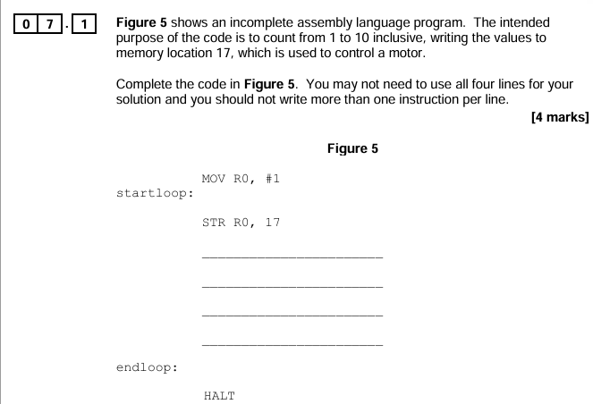

Completed code
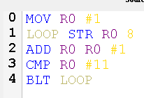
Moves the denary value 1 into register 0
Stores the value in register 0 into memory address 8
Adds the value in register 0 and the denary value 1 and stores it in register 0
Compares the value in register 0 with 11
If the value in register 0 is less than 11 then the program will branch back to “LOOP”
Registers
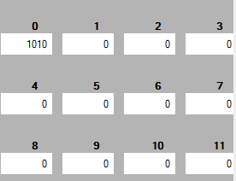
Memory
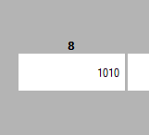
The program successfully iterates from 1-10 inclusive and then stores in a memory address. My program only allows you to write into a memory address up to 15, but for the purpose of this question it works.
Question 2
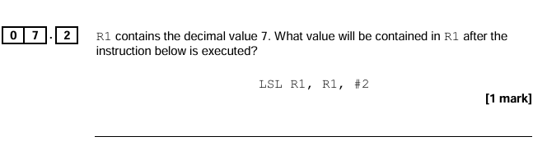
Completed Code
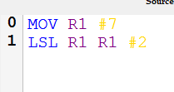
Moves the denary value 7 into register 1
Left shifts the value in register 1 by 2 and then stores the result in register 1
Registers
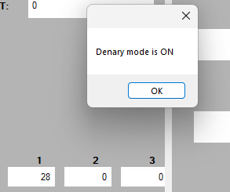
Question 3
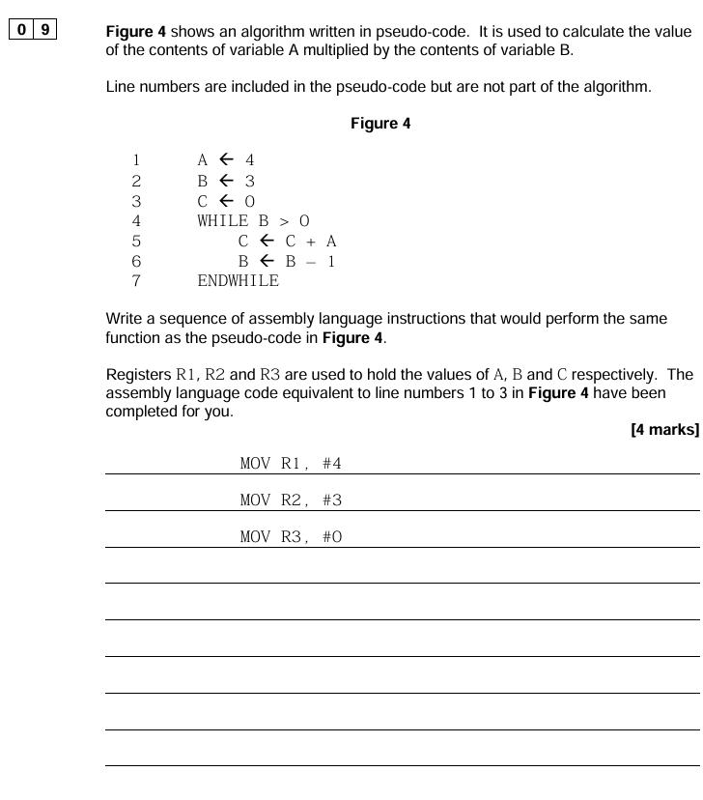
Completed Code
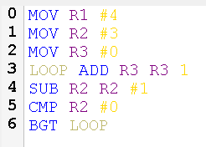
Moves the denary value 4 into register 1
Moves the denary value 3 into register 2
Moves the denary value 0 into register 3
Add 1 to the value in register 3 and then store it in register 3
Subtracts 1 from the value in register 2 and store it in register 2
Compares the value in register 2 and 0
If the value in register 2 is greater than 0 the program will branch to “LOOP”

Test ID | Description | Data | Expected Outcome | Passed?
0.1 | Test the textbox in which users write code and determine whether the program will crash with any given input. | Added an extra line and spaces before at the end of line. | The program should not crash but give the appropriate error message. | Pass
0.2 | Test whether the program halts executes even if there is an error in the code | Made a syntax error and the program throws an error ‘INP T3 #3’ | The program should not execute and then give an appropriate error message. | Pass
0.3 | All of the additional functions in the toolbox work as they are intended to. | All work as intended | All the functional should work as expected. | Pass
0.4 | The conversion between machine code and denary and vice versa work in all cases with no errors. | All function as intended, registers and main memory all display correct data. | Machine code should be converted into their denary equivalent and vice versa. | Pass
0.5 | The error menu should contain all the error if any in the code. | Errors are all detected, and the line number are written into the error menu | Whenever errors are checked, the error menu should contain all the errors in the code. | Pass
0.6 | All of the calculations and mathematical /bitwise operations result in the correct sum. | All calculations result in the correct sum. | The result of the calculation must be outputted in the accumulator without error. | Pass
0.7 | All instructions should intend as functioned without any error or crash | Program does not crash whilst using any instructions correctly. | All the instructions do what they are meant to do | Pass
0.8 | The addressing mode result in the correct registers/ memory being used | Instructions function as intended with different addressing modes. | Memory addresses and registers and immediate addressing all work correctly. | Pass

Instructions

Instruction | Test Data | Expected Result | Pass | Result
LDR | LDR R4 0 | Value in the memory location 0 is stored in register 4. | Pass
STR | MOV R3 #2  STR R3 4 | The value in register 3 (2) is stored in memory location 4. | Pass | 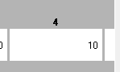
ADD | MOV R3 #2  MOV R4 #2  ADD R5 R3 4 | The value stored in register 5 will be the result of the addition of the values in register 3 and 4. | Pass | 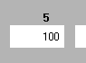
SUB | MOV R3 #4  MOV R4 #2  SUB R5 R3 4 | The value stored in register 5 will be the result of the subtraction of the values in register 3 and 4. | Pass | 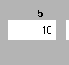
MOV | MOV R3 #4 | Value 4 into register 3. | Pass | 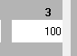
CMP |  | The fact that all of my branch instruction function as expected proves that this instruction also functions as intended. | Pass
B | INP R0 #1  LOOP ADD R0 R0 #1  CMP R0 #5  B LOOP | Always branches no matter what. | Pass
BLT | INP R0 #1  LOOP ADD R0 R0 #1  CMP R0 #5  BLT LOOP | Branches if the value in R0 is less than the specified value. | Pass
BGT | INP R0 #5  LOOP SUB R0 R0 #1  CMP R0 #0  BGT LOOP | Branches if the value in R0 is greater than the specified value. | Pass
BNE | INP R0 #5  LOOP SUB R0 R0 #1  CMP R0 #0  BNE LOOP | Branches if the value in R0 is not equal to the specified value. | Pass
BEQ | INP R0 #3  LOOP SUB R0 R0 #1  CMP R0 #2  BEQ LOOP | Branches if the value in R0 is equal to the specified value. | Pass
AND | MOV R1 #2  MOV R2 #3  AND R3 R1 2 | Applies a logical AND to the values in the registers specified and stores it into another register. | Pass | 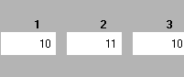
ORR | INP R1 #2  INP R2 #3  ORR R3 R2 1 | Applies a logical OR to the values in the registers specified and stores it into another register. | Pass | 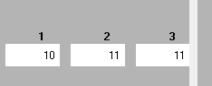
EOR | INP R1 #2  INP R2 #3  EOR R3 R2 1 | Applies a logical XOR to the values in the registers specified and stores it into another register. | Pass | 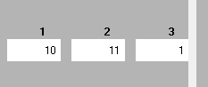
MVN | MVN R2 #2 | Applies a logical NOT to the values in the registers specified and stores it into another register. | Pass | 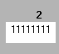
LSL | MOV R1 #2  LSL R2 R1 #1 | Right shift the value in register 1 by 1 to the right and store it in register 2. | Pass | 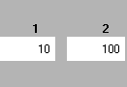
LSR | MOV R1 #2  LSR R2 R1 #1 | Left shift the value in register 1 by 1 to the right and store it in register 2. | Pass | 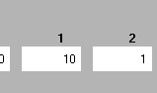
HALT | MOV R3 #3  HALT  MOV R3 #4 | Stops the execution of the program. | Pass | 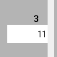

Evaluation

Objective met

- As mentioned in the original description, students should be able to see changes that occur in registers, and this should be made evident. I have achieved this by changing the background colour of the registers when a change is made, and then after a short period of time, the background goes back to the original colour. Moreover, a nice quality of life feature I chose to add was the ability for users to choose what the background colour of the register will be. This helps as some people may have impediments like colour blindness, which can be helped by allowing users to choose whatever colour they wish. I believe that I have met this objective however, to better meet this I could have made the background colour slowly fade away which would make it look less ‘blocky’. Whenever a register is highlighted, it last for a set amount of time. Another improvement I think would be to make it last until the next change happens instead of the small gap before the next instruction is executed. Also, a student suggested a bar which you can use to change the speed of execution, this has been fulfilled by different means, but this may have been more efficient.
- This objective was made to give the user information about errors that have occurred in the program. I would say that the objective was mostly successful because the program can detect if there are any syntax errors in the code. The user can click the check errors button, which will write in the error menu if there is an error in the code and which line the error occurs on. This coincides with the original description. However, to improve this feature, it would be beneficial is when using an instruction like LDR if the user hovers over it, it should tell them the correct syntax and how to lay out the instruction so that there is less chance of the user making an error. Furthermore, providing the user with what error was made, for example, ‘Missing register’. The current error menu is quite broad and doesn’t really give details into what error has occurred, which could definitely be improved. Some students said that they got errors in their code but weren’t sure were the mistake was due to their being nothing to tell them what they did wrong. I order to further improve this I think a tutorial to show students how the syntax works work be very beneficial.
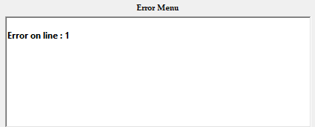
- My next objective is pretty simple but very crucial for the success of the program. The input code by the user should be assembled quickly and efficiently, and it should not take long for the FDE cycle to occur. As said in the description, this is mainly for the convenience of the user. In order to help add to make this objective successful, I implemented a feature where the user can change the execution speed of the program which allows them to control the FDE cycle, consequently, the user is able to slow down the speed of execution if it helps them see changes more easily.
- This is a simple but very important task. Providing examples for students to take inspiration from/learn how the syntax work I believe it is very important, and students also said that examples would be useful. In my survey, students said that they find the syntax hard to by providing examples students can look at them and then write their own code. By being able to see examples, it will have an advantage when writing their own code.
These are some of the example programs I have written which give user a good gist of how techniques such as branching and using memory.
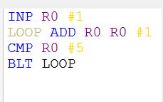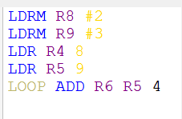
- Students are able to save source code in a text file in their own storage space. Storing it in a text file makes it easier for students to use for whatever purposes they wish. Student said that this would be beneficial as it allows them to come back to programs, they may have been programming. Students can access this save feature by going to the toolbar and then selecting ‘File’ and then the ‘Save As’ button, which will then prompt the user to save their source code wherever they wish. For this exact reason, files are stored as their mnemonics and not their machine code, and the mnemonics are more portable. In addition, students can open files that have been saved by selecting ‘File’ in the toolbar and then selecting the ‘Open’ button, where the students can then select the file and open it. The code in the text file will automatically be copied into the user's source code section. Overall, saving and loading are simple, but I have chosen to keep it as source code and not machine code for the reason stated above.
- Students have the capability to change the execution speed of the program by simple entering the time of delay. In order to see up the execution, the student will enter a lower speed of execution and to increase enter higher time of execution. This feature is pretty success as it does what it’s meant to do and give students the ability to change the speed of execution to allow them to see changes that occur in registers easier; this is a core feature as this would be useful for students when solving A-level questions or just or identifying changes for whatever purpose.
However, I do think that this feature can be improved by using a sliding bar to change the speed as it’s more convenient than having to click several buttons before being able to change the speed of execution and then having to manually type in the delay that you want between each instruction.
- The execution of step programming was successful, due to the implementation of the FDE cycle making another step function was simple. The student is able to write programs and then is able to execute them line by line at their own discretion. I feel like the feature works fine as it is but I definitely think that it could be refined. I think this could be done by first of making it more clear what it does and then secondly by making it step through the FDE instead of line by line. So for instance, instead of running ‘LDR R3 9 Then you click step firstly the value in register 9 is stored into the MAR and then when you click step it then goes into the MDR. I think this would be a more complete solution given that the program should be competing the FDE cycle. All in all, I’m pretty happy with the progress of this objective.
- The user is able to switch between a denary mode and machine code mode with the simple click of a button. This objective has been successfully met and is useful for the user, instead of seeing code which they may not understand, they are able to see denary numbers which they are used to seeing.
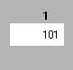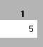
I could have improved this by adding hexadeciaml and or two’s complement which was suggested. This would have made this objecitve a lot more benefical and successful.

Feedback

Teachers
My client, Mr Mullen, a teacher at the Bishop’s Stortford High School when asked “When teaching low level if you were to use LMC to teach students what feature would you want to add (for example 'errors in syntax become highlighted')?”
His answer was ‘Graphic indicators of use of registers’ with which I have made change the background colour of registers whenever a change is made to the register. This made it clear to the user where the change has occurred.
I sent a brief video of this in action to my client and his reply was, “I like the red highlight on the registers makes it nice and clear. Would it be possible to make it last a little bit longer? Otherwise, I think it does the job well. I also like the colour coding on the code window”.
From this feedback, I think it is fair to say that my clients request for my project has been fulfilled. With an improvement of making the change in colour longer so it is slightly more beneficial for all ages.

Students
An A-level student evaluated the functionality of my program, and I will analyse some of the feedback from the student.

Autosave
One of the critiques of my program was that there is no auto save; currently, my program has a feature where you can manually save the program, however, an autosave would save the student time from having to save their work manually. In addition, in case a student were to forget to save their work, this feature would help prevent any work from being lost. In summary, even though my saving feature is ample for a project such as an assembler, I believe that an auto-save would be much more convenient for the user of my program.
As a result of this feedback, I have implemented this feature; so when you load a program into memory, it automatically saves to the file where you saved the last program. The only downside to this is that if you want to save multiple programs in different files, you will have to restart the application.

Instruction Set
At the time of testing my program, it didn’t have an instruction set for the student to follow, so this meant that at times if they didn’t know the syntax by heart they would struggle to program. My program now does have the instruction set in the help menu which should help students out. I think that in order to further improve this, I should have an example of how each instruction works and also it being used with relative, direct, and immediate addressing as one of my extra objectives had stated.

Step Function
A feature which precedes the execution speed is a feature that allows the user to click a button, which will then progress the execution onto the next stage of the FDE cycle was suggested. This seemed like a much better idea than the execution speed because it's solely in the hands of the user when the next execution happens, this is much more beneficial for a user if they are answering questions, they can read the value in the register, write something down and then click the button to go onto the next change. I deemed this suggestion to be quite beneficial, so I implemented it into my program. By selecting the green arrow, the next stage of execution will occur.

Survey
From my survey which I sent out I have received some good feedback
The UI of my program was rated an 8/10 which is a decent score, some of the complains mainly occurred due to the program not scaling very well when you maximised it. As a result of maximising the program, there would be some blank spaces next to the registers which would make it slightly inconvenient for the users. The overall UI though was said to be good.
The example programs were rated a 7/10 in usefulness which is a pretty decent score again. I added these as it gave student the ability to see ready made programs which could help give them an insight to how they should be writing their own program and help them with syntax as in my previous survey, student said that they struggle with AQA instruction set as they do not understand the syntax.
In terms of solving problems, my program seems to work, as 50% of students said that they are able to write an algorithm which counts from 1 to 5 inclusive. This shows that my program can be used to write programs in and that branching works. The other 50% said that they may be able to do so.

Improvements

Some improvements that I think my program would benefit from is as such.
- IntelliSense – I think that having IntelliSense would make programming much more convenient for the user. Having it detect what the user could write and then other possible solutions. This would make my program much more complete than it already is. However, the reason I never really considered adding it was because most mnemonics are very short so having IntelliSense write it for you would be pretty useless.
- UI – I think that the UI could certainly do with some improvements, for example the program does not look as good when you maximise of change the dimensions of the program. This should be resolve by using a table for my items, buttons and etc. Furthermore, the empty space between the registers when the program is maximised can be unsightly to some users so this could definitely be improved. If the resolution is not changed, the programs UI was wated an average of 8 by the students that did my survey. All in all, I think that there is some room for improvement.
- Make use of more classes, given that OOP is pretty important, I think that the implementation of more classes could have added to the OOP side of my program. Although my program does not really require the use of loads of classes, I think that the addition of a few more classes would add to my project.
- Tutorial – I think adding some sort of tutorial mode would certainly be beneficial because despite student having the AQA instruction set, I think them visually being able to see from example of how instructions are used would be more beneficial than just seeing it from the instruction set. In addition to this a test mode so student can test their knowledge and ability.

Conclusion
Overall, I am satisfied that my program functions as intended. My program can be used by A-level students and over computer science students that want to write code using the AQA instruction set. I have added functionalities which make it more practical than other simulator like Little Mans Computer which does not allow you to save, open, view machine code etc. A level students are able to answer questions using my program which could definitely benefit them. There are some improvements which could be made but in conclusion, I am satisfied with my work.

